Province of the
EASTERN CAPE
EDUCATION

DIRECTORATE SENIOR CURRICULUM MANAGEMENT (SEN-FET)
HOME SCHOOLING SELF-STUDY WORKSHEET
SUBJECT | INFORMATION TECHNOLOGY PRACTICAL | GRADE | 10 | DATE | 11 May to 15 May 2020
TOPIC | Revision – Basics of Delphi | TERM 1  REVISION | (Please tick) | TERM 2 CONTENT
TIME ALLOCATION | 2hr | TIPS TO KEEP HEALTHY  1. WASH YOUR HANDS thoroughly with soap and water for at least 20 seconds. Alternatively, use hand sanitizer with an alcohol content of at least 60%.  2. PRACTISE SOCIAL DISTANCING – keep a distance of 1m away from other people.  3. PRACTISE GOOD RESPIRATORY HYGIENE: cough or sneeze into your elbow or tissue and dispose of the tissue immediately after use.  4. TRY NOT TO TOUCH YOUR FACE. The virus can be transferred from your hands to your nose, mouth and eyes. It can then enter your body and make you sick.  5. STAY AT HOME.
INSTRUCTIONS | Resources used// Most of this week’s work is taken from the New DBE practical book chapter 6  - Information Technology Practical Book Grade 10 , DBE  - Past Exam Papers  Answer all questions
Numeric input from an edit

- Input is always captured in the TEXT property as a string data type.
- Numeric input added to the EDIT needs to be converted into a numeric data type.
- StrToInt function converts a String to an Integer value and assigns the integer value to the integer property of the output, e.g. Calender1.Day := StrToInt (edtDay.text);

Built-in Function Numeric
Function | Description | Example and data type
Trunc | Truncates the decimal part of a real number | Trunc(8.97) = 8 | Integer
Round | Rounds off a number to the nearest integer | Round(8.97) = 9 | Integer
Frac | To find the decimal part of the real number | Frac(74.89) = 0.89 | Real
Sqr | Finds the square root of a positive number | Sqr(4.5) = 20.25  Sqr(4) = 16 | Real  Integer
Sqrt | Calculates the square root of a positive number | Sqrt(12.3) = 3.5  Sqrt(25) = 5.0 | Real  Real

Function name | Definition | Examples
Copy(string, start, length) | Returns a sting of given length for the specified string, beginning at the start character position: if length is greater than the number of characters from start onward, the next returned continues to the end of the string | Copy('South',2,3) returns 'out'
Length(string) | Returns the length of the string | Length ('South') is 5
TrimLeft(string) | Removes the leading spaces from string | TrimLeft(' South') is 'South'
TrimRight(string) | Removes the trailing spaces from string | TrimRight('South ') is 'South'
Trim(string) | Removes spaces at both ends of the string | Trim(' South ') is 'South'
StringOfChar(character, length) | Creates a string of the specified character for the given length | StringOfChar('S',5) returns 'SSSSS'
UpperCase(string) | Converts the string to capitals | UpperCase('South') returns 'SOUTH'
LowerCase(string) | Converts the string to lower case | LowerCase('South') returns 'south'
Pos(search, main) | Searches for the first occurrence of the search string in the main string | Pos('o', 'South') is 2

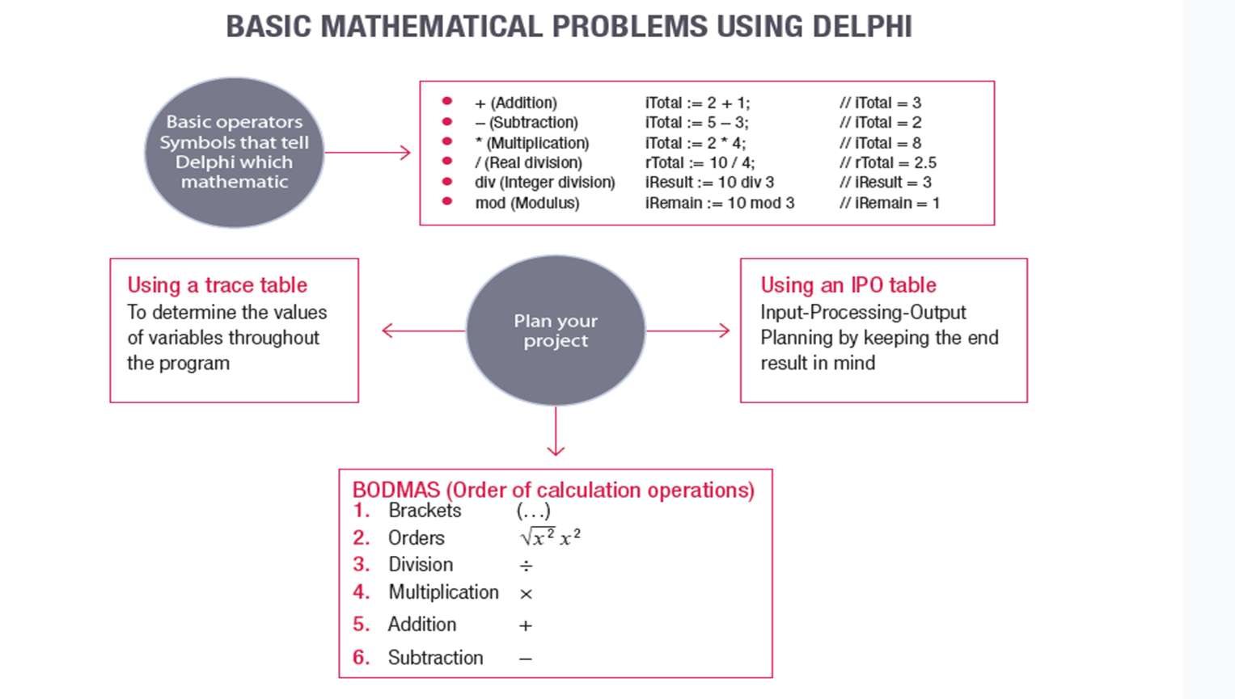

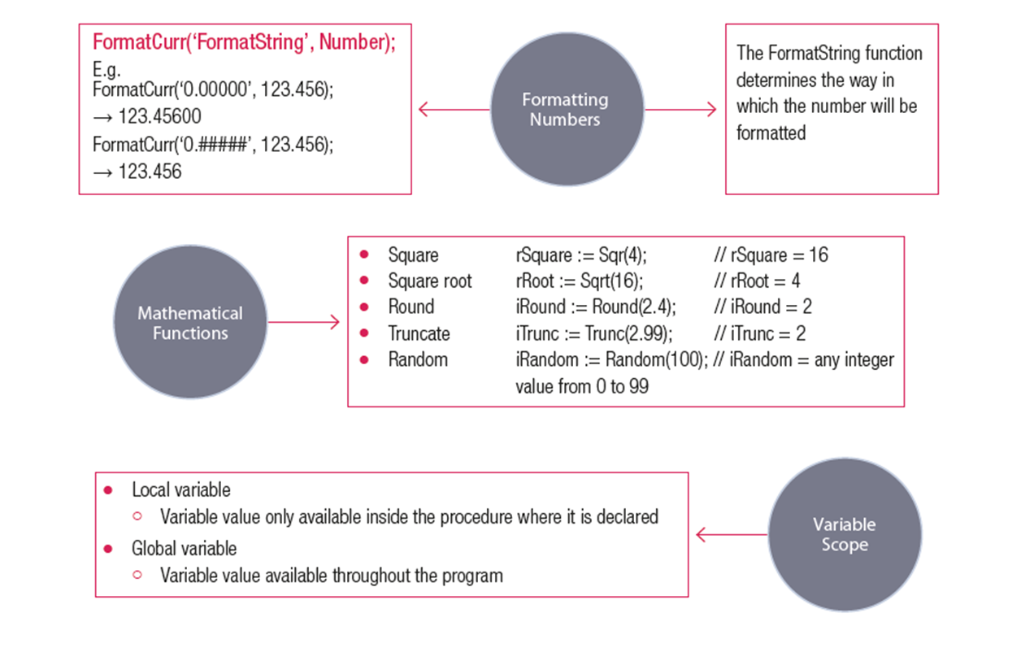

Create the following GUI and save it as Activity 2. Each button explains what needs to be done.

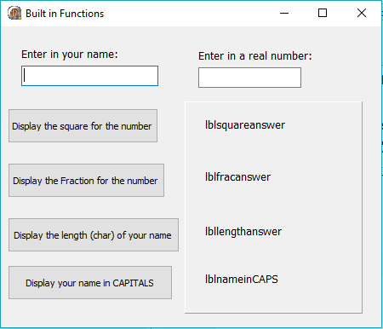

Flowcharts

