DIRECTORATE SENIOR CURRICULUM MANAGEMENT (SEN-FET)
HOME SCHOOLING SELF-STUDY WORKSHEET
SUBJECT | Nautical Science | GRADE | 10 | DATE | 20/4/20
TOPIC | Seamanship | TERM 1  REVISION | X | TERM 2 CONTENT | X
TIME ALLOCATION | 20min | TIPS TO KEEP HEALTHY  1. WASH YOUR HANDS thoroughly with soap and water for at least 20 seconds. Alternatively, use hand sanitizer with an alcohol content of at least 60%.  2. PRACTICE SOCIAL DISTANCING – keep a distance of 1m away from other people.  3. PRACTISE GOOD RESPIRATORY HYGIENE: cough or sneeze into your elbow or tissue and dispose of the tissue immediately after use.  4. TRY NOT TO TOUCH YOUR FACE. The virus can be transferred from your hands to your nose, mouth and eyes. It can then enter your body and make you sick.  5. STAY AT HOME.
INSTRUCTIONS | This worksheet is to be completed in your MRTE exercise/activity book.

Question 1
1.1 Give the nautical term for the following:
- The “foundation” of a vessel. (1)
- The “backbone” of a vessel. (1)
- The “ribs” of a vessel. (1)
- The toilet of a ship (1)
- The kitchen of a ship (1)

Question 2

2.1 Double Bottom is the watertight cellular structure between the Bottom Plating and
the Tank Top. It is formed by the keel, the floors of frames and bottom longitudinals.

2.1.1 What are the two uses of the watertight compartments of/within a double
bottom? (2)

Question 3

3.1 State two (2) advantages of using Mild Steel as a shipbuilding material? (2)

3.2 The use of aluminium in the internal structures of a ship contributes to the reduced weight in the final structure. Explain why the presence of aluminium would not be desirable during large onboard fires. (2)

3.3 If cost was not a factor, give two reasons why Stainless Steel would be the ideal shipbuilding material. (2)

3.4 As a ship-building material, Fibre Glass (GRP) is only recommended for hull construction of small sea-going vessels and internal structures such as bath tubs, showers, and basins of large ships. Give any two (2) reasons why this is the case. (2)

3.5 What is the common property making both Wood and Fibre Glass (GRP) ideal materials for construction of mine countermeasure vessels (MCM)? (2)

3.6 Large Wooden ships at sea experience excessive sagging and hogging. Supply two (2) more disadvantages of Wood as a shipbuilding material. (2)
Question 4

4.1 Write down in your answer sheet the name of the structural member indicated in the Sketch below. (10)

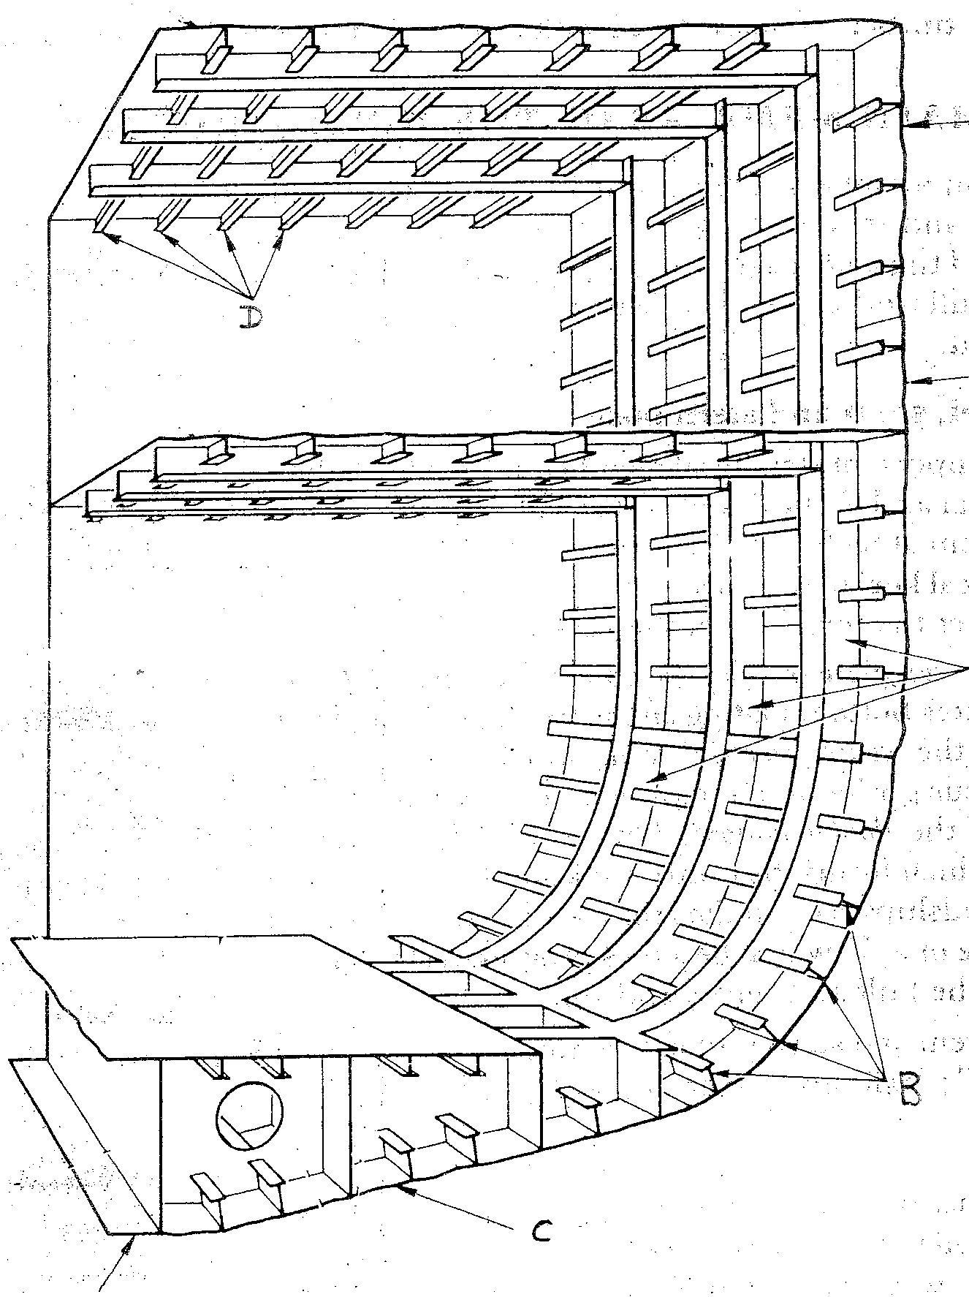
j
b
c
d
i
f
g
Keel
h
e
a

