Province of the
EASTERN CAPE
EDUCATION

DIRECTORATE SENIOR CURRICULUM MANAGEMENT (SEN-FET)
HOME SCHOOLING SELF-STUDY WORKSHEET
SUBJECT | GEOGRAPHY | GRADE | 11 | DATE | 18 May 2020
TOPIC | GEOMORPHOLOGY | TERM 2  REVISION | √√ | TERM 2 CONTENT | √√
TIME ALLOCATION | 1HOUR | TIPS TO KEEP HEALTHY  1. WASH YOUR HANDS thoroughly with soap and water for at least 20 seconds. Alternatively, use hand sanitizer with an alcohol content of at least 60%.  2. PRACTICE SOCIAL DISTANCING – keep a distance of 1m away from other people.  3. PRACTISE GOOD RESPIRATORY HYGIENE: cough or sneeze into your elbow or tissue and dispose of the tissue immediately after use.  4. TRY NOT TO TOUCH YOUR FACE. The virus can be transferred from your hands to your nose, mouth and eyes. It can then enter your body and make you sick.  5. STAY AT HOME.
INSTRUCTIONS

- Notes on Topography Associated with Inclined/Tilted Strata
- Worksheet on Incline strata
- Please revise all concepts before going through your worksheet.
- Revise at least 1 hour per day.
- Please revise question papers from 2014 to 2019 on the ECEXAMS website

NB: Answer sheets will follow on Friday

2. Topography associated with Inclined/Tilted rock strata
Dip and Scarp Slopes
Dip Slope
- The Dip slope shows the direction in which the rock layers dip.
- the dip slope is less steep than the scarp slope.
- The soils are thinner on the dip slope because of the resistant nature of the rock layer

Scarp slope
- The scarp slope is steeper than the dip slope
- Forms a cliff face
- Eroded rock from the scarp face lands on the Ta;us slope below the cliff
- Concave in shape
Horizontal line
- This line is parallel to the horizon
- This line is used to measure the angle at which the slope dips

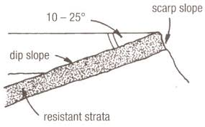

Angle of Dip
- Angle formed between the dip slope and the horizontal line
- This angle is used to classify the homoclinal ridge as being a Hogsback or cuesta

- Characteristics and processes associted with the development of Homoclinal ridges

- A homoclinal ridge is the collective name given to landforms formed when rock layers are tilted
- Sedimentary rocks that were once horizontal become inclined as a result of folding or the intrusion of magma below the sedimentary rock.
- Hoocinal ridges for a a result of the tilted rock strata
- Erosion removes the layers of the material above the inclined rock layer
- The gentler slope is the dip slope and the steeper slope is the scarp slope
- The landform is is referreto as a Homoclinal ridge.
- The more resistant rock layers forms the ridge and the softer rock layers forms the valleys between the ridges

Cuestas and Hogsbacks

Feature | Cuestas | Hogsbacks
Diagram | 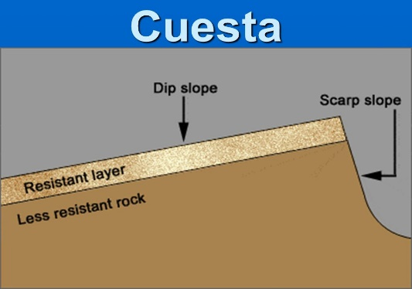 | 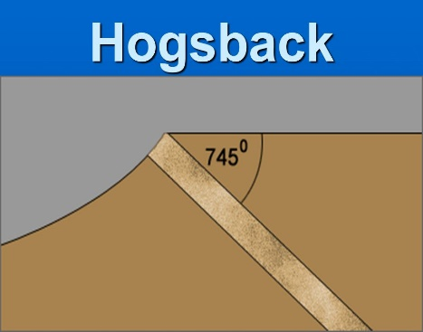
Characteristics | - Angle of dip slope is less than 45  - Assymmetrical in shape  - Has a gentle dip slope and a steeper scarp slope | - Angle of dip is greater than 45  - Symmetrical in shape  - Dip and scarp slopes are nearly equally steep  - Forms a narrow crested ridge.
Similarities | - Forms an inclined Strata  - Alternating layers of hard and soft rocks

- Cuesta Dome
- Formed in layered sedimentary rocks
- Forces deep beneath the surface of the earth thrust up a portion of the earth.
- Intruding batholiths or laccoliths causes the overlying rock strata to become tilted.
- The tilted sedimentary rock forms an anticline on the surface of the earth
- Erosion and weathering will further lead to the formation of a circular cuesta dome landscape.The dip slope faces outwards and the steeper scarp slope towards the centre of the dome

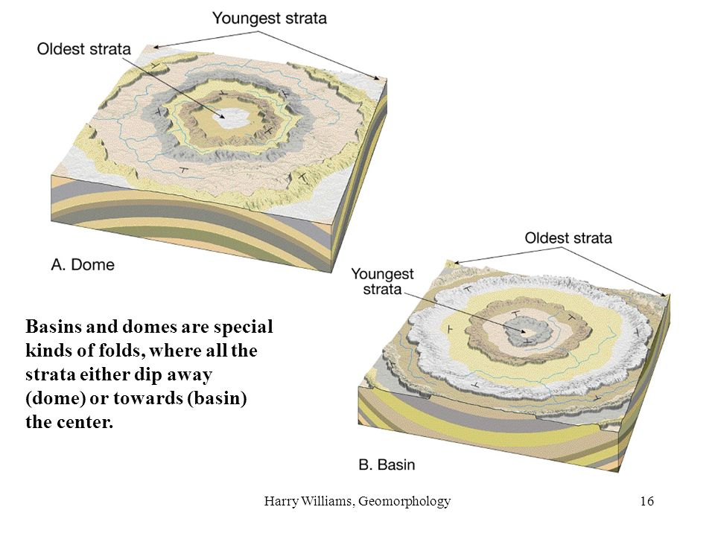
B. Cuesta Basin
- Are circular depressions on the Earth’s surface
- The sedimentary rock strata are intruded by magma.
- When the magma cools down it shrinks and sags causing the sedimentary rock strata to sag as well.
- The sagging cause the rock strata to become tilted.
- Erosion and weathering results in circular cuesta
- The dip slope will face inwards towards the centre of the basin and the scarp slopes face outwards.
- The bushveld Igneous complex is a local example of a cuesta.

- Utilization of these landcapes by people

Landform | Utlization
Cuesta Basins | - Allow for the seepage of water into the centre of the basin resulting in a good source of ground water.  - Sandstone acts as a aquifer sand shale acts as a aquiclude.  - Farmers can use the water for irrigation.  - New Settlements can be established.
Cuesta Domes | - Domes have prous sandstone and impermeable shale,this allows for the buid up of Petroleum which can be mined  - Salt domes have a similar effet,trapping petroleum between the sandstone and the shale.

Questions on Topography associated with massive inclined/tilted Strata

1.1 Refer to FIGURE 1.1 which indicates a cuesta and a hogsback. Match each of the descriptions below with sketches A or B.
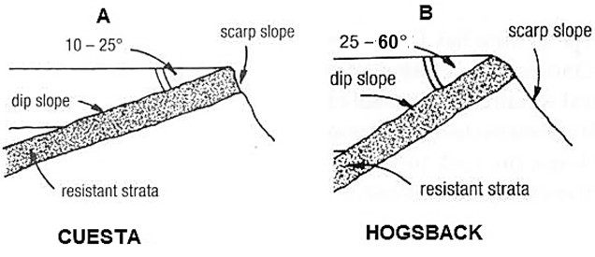
FIGURE 1.1 : INCLINED STRATA

1.1
 | 1.1.1 | Can form in a dome or basin
 | 1.1.2 | Has a steep scarp slope and a gentle dip slope
 | 1.1.3 | Scarp slope is more than 45°
 | 1.1.4 | It is a suitable location for dams
 | 1.1.5 | An example of this ridge is found in Alice in the Eastern Cape
 | 1.1.6 | The gentle dip slope can be used for farming
 | 1.1.7 | Composed of steeply tilted strata of rock
 | 1.1.8 | Formed by gently tilted rock strata | (8x1) | (8)
Refer to FIGURE 2.1 showing landforms that formed because of inclined/tilted strata.

FIGURE 2.1
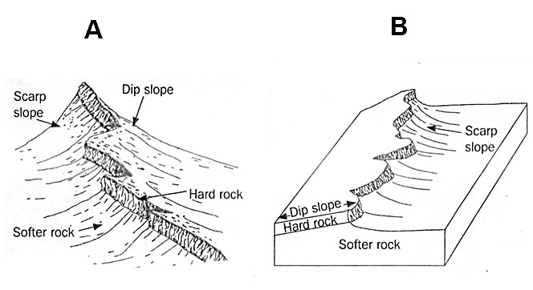

Homoclinal Ridge

Cuesta

[
Source
:

google/image
s
]

2.1
 | 2.1.1. | Differentiate between the dip slope of a homoclinal ridge and a cuesta. | (2x1) | (2)
 | 2.1.2 | Did the landforms in the sketches of FIGURE 2.5, develop because of igneous or sedimentary rocks? | (1x1) | (1)
 | 2.1.3 | Name the tectonic process that may have caused these landforms to be tilted. | (1x1) | (1)
 | 2.1.4 | Refer to the dip slope and scarp slope in landforms A and B.  (a)Describe the difference between the dip  slope and scarp slope.  - Comment on the fact that erosion is faster at the scarp slope than at the dip slope. | (1x2)  (2x2) | (2)  (4)
 | 2.1.5 | Why is it difficult to farm in tilted/inclined landscapes? | (2 x 2) | (4)
[14]

