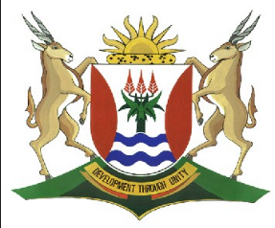
Province of the
EASTERN CAPE
EDUCATION

DIRECTORATE SENIOR CURRICULUM MANAGEMENT (SEN-FET)
HOME SCHOOLING SELF-STUDY WORKSHEET
SUBJECT | GEOGRAPHY | GRADE | 11 | DATE | 18/05/20
TOPIC | SLOPES | TERM 2  REVISION | √√ | TERM 2 CONTENT | √√
TIME ALLOCATION | 1HOUR | TIPS TO KEEP HEALTHY  1. WASH YOUR HANDS thoroughly with soap and water for at least 20 seconds. Alternatively, use hand sanitizer with an alcohol content of at least 60%.  2. PRACTICE SOCIAL DISTANCING – keep a distance of 1m away from other people.  3. PRACTISE GOOD RESPIRATORY HYGIENE: cough or sneeze into your elbow or tissue and dispose of the tissue immediately after use.  4. TRY NOT TO TOUCH YOUR FACE. The virus can be transferred from your hands to your nose, mouth and eyes. It can then enter your body and make you sick.  5. STAY AT HOME.
INSTRUCTIONS

- Notes on Slopes
- Worksheet on Slopes
- Please revise all concepts before going through your worksheet.
- Revise at least 1 hour per day.
- Please revise question papers from 2014 to 2019 on the ECEXAMS website
NB: Answer sheets will follow on Friday

Overview of South Africa’s Topography
The Escarpment
- Separates the high interior from the low lying coastal plain.
- Runs the entire edge of the South African Coastline
- Escarpment along eastern side is 1900 m above sea level(A on the map)
- The escarpment in KZN forms the majestic Drakensberg range which separates Lesotho from KZN (B on the Map)

The Interior Plateau:
- South Africa consist mainly of a flat interior
- Interior lies approximately 1000m above sea level

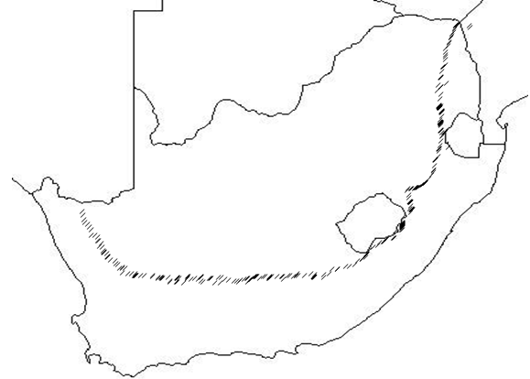

Rivers on the Western Side
- Rivers from the plateau drain westwards to the Atlantic Ocean.
- Limpopo river is the only river on plateau to flow eastwards into the Indian Ocean

A

B
The Coastal Plain
- Wide on the Eastern Side of the Country
Y
X

The Escarpment on the Western Side
- Only reaches a height of 1000m above Sea level
Rivers on The Eastern Side
- Shorter rivers drain down the escarpment
The Coastal Plain
- Narrow on the western side of the country

The Topography of South Africa
- The escarpment separates the coastal Plain from the high Interior.
- The high escarpment has a major effect on the rivers, climate, and infrastructure of South Africa.
- The escarpment is a major watershed for most rivers
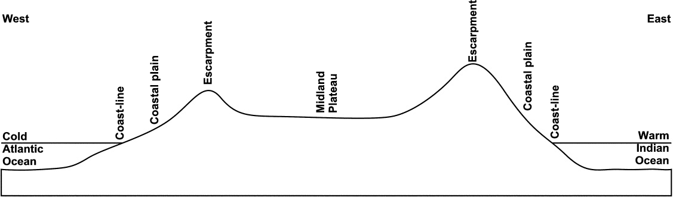

- The Interior plateau gently slopes from East to West.
- The interior plateau, the escarpment and surrounding mountain ranges and low coastal plain, results in a wide variety of topographical features and vegetation types.

Types of Slopes
- Slopes types are mainly determined by the type of rock in the area.
- Resistant rocks erode slowly and form cliffs
- Less resistant rock erodes faster and forms gentle slopes.
- The orientation and presence of resistant rock determines the slope type that forms.

Type of Slope | Slope Formation | Example
Concave slope | - Forms when the top layer of rock is more resistant to erosion than the layer of rock below it  - Formed when intruding sills are exposed by erosion | 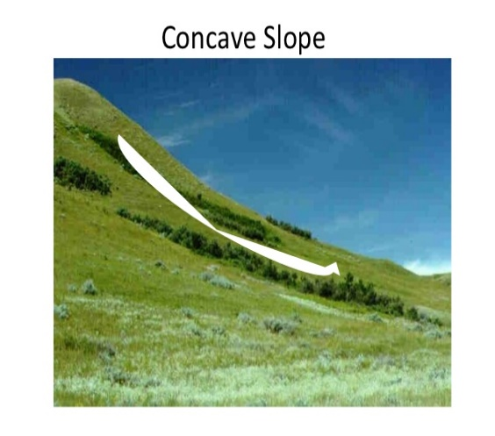
Convex Slope | - Common in Humid areas.  - Forms when massive igneous intrusions are exposed.  - Forms when resistant rock layers of rock have been removed | 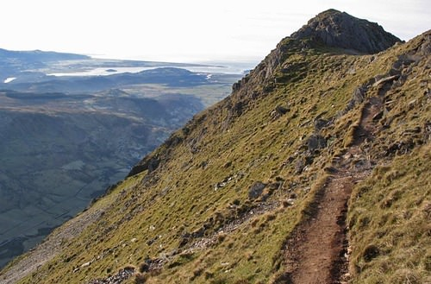  Convex Slope
Stepped slope | - Areas of alternating rock types  - Resistant rocks form the cliffs and less resistant rock layers from the gentler slopes  - Areas where layers of intruding sills have been exposed. | 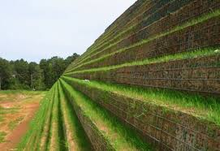  Stepped Slope
Cliff | - Formed by a layer of resistant rock  - Erosion of the cliff face results in the retreat of the cliff.  - Rocks eroded fall to the base of the cliff. | 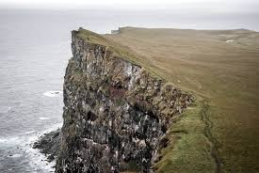  Cliff

Slope Elements

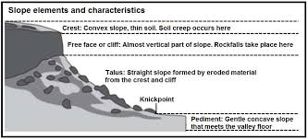

Characteristics of the Slope Elements: Crest, Cliff, Talus and Pediment
Cliff
- Also called free or scarp face
- Vertical to the bottom
- Hard resistant rock layer
- Loose material falls to the foot of the cliff
- Cliff retreats backwards parallel to itself

Crest
- Top of the hill
- Convex in shape
- Thin layer of soil
- Weathered material removed
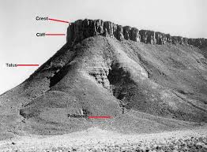
Talus Slope
- Also called the scree or Debris slope
- Material from cliff and crest land on this slope
- Uniform Slope angle
Pediment
- Slope has a low angle
- Concave slope – steeper towards the talus slope and gentler at the base
- Pediment increases as the slope retreats backwards because of scarp retreat

Knick point
- This is not a slope element but marks the change in the angle between the Talus Slope and the pediment

Questions on Slopes
1.1 FIGURE 1.1 illustrates slope elements. Choose the correct slope element for the descriptions below. A slope element can be used more than once.
SLOPE ELEMENTS

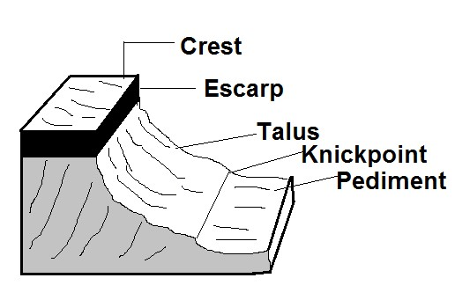

1.1.
 | 1.1.1 | The slope element with the least soil coverage
 | 1.1.2 | The slope element with a constant gradient
 | 1.1.3 | The slope element where the construction of buildings and  infrastructure is possible
 | 1.1.4 | The feature that indicates the transition from one slope element to another
 | 1.1.5 | The slope element where the exposed rocks are usually unequal as weathering enlarged the joints and cracks in the rocks
 | 1.1.6 | Rockfalls are the main mass wasting process on this slope element
 | 1.1.7 | The slope element with a convex shape
 | 1.1.8 | The slope element where the accumulation of weathered material is not possible. | (8 x1) | (8)
1.2. Refer to FIGURE 1.2 which shows slope elements. Match the descriptions below with slope elements A, B, C or D. Choose the answer and write only the letter A, B, C or D next to the question numbers (1.2.1–1.2.7) in the ANSWER BOOK, for example 1.2.8 A. You may choose the same letter more than once

[Source:
sageography.myschoolstuff.co.za
]

 | 1.2.1 | This slope element is usually convex in shape
 | 1.2.2. | The steepest slope element
 | 1.2.3 | Knickpoints form at the base of this slope element
 | 1.2.4 | Angle is 40° and little vegetation occurs on it
 | 1.2.5 | The shape of this slope element is concave
 | 1.2.6 | Gentle gradient of this slope element is suitable for farming and settlements
 | 1.2.7 | This slope element is commonly referred to as the talus, scree or debris slope | (7x1) | (7)
 |  |  | [15]

