SUBJECT and GRADE | Civil Technology (Woodworking) Grade 12
TERM 2 | Week 3
TOPIC | Casements (Specific)
AIMS OF LESSON | To understand the sectional drawing of casements.  To be able to sketch the section through a transom, bottom rail of fanlight and top rail of casement with glass and putty in.  Understand and interpret the double casement window
RESOURCES | Paper based resources:  In your textbook on page 86 – 92 of Chapter 7 | Digital resources:  See digital Power Point
INTRODUCTION | Casement window can be defined as a window assembly that has at least one casement or vertically hinged sash (frame that holds the glass). Single casements and the double casement with two horizontal glazing bars were dealt with in Grades 10 and 11 respectively. This chapter focuses on the double casement with fanlights and two horizontal glazing bars.  As a dedicated learner you were exposed to many drawings and concepts within Graphics as Means of communication where you did drawings and sketch some images freehand.  In this lesson we are going to look at casements and do some scale drawings to understand the content.
CONCEPTS AND SKILLS | Sketch of vertical section through the transom, bottom rail of fanlight and top rail of casement with glass and putty in position Identification of parts and the drawing of the external elevation of a double casement with fanlights and two horizontal glazing bars in the casement within a frame.  Drawings skills will be acquired by doing this lesson. Proportionally sketch work and sectional interpretation will be part of the skill set. Knowledge of the different parts of the fanlight will be acquired as well. |  | CAN YOU?  - Sketch a vertical section through a transom, bottom rail of a fanlight  - Sketch a top rail of a casement with glass and putty in position.  - Identification of parts of an external elevation of a double casement with fanlight  - Draw a two horizontal glazing bars in the casement within a frame.

 | 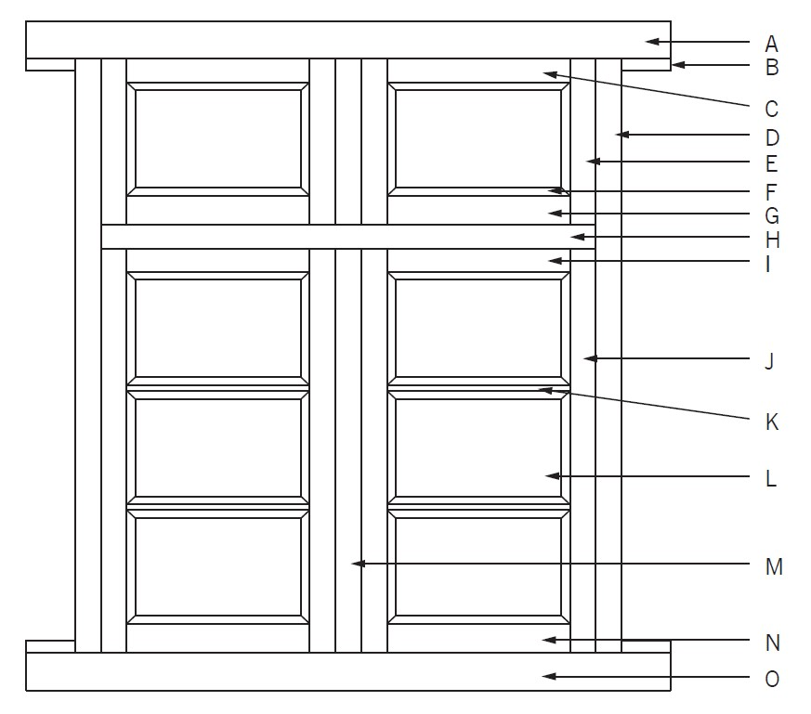  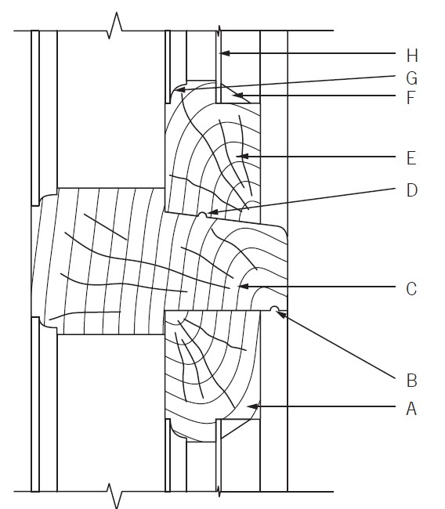 | 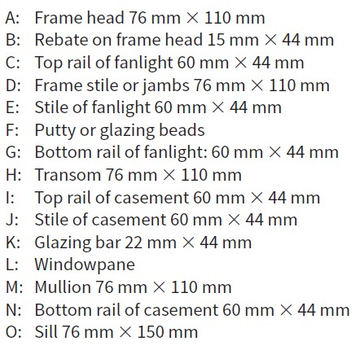  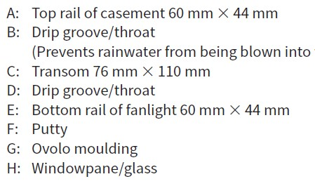

ACTIVITIES/ASSESSMENT | Do you know the different parts of a double casement?  Members of the frame of a double casement  Frame head: Top horizontal member fixed to the walls by means of horns at both ends  Transom: Horizontal member that separates the casement and fanlight (glazed or solid crossbar above the casement)  Frame stile or jambs: The outer vertical members of the frame  Mullion: Intermediate vertical member between the jambs  Sill: The bottom horizontal member of the frame fixed to the walls by means of horns at both ends.  You can now look on page 111 and start with activity 1 – 4. After mastering the activity challenge yourself with activity on page 115 as in the textbook.
CONSOLIDATION | With this topic you will required basic mathematical skills.  Measuring is another skill that will be required and mastered.  You will also engage with the physical properties of materials.  Graphics as a mean of communication is a helpful section as you need to engage with drawings. Interpretation of drawings to work out quantities is very important in this lesson.
VALUES | You will engage with the parts of a double casement.  You will be able to sketch a vertical section through a transom, bottom rail of a fanlight  Understand how sectional view will be done of a top rail of a casement with glass and putty in position and identification of parts of an external elevation of a double casement with fanlight

