|  |  |  |
| --- | --- | --- |
| **SUBJECT and**  **GRADE** | ENGINEERING GRAPHICS AND DESIGN GRADE 12 | |
| **TERM 2** | *Week 5* | |
| **TOPIC** | INTERPENETRATION (Nov 2009 Paper 1 Question 2) | |
| **AIM OF LESSON** | Learners are required to draw a penetration of two solid structures. The square prism penetrates a hexagonal prism at an angle of 30.̊ Develop the square branch piece. | |
| **RESOURCES** | ***Paper based resources*** | ***Digital resources (Lesson on the content)*** |
| INTERPENETRATION  Nov 2009 Paper 1: Question 2 *(JP 77) (JP 81)* See attached drawings. | <https://youtu.be/wmtaEEBFVE0><https://youtu.be/9wnvqz4ZYRY> |
| **INTRODUCTION** | **REVISION:**  Revision work from grade 11:  Four basic geometric shapes: prisms, pyramids, cones and cylinders    ***WEEK 5: LESSON 1***  Start by copying the given views.  Emphasize that all solids start with the drawing of the basic shape    ***WEEK 5: LESSON 2***  Start by copying the given views.  Emphasize that all solids start with the drawing of the basic shape | |

|  |  |  |
| --- | --- | --- |
| **CONCEPTS AND**  **SKILLS** | Learners must be able to:  Draw solid structures as within the activities provided.  Draw solid structures penetration one another at an angle.  The skill to see and draw hidden detail | **CAN YOU**?   * Copy the given views? * Identify the different sides / corners on a view? * Draw solid structures penetrating one another at an angle? * Identify where hidden detail will be if instructed to draw it in?   Learners must adhere to all drawing criteria. |
| **ACTIVITIES/**  **ASSESSMENT** | Complete the activities/questions on Interpenetrations attached.  *RECOMMENDATION*:  See attached grade 12 exercise for INTERPENETRATIONS  Standard of Exercise meet all external examination requirements  Draw to scale 1: 1  Read the instruction on the question given.  ALL drawings must comply with the guidelines contained in the SANS 10143. | |
| **CONSOLIDATION** | * Define all the terminology relevant to the topic/s covered in this lesson: * Printing of measurements are in some cases important. * Practice and complete the drawings if you did not finish in time. * Use the correct line types: Construction lines, hidden lines, ext. * Practice daily. | |
| **VALUES** | After engaging with this lesson you should:   * Realise the importance of interpenetration drawings * Know that neatness and accuracy is important when doing drawings. * Realise that a wrong drawing can lead to a waste of resources. * Appreciate the importance of geometry drawings. | |

|  |  |  |  |  |  |  |  |  |
| --- | --- | --- | --- | --- | --- | --- | --- | --- |
|  |  |  |  | **VRAAG 2: DEURDRINGING EN ONTWIKKELING GEGEE:**  **Die onvolledige vooraansig, bo-aansig en onvolledige linkeraansig van ‘n ankerblok wat gebruik word om**  **‘n boog oor ‘n stadion te bevestig. Die ankerblok is ‘n betongietstukwat bestaan uit ‘n seskantige prismatiese voetstuk A en ‘n vierkantige takstuk B wat om die voetstuk gevorm is. Die asse van beide dele lê in ‘n gemeenskaplike vertikale vlak.**  **INSTRUKSIES**  **Teken, volgens skaal 1 : 100 die volgende aansigte van die volledige ankerblok wat die deurdringingskurwe tussen die twee dele duidelik toon. TOON ALLE ONSIGBARE BESONDERHEDE:**   * **Die bo-aansig. Gebruik punt S as verwysing.** * **Die volledige linkeraansig.** * **Die volledige vooraansig.** * **Ontwikkel die oppervlak van takstuk B.**   Too n ALLE no dig e konstruksies en berekeninge. **[40]** | | | | |
| **QUESTION 2: INTERPENETRATION AND DEVELOPMENT GIVEN:**  **The incomplete front view, top view and incomplete left view of an anchor used to secure an arch over a stadium. The anchor is a concrete casting in the form of a hexagonal prismatic footing A and a square branch piece B, that has been shaped to fit around the footing. The axes of both pieces lie in a common vertical plane.**  **INSTRUCTIONS:**  **Draw to scale 1 : 100 the following views of the complete anchorclearly showing the curve of the interpenetration that will be formed between the two pieces. SHOW ALL HIDDEN DETAIL:**   * **The top view using point S as a reference.** * **The complete left view.** * **The complete front view. [40]** * **Develop the surface of branch piece B.**   S how A LL n ece ssary con stru ction a nd c alcu la tions. | | | | |
| **S** |  |  |  |  | | | |
| ASSESSERINGSKRITERIA / ASSESSMENT CRITERIA | | | |
| **1** | BO-AANSIG & KONSTRUKSIE **(14 x ,5)**  TOP VIEW & CONSTRUCTION | **7** |  |
| **2** | VOORAANSIG / FRONT VIEW **(26 x ,5)** | **13** |  |
| **3** | LINKERAANSIG / LEFT VIEW **(14 x ,5)** | **7** |  |
| **4** | ONTWIKKELING / DEVELOPMENT **(13 x 1)** | **13** |  |
|  | **TOTAAL / TOTAL** | **40** |  |

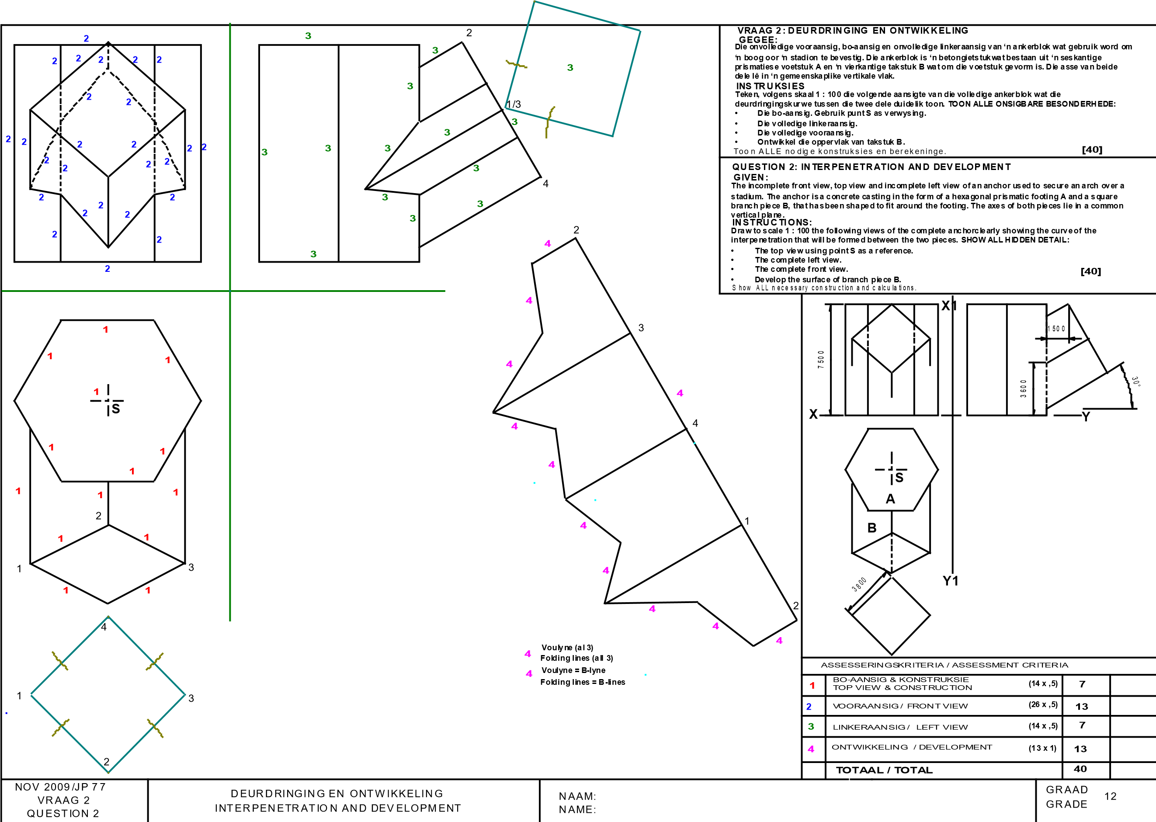

|  |  |  |  |  |  |  |  |  |  |
| --- | --- | --- | --- | --- | --- | --- | --- | --- | --- |
| **V1 V~~R~~ 2** | **3** |  | **O** |  | **VRAAG 2:**  **DEURDRINGING EN ONTWIKKELING GEGEE:**  D i e on v ol led ig e v o o raa ns ig en b oaa ns i g v an 'n reë lm a ti ge v ierk a nt ig e pri s m a w at ge v orm i s o m ron d o m 'n reg te reël m at ig e s e s k an ti ge p ris m a t e p as .  D i e as s e v an b eid e pri s m as l ê in 'n gem e en s k a pli k e v e rti k al e v la k .  D i e hu lpa an s ig v a n di e v ie rk an t ige p ris m a . D i e po s is ie v an p u n t O op d ie t ek e n v el .  **INSTRUKSIES**  T ek en v o lge ns s k a al 1 :1 die v olg en de a a n s igt e v a n die TW E E p ris m a s  2 .1 D i e ge gew e b oa a ns i g  2 .2 D i e lin k era an s ig  2 .3 D i e v ol led ig e v oo raa ns ig v an d ie d e u rdrin gi n gs k urw e du ide lik t e t oo n.  2 .4 O nt w i k k el d ie o pp erv l ak k e v an S L E G S d ie v a n di e v ie rk an t ige p ris m a. **[40]** T o o n A LL E v erbo rge b es o nd erh ede en v o ul yn e.  **QUESTION 2:**  **INTERPENETRATION AND DEVELOPMENT GIVEN:**  T he inc o m p let e f ro n t v i ew a nd t he to p v ie w of a reg ul ar s qu are p ris m t ha t h as be en s h ap ed t o f it arou nd a righ t re gu lar he x ag on al pri s m . Th e ax e s of b ot h pri s m s lie in a c o m m o n v ert ic a l pl an e.  T he au x i lia ry v iew of th e s qu a re p ris m .  T he po s it ion o f p o i nt O on t h e dra w in g s h eet .  **INSTRUCTIONS:**  2 . 1 D raw , t o s c al e 1: 1, t he f o l low in g v ie w s of th e T W O p ris m s .  2 . 1. 1 Th e gi v en t o p v ie w  2 . 1. 2 Th e le ft v ie w  2 . 1. 3 Th e c om ple t e fro nt v ie w , c lea rly s ho w i ng t he c u rv e o f in t erp ene t rat ion .  2 . 1. 4 D ev elo p t he s u rfa c e of t he s q ua re p ris m .  **[40]**  S how A LL n ec e s s ary c on s t ruc t ion and c a lc ula ti on s . | | | | |
| **P1 QE 2** | **3** |
|  | |
| 3  4  1  5  5  0  4  5  3  5  7  0  **X**  **Y**  4  2  **O** | | | | |
| ASSESSERINGSKRITERIA / ASSESSMENT CRITERIA | | | | |
| **1** | BOAANSIG  TOP VIEW **(10 x ,5)** | | **5** |  |
| **2** | LINKERAANSIG  LEFT VIEW **(14 x ,5)** | | **7** |  |
| **3** | VOORAANSIG **(24 x ,5)**  FRONT VIEW | | **12** |  |
|
| **4** | ONTWIKKELING / DEVELOPMENT **(16 x 1)** | | **16** |  |
|  | **TOTAAL / TOTAL** | | **40** |  |
| NOV 2012/JP 81  VRAAG 2  QUESTION 2 | | | DEURDRINGING EN ONTWIKKELING INTERPENETRATION AND DEVELOPMENT | NAAM / NAME:  DATUM / DATE: | | | **GRAAD**  12 **GRADE** | | |

|  |  |  |  |  |  |  |  |  |  |  |  |
| --- | --- | --- | --- | --- | --- | --- | --- | --- | --- | --- | --- |
| **V1 VR 2** | **3** | **4**  **4**  **4**  **4**  **4**  **4**  **4**  **4**  **4**  **4**  **4** | | **4**  **2**  **2** | **4**  **2** | **4**  **4**  **4** | **VRAAG 2:**  **DEURDRINGING EN ONTWIKKELING GEGEE:**  D i e on v ol led ig e v o o raa ns ig en b oaa ns i g v an 'n reë lm a ti ge v ierk a nt ig e pri s m a w at ge v orm i s o m ron d o m 'n reg te reël m at ig e s e s k an ti ge p ris m a t e p as .  D i e as s e v an b eid e pri s m as l ê in 'n gem e en s k a pli k e v e rti k al e v la k .  D i e hu lpa an s ig v a n di e v ie rk an t ige p ris m a . D i e po s is ie v an p u n t O op d ie t ek e n v el .  **INSTRUKSIES**  T ek en v o lge ns s k a al 1 :1 die v olg en de a a n s igt e v a n die TW E E p ris m a s  2 .1 D i e ge gew e b oa a ns i g  2 .2 D i e lin k era an s ig  2 .3 D i e v ol led ig e v oo raa ns ig v an d ie d e u rdrin gi n gs k urw e du ide lik t e t oo n.  2 .4 O nt w i k k el d ie o pp erv l ak k e v an S L E G S d ie v a n di e v ie rk an t ige p ris m a. **[40]** T o o n A LL E v erbo rge b es o nd erh ede en v o ul yn e. | | | | |
| **P1 QE 2** | **3** |
| **3**  **1** | |
| **QUESTION 2:**  **INTERPENETRATION AND DEVELOPMENT GIVEN:**  T he inc o m p let e f ro n t v i ew a nd t he to p v ie w of a reg ul ar s qu are p ris m t ha t h as be en s h ap ed t o f it arou nd a righ t re gu lar he x ag on al pri s m . Th e ax e s of b ot h pri s m s lie in a c o m m o n v ert ic a l pl an e.  T he au x i lia ry v iew of th e s qu a re p ris m .  T he po s it ion o f p o i nt O on t h e dra w in g s h eet .  **INSTRUCTIONS:**  2 . 1 D raw , t o s c al e 1: 1, t he f o l low in g v ie w s of th e T W O p ris m s .  2 . 1. 1 Th e gi v en t o p v ie w  2 . 1. 2 Th e le ft v ie w  2 . 1. 3 Th e c om ple t e fro nt v ie w , c lea rly s ho w i ng t he c u rv e o f in t erp ene t rat ion .  2 . 1. 4 D ev elo p t he s u rfa c e of t he s q ua re p ris m .  **[40]**  S how A LL n ec e s s ary c on s t ruc t ion and c a lc ula ti on s . | | | | |
| 3  4  1  5  5  0  4  5  3  5  7  0  **X**  **Y**  4  2  **O** | | | | |
| ASSESSERINGSKRITERIA / ASSESSMENT CRITERIA | | | | |
| **1** | BOAANSIG  TOP VIEW **(10 x ,5)** | | **5** |  |
| **2** | LINKERAANSIG  LEFT VIEW **(14 x ,5)** | | **7** |  |
| **3** | VOORAANSIG **(24 x ,5)**  FRONT VIEW | | **12** |  |
|
| **4** | ONTWIKKELING / DEVELOPMENT **(16 x 1)** | | **16** |  |
|  | **TOTAAL / TOTAL** | | **40** |  |
| NOV 2012/JP 81  VRAAG 2  QUESTION 2 | | | DEURDRINGING EN ONTWIKKELING INTERPENETRATION AND DEVELOPMENT | NAAM / NAME:  DATUM / DATE: | | | | | **GRAAD**  12 **GRADE** | | |