Province of the
EASTERN CAPE
EDUCATION

DIRECTORATE SENIOR CURRICULUM MANAGEMENT (SEN-FET)
HOME SCHOOLING SELF-STUDY ANSWER SHEET
SUBJECT | ECONOMICS | GRADE | 12 | DATE | 14/05/2020
TOPIC | MICROECONOMICS MARKS: 40 | TERM 1  REVISION |  | TERM 2 CONTENT | X

QUESTION 1 MICROECONOMICS 40 MARKS – 40 MINUTES
The existence and survival of any business depend on how they are conducting themselves.
- Compare the market structure of a monopoly with that of a perfect competitor. (26 marks)
- Draw a clearly labelled graph indicating the shut-down point for the perfect competitor. Briefly explain why a business will stop producing goods at this point. (10 marks)
(DBE/Feb-Mar 2016) [40]
INTRODUCTION
- A perfect competitor has many sellers while a monopolist only has one seller √√
(Accept any other correct relevant introduction.) Max (2)
MAIN PART
 | Perfect Competitor | Monopoly
Price: | - Price taker √√  - The market determines the price for the individual firm √√ | - Is regarded as a price maker √√  - Have some control over price √√  - Prices not determined by market forces of supply and demand but by the business itself √√
Output: | - The demand curve for the perfect competitor is horizontal √√ | - The demand curve for monopolist is downward sloping √√
Profit: | - The perfect competitor can realise economic profits in the short term √√  - Abnormal profits will attract new entrants into the market for both structures √√  - Both perfect and monopoly can only realise normal profits in the long term √√  - The price for the product for both market structures equals the average cost √√  - The perfect competitor does produce the ideal production quantity and has no surplus capacity √√ | - The monopolist also realise economic profits in the short term √√  - The monopolist will charge a higher price than the perfect competitor √√  - The monopolist will not produce at the lowest point of the LAC, like the perfect competitor, the output will be less than the perfect competitor √√  - Both perfect and monopoly can only realise normal profits in the long term √√  - The monopolist's production will be less than the ideal production quantity where LAC is the minimum and has surplus capacity √√
Number of businesses | - So many that no single business can influence the market price √√ | - One business √√
Nature of product | - Homogeneous e.g. maize √√ | - Unique product without any close substitutes √√
Information | - Complete √√ | - Complete √√
Entry | - Completely free √√ | - Blocked √√
(Accept any other relevant fact) |  | (Max. 26)
(Accept essay format)

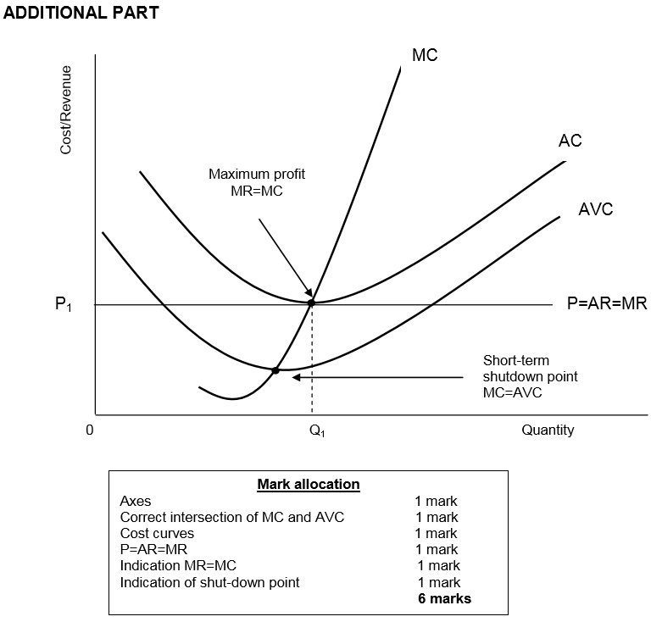
Briefly explain why a business will stop producing goods at this point.
- A firm will shut down if it cannot meet its average or total variable costs √√
- The firm will not produce here because AR < AVC √√
- The firm will not keep on producing from the shut-down point down because the firm cannot meet its operational cost √√
- Below the shut-down point, the firm will not sell any goods. A firm will sell goods if the price is above the shutdown price level (supply curve) √√
(Accept any correct relevant response.) (Max 10)

CONCLUSION
- Although it is not completely possible to compare the monopoly market with the free market, a comparison can give us insightful information about the profit maximising quantity and price √√
(Accept any other relevant conclusion.) Max (2) [40]

