Province of the
EASTERN CAPE
EDUCATION

DIRECTORATE SENIOR CURRICULUM MANAGEMENT (SEN-FET)
HOME SCHOOLING SELF-STUDY ANSWER SHEET
SUBJECT | ECONOMICS | GRADE | 12 | DATE | 20/04/2020
TOPIC | MICROECONOMICS MARKS: 80 | TERM 2  REVISION |  | TERM 2 CONTENT | X

QUESTION 1: 40 MARKS
Markets are broadly categorised into perfect and imperfect markets. However, in reality very few examples of perfect markets exist.
- Examine the conditions for the existence of a perfect market in detail. (26)
- Illustrate by means of graphs the position of the industry and firm in the long term if a loss was incurred in the short term. (10 ) | [40]
INTRODUCTION
- It is a market structure with a large number of participants who are price-takers.  - The price is determined by the market demand and supply, This market is most efficient in the allocation of resources (Max 2) | (2)
BODY
MAIN PART
Characteristics:
a) Products must be homogenous (i.e. identical)
- Products must be identical. There should be no differences in style, design and quality.
- In this way products compete solely on the basis of price and can be purchased anywhere.
b) There should be a large number of buyers and seller
- It should not be possible for one buyer or seller to influence the price.
- When there are many sellers the share of each seller to the market is so small that the seller cannot influence the price
- Sellers are price-takers, they accept the prevailing market price.
c) No preferential treatment/discrimination
- Buyers and sellers base their actions solely on price, homogenous product fetch the same price and therefore no preference is shown for buying from or selling to any particular person.
d) Free competition/Unregulated market
- Buyers must be free to buy whatever they want from any firm and in any quantity.
- Sellers must be free to sell what, how much and where they wish
- There should be no state interference and no price control.
e) Efficient transport and communication
- Efficient transport ensures that products are made available everywhere.
- In this way changes in demand and supply in one part of the market will influence the price in the entire market
- Efficient communication keeps buyers and sellers informed about market conditions.
f) All participants must have perfect knowledge of market conditions
- All buyers and sellers must be fully aware of what is happening in any part of the market.
- Technology has increased competition as information is easily obtained via the Internet
g) Freedom of entry/exit
- There is complete freedom of entry and exit, that is to say the market is fully accessible.
- Buyers and sellers are completely free to enter or to leave the market
h) Mobility of factors of production
- All factors of production are completely mobile, in other words labour, capital and all other factors of production can move freely from one market to another.
i) No collusion
- In a perfectly competitive market, each buyer and seller acts independently from one another
NOTE: A maximum of 8 x 1 marks will be allocated for headings Max (26) | (26)
ADDITIONAL PART
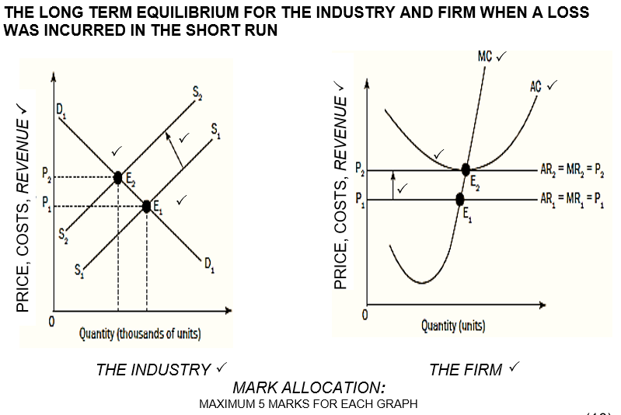
(Max 10) | (10)
CONCLUSION
- The characteristics above indicate that the market has to meet strict requirements before it can be described as perfectly competitive  - Although there are very few examples, the conditions of a perfect market does serve a frame of reference when studying other markets.  (Accept any other correct relevant conclusion.) (Max 2) | (2)
 | [40]
QUESTION 2: 40 MARKS
Sometimes free market fail to produce the quantities of goods and services that people want at the prices that reflect marginal utilities and relative scarcities.
- Discuss the causes of market failure by referring to externalities and missing markets. (26)
- How does the government discourage or encourage externalities? (10 ) | [40]
INTRODUCTION
A market failure is when the optimal production quantity is not produced and inefficiency occur (Max 2) | (2)
BODY
MAIN PART
Externalities
- Externalities are costs not included in the pricing of goods/services, and consequently there is a difference between the private costs/benefits and the social costs/benefits of production.
- Private costs are the cost of producing the good or service which translate into the prices that consumers pay. Also called internal costs
- Private benefits are internal benefits that accrue to those who produce goods and buy these goods, e.g. producing a bicycle (for producer) and using the bicycle (consumer).
- Social costs are total costs incurred by society as a whole
- Social cost = private costs plus external costs.
- Social benefits include the total benefit experienced by society as a whole.
- Social benefits = private benefits plus external benefits.
Negative externalities:
- Are things like pollution, tobacco smoking and alcohol abuse
- The costs of negative externalities are paid by society rather than by the producers
Missing markets
- Markets are incomplete because they cannot meet the demand for certain goods.
Public goods
This includes community and collective goods and has two features:
- Non-rivalry: Consumption by one person does not reduce consumption by another individual, e.g. a lighthouse.
- Non-excludability: Consumption can’t be confined to those who pay for it (free riders can use them), e.g. radio and television
- Social benefits outstrip private benefits : e.g. health care and education.
- Non-rejectability: Individuals are not able to abstain from consumption, e.g. street lighting.
- Continuous consumption. E.g. traffic lights
Community goods
- These are goods such as, defence, police services, prison services, street-lighting, flood control, storm water drainage and lighthouses.
Collective goods
- These are goods such as parks, beach facilities, streets
Merit goods
- These are highly desirable for general welfare, but not highly rated by the market, e.g. health care, education and safety.
- If people had to pay the market price for them, very little would be consumed. The market fails because the market produces less than the desired quantity.
Demerit goods
- These are over-consumed goods, e.g. cigarettes, alcohol and drugs.
NOTE: A maximum of 8 x 1 marks will be allocated for headings Max (26) | (26)
ADDITIONAL PART
The government has used three methods to reduce negative externalities:
- The government has carried out campaigns in order to change/persuade people from causing negative externalities.
- Levying taxes on goods that cause negative externalities. E.g. Taxes are levied on cigarettes and alcohol.
- Passing laws and regulations to prevent activities that cause negative externalities. E.g. Tobacco companies are not allowed to advertise. There are laws that regulate the amount of air pollution and waste. (5)
The government encourages positive externalities by:
- Advertising on the radio or television.
- Providing education, health care and other services at a low cost or free.
- Providing consumer subsidies.
- Consumer subsidies lower the cost of a good and encourage its usage. (5)
Accept any relevant measure taken by the government (10)
(Max 10) | (10)
CONCLUSION
- When market failures occur, it causes inefficiency and misallocation of resources and the government will have to intervene to recover the instability.  (Accept any other correct relevant conclusion.) (Max 2) | (2)
TOTAL [80] | [40]

