Area and Perimeter of Basic Shapes

Part 1: 2D Shapes

Key Concepts
In this worksheet we will focus on summarising what you need to know about:

• Area : the 2D space taken up by a shape
- Units used: Square units eg $m^{2},{cm}^{2},m^{2},etc.$

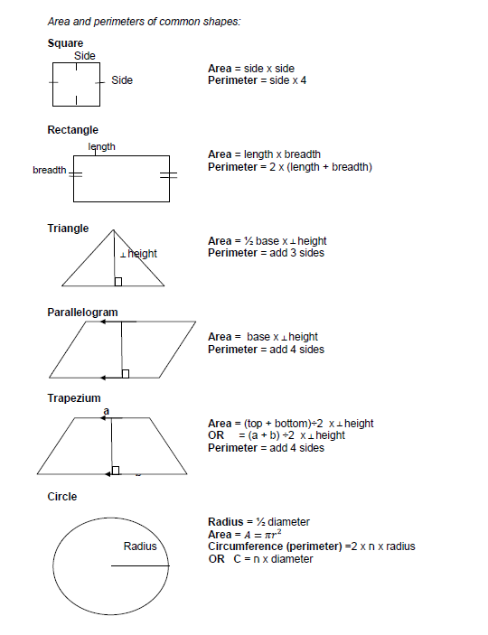
Basic Shapes

Activity (Area of Basic Shapes)

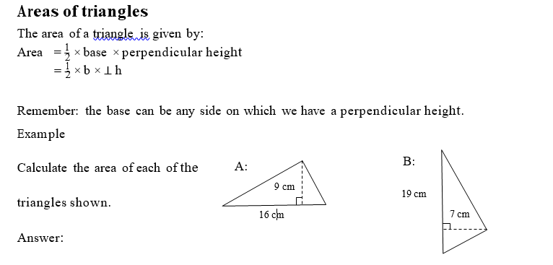
A = ½ b X perpendicular H
= ½ (16)(9)
= 72cm²
For B note that the Perpendicular height is that height that runs at 90 degrees
to the side you use as the base. In this case we use 19cm as the base so…
B= ½ b X perpendicular Height
= ½ (19)(7)
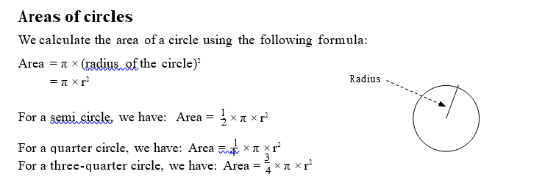
= 66,5cm²

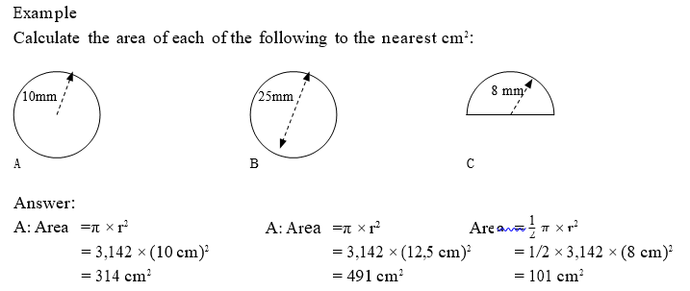

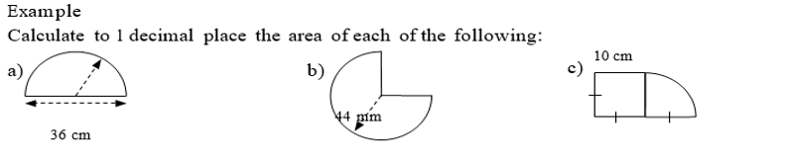
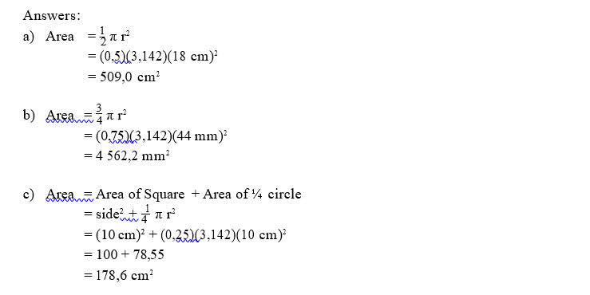
Now it’s your turn: (Basic Shapes)
1. The following sketch illustrates the design for the sandpits on a playschool playground.
The playground is has a large rectangular shape with 3 sandpits in it. The sandpits are
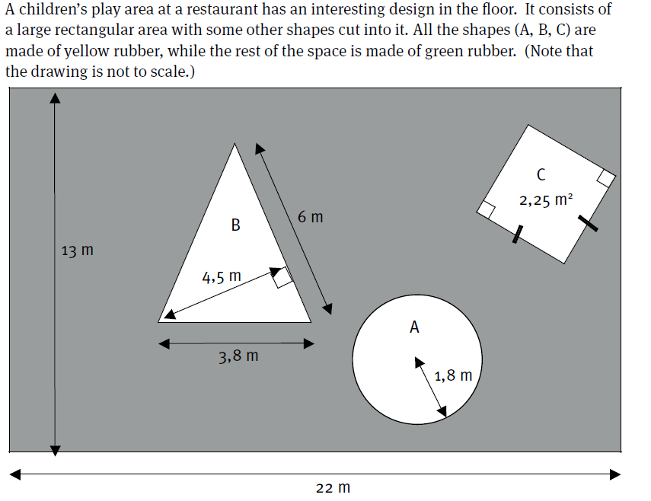
surrounded by grass. (drawing not drawn to scale).

a) Calculate the area of shape A (to one decimal place)
b) Calculate the area of the triangle.
c) Calculate the side length of the square.
d) Calculate the area covered by grass. (to 2 decimal places)
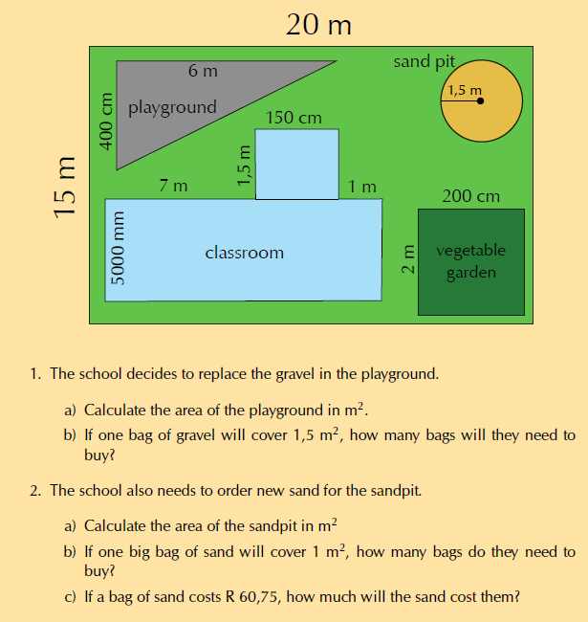
2. A second design is proposed given below:

2.1. The school decides to replace the gravel in the playground.
a) Calculate the area of the playground in m2.
b) If one bag of gravel will cover 1,5 m2, how many bags will they need to buy?

2.2 The school also needs to order new sand for the sandpit.
a) Calculate the area of the sandpit in m2
b) If one big bag of sand will cover 1 m2, how many bags do they need to buy?
c) If a bag of sand costs R 60,75, how much will the sand cost them?

2.3. The school’s gardener decides that they also need buy compost for the vegetable garden.

a) Calculate the area of the vegetable garden in m2.
b) If half a bag of compost will cover 1 m2 of garden, how many bags do they need to buy?

2.4. The gardener decides to plant rows of lettuce seedlings in his newly composted garden.

a) If each row is 2 m long and 50 cm wide, and they are planted right next to each other, how
many rows can he plant in the vegetable garden?

b) If one row of lettuce seeds costs R 12,95, how much will the seeds cost in total?
c) If the gardener leaves 1 m2 of space in which to plant carrots, what percentage
of the total area of the vegetable garden will be taken up by carrots?

2.5. Lastly, the school decides they want to tile the floor of the classroom.
a) Calculate the total floor area of the classroom.
b) The tiles cost R 73,49 per square metre. How much will the tiling cost in total?

2.6. The school is renting the property for R 10 000 a month.
a) Calculate how much they are paying each month, per metre² of property.
b) How much is the school’s rent for 1 year?

Determining the Area of Composite Shapes
A composite shape is a shape made up of other basic shapes. Thus the idea here is to break the “big” shape up into smaller parts.
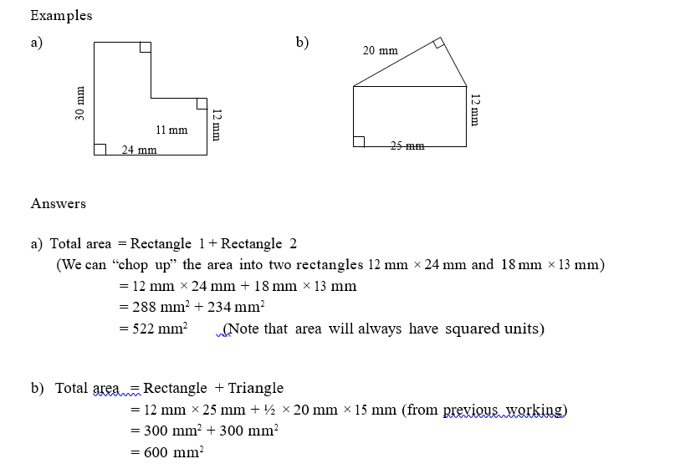

Working with shaded areas
When asked to calculate the shaded area within a shape it is often best to ask yourself
1. Which basic shapes am I dealing with?
2. Where is the shaded area located, can I not take the small shape out of the bigger shape?
ie. Big – Small
eg. 1. The wooden frame below is 25cm long and 15cmwide, but the glass section on the inside
is 23cm long and 13cm wide. Calculate the area of the wooden section of the frame.
25cm

15cm

Thus: Big Shape = wooden frame (rectangle)
Small shape= glass inner (rectangle)
Big area – small Area = Wood – Glass
= (25cm X15cm) – (23cm X 13cm)
= 76cm²

2. The sketch below gives the outline of a circular track for kids. Calculate the painted (Shaded)surface
of the track. The diameter of the track is 12m and the track is 2m wide. Calculate the amount of paint
needed to paint the track is the spread rate is 50ml per square meter.
2m
12m

Here there are two sections to the question:
Find the painted area
Find the amount of paint needed
1. Painted area= Big – Small (Radius= 12/2 =6m for big circle)
= $πr^{2}$ (Big) - $πr^{2}$(Small)
(Small circle is 2m inside big circle, thus diameter is 8m and radius is 4m)
= 3,142 $(6^{2})-3,142(4^{2})$
= 62,84 m²

Your turn: Composite shapes in Real Life Contexts
1. Your Maths Literacy classroom gets new tables, shaped as shown below.

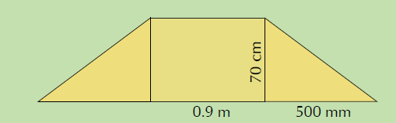
a) Using the appropriate formulae, calculate the area of each table, in m2.
b) If each table cost R 615,00 and ten tables were bought, calculate how much the tables cost per m2.
(Hint: calculate the total cost of the tables and their total area first).
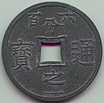
2. For your birthday, a friend gives you a rare, lucky coin that has a square cut out of the middle as shown in
the photo and diagram below:

a) You measure the diameter of the circle to be 3 cm, and the length of one side of the square
to be 0,9 cm. Calculate the area of the coin in cm2. Round your answer to one decimal place.
b) If the coin is worth R 3,58 per cm2, calculate its value.

3. The sketch below shows the decking around a circular pool.
18 m
12 m
12 m

3.1 Calculate the perimeter of the decking (3)
3.2 Provide the area taken up by the decking given the pool fits snuggly into the decking.

4. Mr Dlamini still has not decided on a shape for his new fish pond.

a) One option is for Mr Dlamini to install a circular fish pond with a radius of 1,5 m, as shown
in the diagram:

R= 1,5m

Calculate the area of this pond in metres squared, using the formula:
Area =$π {radius}^{2}$, where $π$ = 3,142.

b) The alternative design for the fish pond, as we have already seen looks as follows:

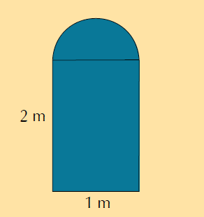

Using the dimensions given on the diagram above, calculate the area of the other possible fish pond
using the formulae: Area = $π$ radius² and Area = length X width, where$π$ = 3,142.

c) How does your answer to b) compare to the area of the circular fish pond that we calculated in a)?
Which shape of fish pond should Mr Dlamini choose if he is worried about the pond taking up too much
space in his garden? Give reasons for your answer.

5. Mr Dlamini is concerned that his dog will try to climb into the fish pond once it’s built. He will need to put a
fence around the fish pond. He has still not decided which style of fish pond he wants to build. He decides to
get quotes from a fencing company called “Fence-Me-In”. They give him the following information:

* Labour costs: R 549,99 for the whole project
* 1 metre of fencing costs R 29,99.

Calculate the total cost for each style of pond.

6. Based on your answers to Questions 2 c) and d), which style of fish pond do you think Mr Dlamini should choose? Give reasons for your answer.

Test Your Knowledge
1.Carl needs to measure the width of a window, to find out how much material he must buy to
make a curtain. The curtain material costs R55 per metre on sale, sold only in full metres
a) Carl estimates the width of the window to be 1,9 metres wide.
If Carl goes to the shop with this estimate:
    - How many metres of material should he buy?
    - How much would the material cost?
b) Carl decides to double-check his estimated measurement before he buys the material and so he
uses his tape measure to accurately measure the width of the window. He determines that the window
is actually 2,2 m wide.
i) How many metres of material does he need to buy?
ii) How much will the material cost?

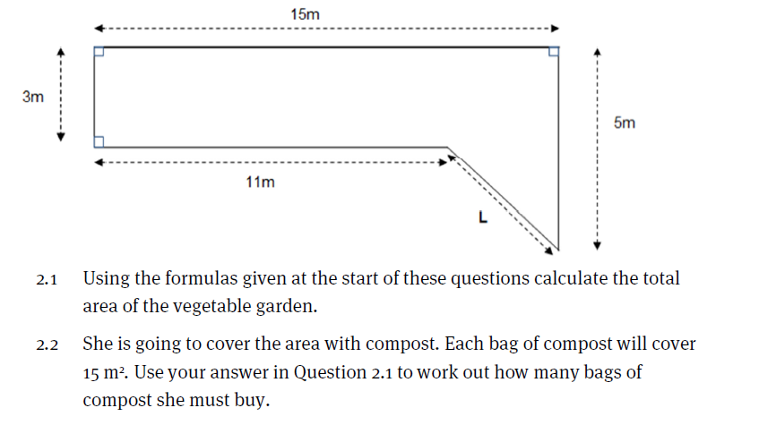
3.Liz sews dresses for children. The material costs R89,50 per metre and she needs 2 metres of
material to make a dress for a 4-year-old; 2,5 metres to make a dress for a 7-year-old and
3 metres to make a dress for 10-year-old. The embroidery cotton costs R12,55 for a roll
of 3 metres. She uses 2 rolls of cotton per dress.

- How many metres of material will she need to make the following four dresses:
She makes 1 dress for a 7-year-old, 2 dresses for four-year olds, and 1 dress for a
10-year-old?
- What will the material cost for the four dresses?
- What is the length of embroidery cotton that Liz is going to use when sewing one dress, in metres and centimetres?
- What is the total amount that she will pay for the embroidery cotton?
- What is the total cost of a dress for a 10-year-old?

4. A 2 m path is built around a circular lawn with a diameter of 20 m.
2 m
20m

4.1 Calculate the area of the path. (4)
4.2 The paving is roughly 40 paving bricks per m2 and the contractor needs 5% more bricks
than needed. Calculate the amount of bricks the contractor needs to order. (4)
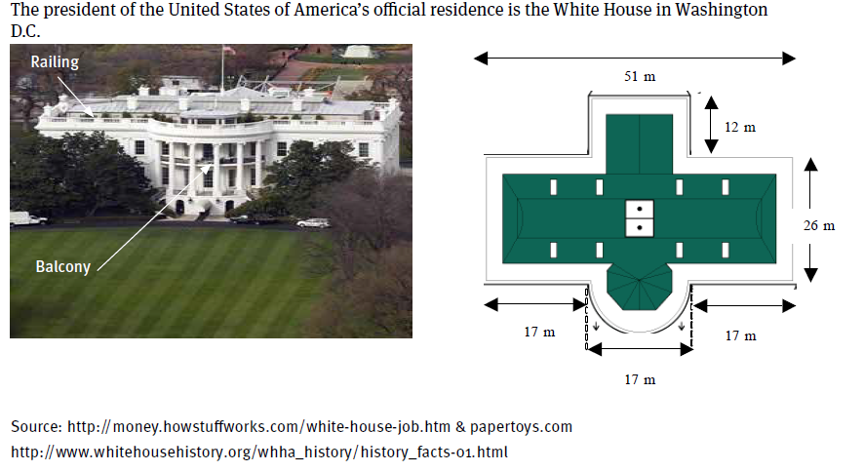
5.

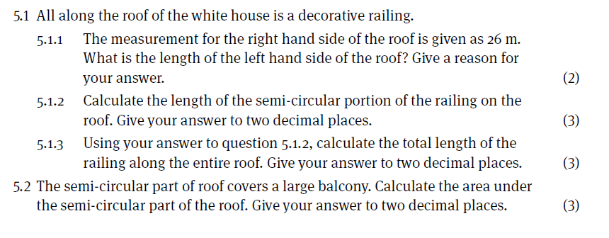
Answers: Basic Shapes
Question | Working | Marks
1.1 | Area = π × r2  = (3,142) × (1,8 m)2  = 10,2 m2 | 3
1.2 | Area = 1 b × h  = 0,5 × 6 m × 4,5 m  (we use the two measurements that are at right angles to each other)  = 13,5 m2 | 3
1.3 | Area = side2  = 1,5 X 1,5 = 2,25 m2  1,5 m = side  (we find the square root) | 2
1.4 | Total area  = l × b  = 13 m × 22 m = 286 m2  Green area = total area – area of shapes  = 286 m2 – (10,2 m2 + 13,5 m2 + 2,25 m2)  = 286 m2 – (25,95 m2)  = 260,1 m2 | 5
2.1 | a) ½ base X height = ½ (6 )( 4 m) = 12 m2  b) 12 m2 X1,5m2 = 8 bags
2.2 | a) Area = πr2 = 3,142(1,5 m)2 = 7,07 m2  b) 7,07 X1,5 = 4,713 bags. So they will have to buy 5 bags.  c) 5 X R 60,75 = R 303,75
2.3 | a) Area = 2 m X 200 cm = 2m2  b) 1 bag.
2.4 | a) 2 m X 50 cm = 2 m X 0,5 m = 8. He can plant 8 rows of seedlings.  b) 8 X R 12,95 = R 103,60  c) Total area = 16 m2. 1 m2 16 m2 = 0,0625. 0,0625 X 100 = 6,25%
2.5 | a) Area = Area rectangle + area square  = (5 m X (7 + 1,5 + 1,5 m)) +(1,5 X1,5 m) = 50 m2 + 2,25 m2  = 52,25 m2  b) 52,25 m2X R 73,49 = R 3839,85
2.6 | a) Area of entire property = 15 m X 20 m = 300 m2.  R 10 000 X 300 m2 = R 33,33 per m2  b) R 10 000 X12 months = R 120 000

Answers: Composite Shapes
1. We can see that the table is made up of two identical triangles, and one rectangle.
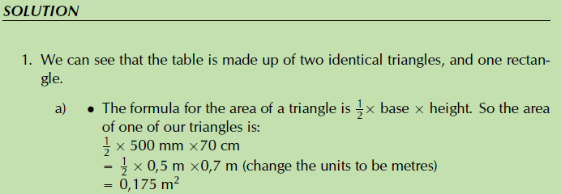
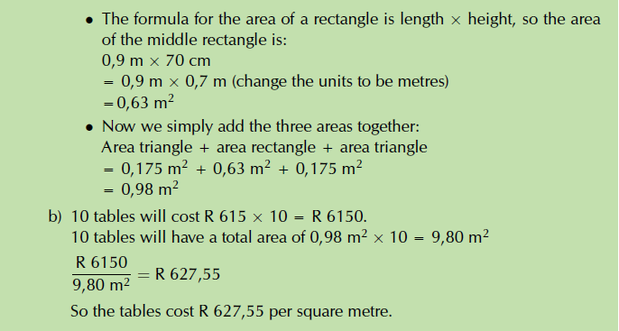
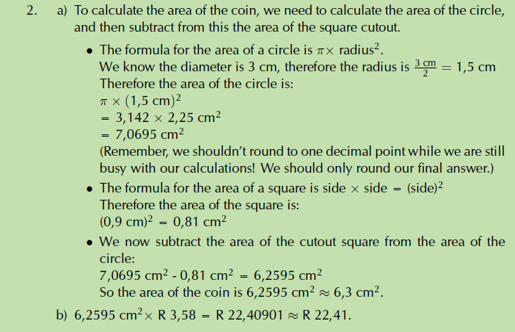
3. a) Perimeter = 12 + 12 + 6 +6+6+18 = 60m
b) Area= (rectangle + square – circle)
= (12 X 12) + (6 X 6) – (3,142 X (6)² )
= 66,96m²
4. a) Area = 3,142 X(1,5 m)2 = 7,07 m2

b) Area = area rectangle + area semicircle = (2 m X1 m) + ½ (π(1 m)²)
= 2 m + 1,57 = 3,57 m²

c) The second design is much smaller than the first. If he is concerned that the pond will be too large,
he should decide on the second shape.

5. Pond shape 1 (circle): cost= Labour + fencing price X perimeter
= R 549,99+ (R 29,99)(2_X 1,5 m)
= R 549,99+R(29,99)(9,426 m)
= R 549,99+ R 282,69
= R 832,68.

Pond shape 2: Cost = Labour + fencing price X perimeter
= R 549,99 + (R 29,99) (2 m + 1 m + 2 m + ½ (π X 1 m)
= R 549,99 + (R 29,99) (5 m + 3,142 m) = R 549,99 + R 244,18
= R 794,17

6. Learner-dependent answer, but based on his concern about the size of the pond
he should choose the second design - it’s cheaper to fence too.

Test your knowledge

Question | Working | Marks
1.a).i.  ii. | 1.9 x 3 = 5.7m thus 6m should be bought  6 x R55 = R330 | 4
b).i  ii | 2.2 x 3 = 6.6m thus 7m should be bought  7 x R55 = R385 | 4
2.1 | The area can be split up into a long rectangle and a triangle:  Area of rectangle = 15 m × 3 m = 45 m²  Area of triangle = ½ × 2 m × 4 m (worked out by subtracting lengths)  = 4 m²  Total area = 45 m²+ 4 m²= 49 m² | 6
2.2 | Bags of compost = 49 m²÷ 15 m2/bag  = 3,27 bags » 4 bags  (although by spreading it a bit thinly,you could get by with 3 bags) | 4
3 a) | 2,5m + 2X2 + 3m = 9,5m of material | 2
b) | R89,50 X 9,5m = R850,25 | 2
c) | 2 rolls per dress X 4 dresses = 4x 2 X3m = 24m  2400cm of thread | 3
d) | R 12,55 X 8 = R 100,40 | 2
e) | 3 X R89,50 + 2 X R12,55  = R293,60 | 3

4 | Diameter = 20 m thus radius = ½ diameter. So,  R1 = 10m and R2 = 12m  Big circle – small circle  = 3.142 (${12}^{2}- {10}^{2})$  = 138,25 m²  But 1 m² : 40 pavers  Thus 138,25 X 40 = 5530  However, contractor needs 5% extra  Thus 5530 X 105% = 5806,5 pavers, thus 5807 needed | 7

Question | Working | Marks
5.1.1 | Also 26 m. The building is symmetrical and so the length on the left is the same as the length on the right. | 2
5.1.2 | Edge of semi-circle  1  = 2 × π × Diameter  = 0,5 × 3,142 × 17  = 26,71m | 3
5.1.3 | Total length = 2 front + 2 sides  + curved + 3 back horizontal + 2 back vertical  = 2 × 17 m + 2 × 26 m + 26,71 m + 3 × 17 m + 2 × 12 m  = 187,71 m | 3  555
5.2 | Area of semi-circle  = ½ π × r2  = 0,5 × 3,142 × (8,5)2  = 113,50 m2 | 3

