PHYSICAL SCIENCES
ECDE MATERIAL
2020 MEMO

QUESTION 1
  - D
  - C
  - C
  - D
  - A
QUESTIO 2
    - No molecules have zero kinetic energy
    - Molecules with sufficient kinetic energy
    - Catalyst

Z
R
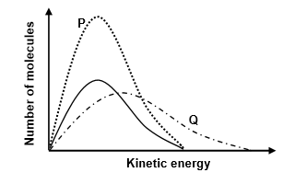R
2.1.8.
- An increase in temperature increases the average kinetic energy of particles
- More molecules have sufficient kinetic energy
- More effective collisions per unit time.
2.2.1. Rate Change in concentration of products / reactants per unit time.
2.2.2. The rate of reaction is decreasing
(mass of magnesium decreases and the concentration of HCl decreases)
2.2.3. 5 (min)
2.2.4. positive catalyst is a substance that increases the rate of a chemical reaction without itself undergoing a permanent change
2.2.5. 0.1g ( remains the same)
2.2.6. n(H₂O₂) $c=\frac{n}{v}$
$0.2=\frac{n}{0.2}$
n = 0.04 mol
n(O₂) = 0.04 mol/2
= 0.02 mol
c(O₂) $c=\frac{n}{v}$
$c=\frac{0.2}{0.116}$
c =
2.2.7. • A catalyst provides an alternative pathway of lower activation energy.
• More molecules have sufficient kinetic energy.
• More effective collisions per unit time.
2.2.8.
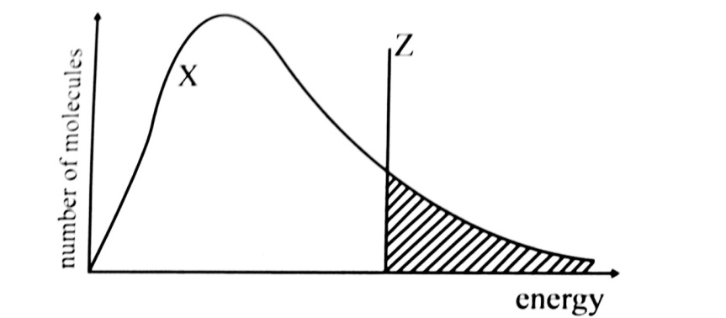

QUESTION 3
3.1. Hydrogen (H₂)
3.2.

3.3. 2.3 minutes
3.4.1. 1 minute = 18 cm3, 2 minutes = 28, 3 minutes = 33
3.4.2. The rate of gas production deceases means the rate of reaction is decreasing. This is because mass of metal decreases and the concentration of HCl decreases
3.4.3.
- Less HCl particles per unit volume.
- less particles with correct orientation.
- less effective collisions per unit time.

3.5 and 3.7
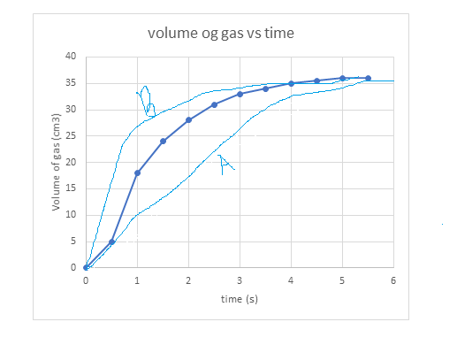
3.6. The chunk has a smaller surface area than the pellets
The curve of A will be gentle than the original curve to show the lower rate of reaction in A

QUESRTION 4
4.1. MgCl₂ Zinc chloride
4.2. $rr=\frac{∆c}{∆t}$
$rr=-\frac{57-25}{2-0.5}$
rr =
4.3. 0-1/2
4.4. as the reaction progresses mass of Magnesium decreases and the concentration of HCl decreases
4.5. increase the Temperature
Increase Surface area of Magnesium
Increase the Concentration of hydrochloric acid
Add a suitable Catalyst

Question 5

5.1 Temperature
Surface area
Concentration
Catalyst

5.2 a) BA
b) CB
d) CA

5.3 a) Decreases
b) Remains the same.

Question 6

6.1 Exothermic , temperature increases after reaction

6.2 State of division/surface area

6.3. No , both concentration and state of division were changed

6.4 Faster.
A catalyst was added. A catalyst Lowers the activation energy of the reaction. There will be more particles available with enough energy to cause effective collisions. Therefore there will be more effective collisions per given time.

6.6 n(Zn) = $m/M$
= 1.2/65
= 0.018mol
N(HCl) = 2 x 0.018
= 0.036

Rate=∆mol of HCl/∆t
= -(0-0.036)/8
=4.50X 10⁻³mol.s⁻¹

