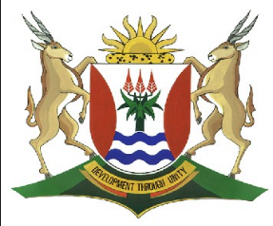
Province of the
EASTERN CAPE
EDUCATION

DIRECTORATE SENIOR CURRICULUM MANAGEMENT (SEN-FET)
HOME SCHOOLING SELF-STUDY WORKSHEET
SUBJECT | GEOGRAPHY | GRADE | 12 | DATE | 2805/20
TOPIC | URBAN GEOGRAPHY:  URBAN SETTLEMENT ISSUES | TERM 1  REVISION | ✓ | TERM 2 CONTENT | ✓
TIME ALLOCATION | 1 HOUR | TIPS TO KEEP HEALTHY  1. WASH YOUR HANDS thoroughly with soap and water for at least 20 seconds. Alternatively, use hand sanitizer with an alcohol content of at least 60%.  2. PRACTICE SOCIAL DISTANCING – keep a distance of 1m away from other people.  3. PRACTISE GOOD RESPIRATORY HYGIENE: cough or sneeze into your elbow or tissue and dispose of the tissue immediately after use.  4. TRY NOT TO TOUCH YOUR FACE. The virus can be transferred from your hands to your nose, mouth and eyes. It can then enter your body and make you sick.  5. STAY AT HOME.
INSTRUCTIONS

URBAN SETTLEMENT ISSUES RELATED TO URBANISATION

In this section we focus on Congestion, Urban decay and Centralisation.
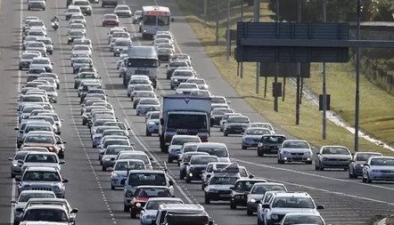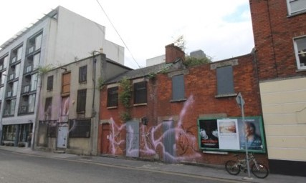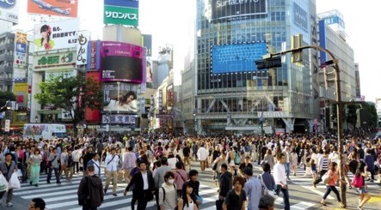

 | CONGESTION (Too many cars on the road) | URBAN DECAY  (Parts of the city are not looked after) | CENTRALISATION  (Too many people and  activities moving into the city)
CAUSES | - Too many people using own cars  - Not enough public transport  - Old street pattern | - Too many people living in the city  - Empty buildings | - High demand for land in the city  - Too many people living in the city
EFFECTS | - Air pollution  - More accidents  - Stress, health problems road rage | - Slums develop  - Services decline  - Increased pollution  - Area becomes dirty | - Increased pollution  - Health problems  - Destruction of environment  - Production of too much waste
SOLUTIONS | - Improve public transport  - Lift schemes  - Decentralise businesses  - Synchronise traffic lights | - Renovate buildings  - Renew areas  - Reduce housing density  - Improve services | - Decentralise functions  - Create green belts  - Stricter control of pollution

ACTIVITY: Traffic congestion.
The questions are based on the infographic below.

Infographics are regularly used as a source on which examination questions are based. Study the infographic carefully BEFORE answering the question. Look for links between the different types of information, in this case a map, extract from an article and a graph. In doing so you will get an idea of what the infographic as a whole, is telling you.

Traffic congestion in major South African cities
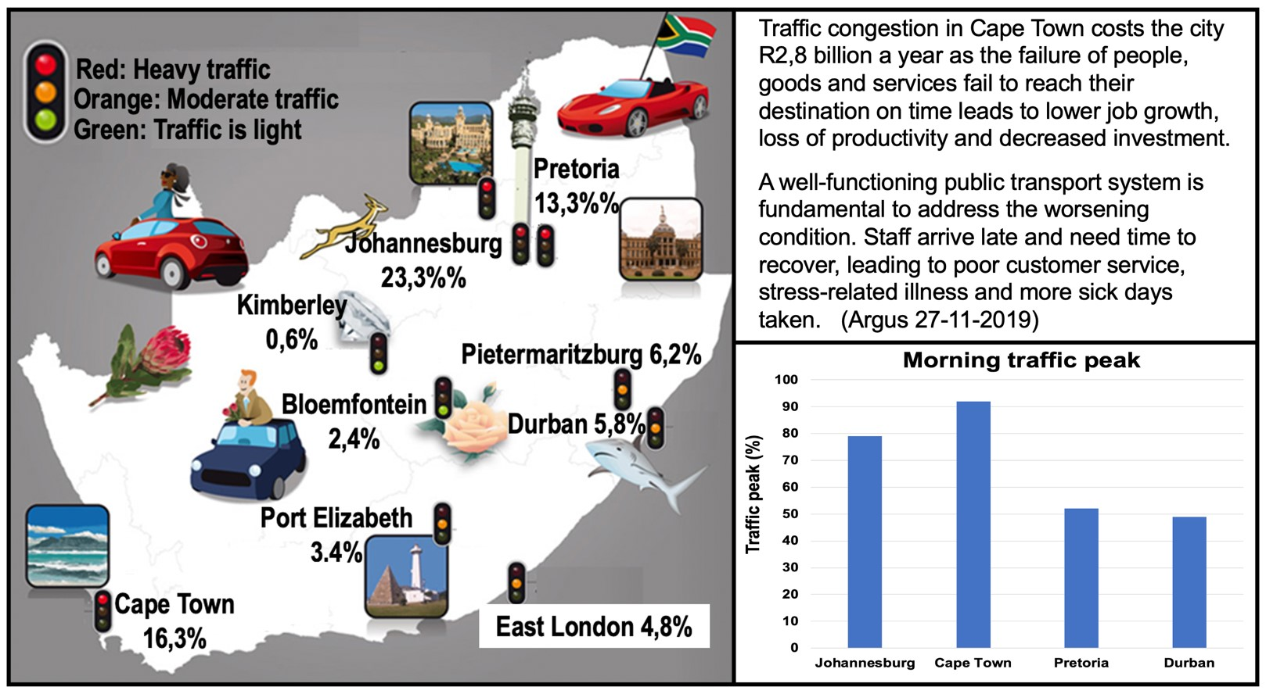
Infographic: Glenn Samaai

1 | Name TWO South African cities with:
 | (a) heavy traffic | (2x1) (2)
 | (b) moderate traffic | (2x1) (2)
 | (c) light traffic | (2x1) (2)
- Pretoria and Cape Town
- Port Elizabeth and East London
- Kimberley
- Bloemfontein
2 | Which South African city has the heaviest morning traffic peak?  - Cape Town | (1x1) (1)
3 | Arrange the cities in the graph from the highest to the lowest  according to their morning traffic peak.
- Cape Town,
- Johannesburg,
- Pretoria
- Durban. (4x1) (4)
4 . | How much does traffic congestion cost the city of Cape Town
 | a year? | (1x1) (1)
 | - 2.8 Billion per year
5. | What, according to the article, could be done to address worsening traffic congestion in Cape Town? | (1x2)(2)
 | - A well-functioning Public transport system
6. | Discuss THREE possible effects that traffic congestion could have on the city and the people of Cape Town. | (3x2) (6)
- Air pollution
- More accidents
- Stress, health problems and road rage
7. | Write a paragraph of approximately EIGHT lines to the editor of the Argus, in which you give possible solutions in response to the  challenges stated in the article. | (4x2) (8)
- Improve public transport
- Lift schemes
- Decentralise businesses
- Synchronise traffic lights
 |  | [28]

INFORMAL SETTLEMENTS

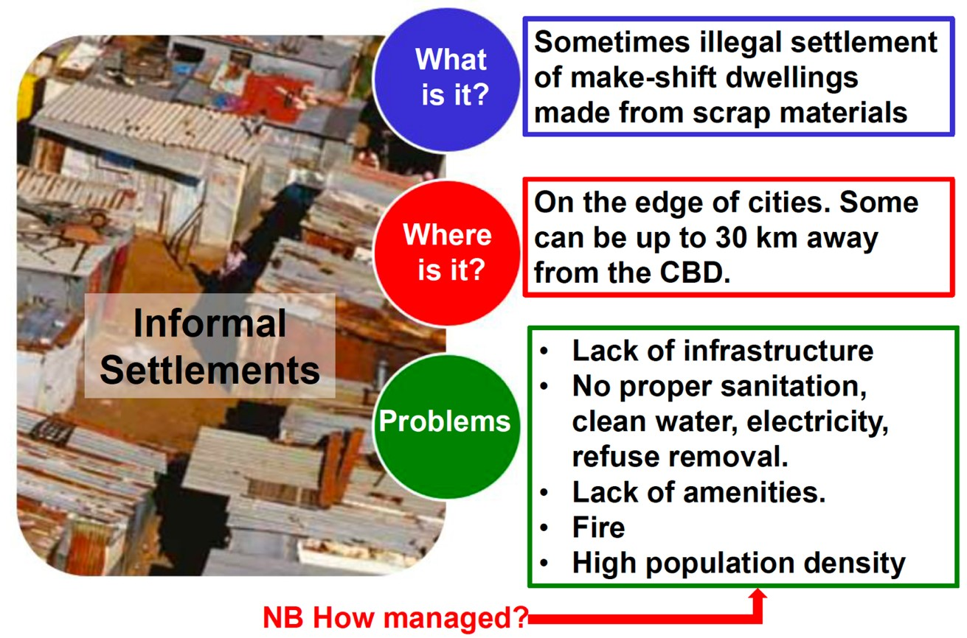

ACTIVITY: The following question comes from the 2019 Geography Question paper.

Do not treat a question based on an article or case study as a comprehension test. Although some of the answers can be found in the text, it is mostly used to set the scene on which the questions are based.

Study the article based on an informal settlement and associated issues.
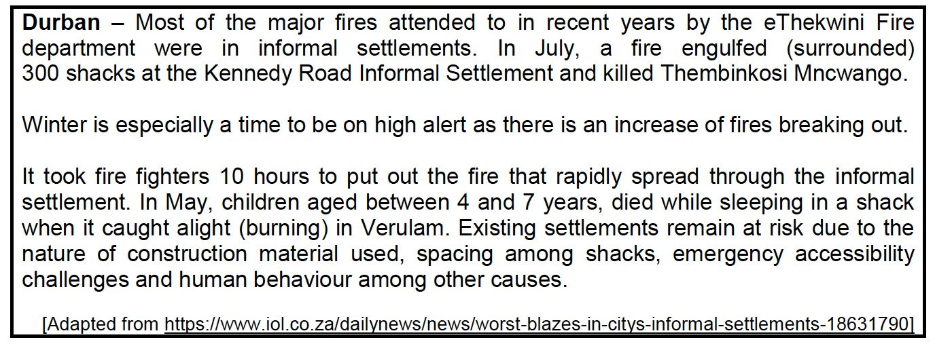

- Define the term informal settlement. (1x1) (1)

- When people occupy land illegally/When people live in self-constructed structures, that is made up of any available material (1) [CONCEPT]

- According to the newspaper article, why is there an increased
risk of fires in informal settlements?
(2x1) (1)
- Nature of construction material used (1)
- Spacing among structures (1)
- Emergency accessibility challenges (1)
- Human behavior (1)
[ANY TWO]

- Why does the occurrence of destructive fires increase in informal?
settlements in winter.

- People light fires, use paraffin heaters etc. (to keep warm) which are highly flammable (2)
- Increased use of paraffin/gas stoves (2)
- Increased use of coal or wood to make open fires (2)
- Illegal electricity connections (2)
- Negligence when using open fires (2)
- Material used to make fires stored around shacks (2)
- Increased use of candles to generate light (2)
[ANY TWO] (2x2) (4)

- In a paragraph of approximately EIGHT lines, explain how the local municipality can reduce fire hazards for people living in informal
settlements. (4x2) (8)

- Provide safer electricity /solar panels to these settlements (2)
- Provide proper infrastructure so that emergency personnel can promptly attend to fires (accept examples) (2)
- Provide regular policing services to monitor illegal connections (2)
- Establish community forums to assist in case of fires (2)
- Increased access to potable (clean) water (2)
- Create safe after-care places to ensure safety and supervision of children (2)
- Access to community halls in case of emergency (2)
- Demarcate specific plots for people to settle so that there is space between houses (2)
- Build formal brick houses (2)
- Increased awareness programs (2)
- Install fire hydrants (2) [ANY FOUR] (4 x 2) (8)

