Province of the
EASTERN CAPE
EDUCATION

DIRECTORATE SENIOR CURRICULUM MANAGEMENT (SEN-FET)
HOME SCHOOLING SELF-STUDY WORKSHEET
SUBJECT | LIFE SCIENCES | GRADE | 11 | DATE | 24 JULY 2020
TOPIC | PROCESS OF DIGESTION AND ABSORBTION | TERM 1  REVISION |  | TERM 2 CONTENT
TIME  Marks | 50 MINUTES  40 | TIPS TO KEEP HEALTHY  1. WASH YOUR HANDS thoroughly with soap and water for at least 20 seconds. Alternatively, use hand sanitizer with an alcohol content of at least 60%.  2. PRACTICE SOCIAL DISTANCING – keep a distance of 1m away from other people.  3. PRACTISE GOOD RESPIRATORY HYGIENE: cough or sneeze into your elbow or tissue and dispose of the tissue immediately after use.  4. TRY NOT TO TOUCH YOUR FACE. The virus can be transferred from your hands to your nose, mouth and eyes. It can then enter your body and make you sick.  5. STAY AT HOME.
INSTRUCTIONS | Use the provided template answer all the questions.
Question 1
  - Choose the correct answer and circle the letter (A-D) for the chosen answer.

1.1.1 A substance that needs to be digested before it can be absorbed

A Protein
B Glucose
C Glycerol
D Amino acid (2)
1.1.2 The tiny finger-like projections in the small intestine

A Goblet cells
B Microvilli
C Villi
D Epithelium (2)
(2×2) (4)

  - Give the correct biological term for each of the following descriptions
1.2.1 A protein that acts as a catalyst to regulate or speed up most biochemical reactions in living cells.
1.2.2 A lymph capillary in the villi of the small intestine where fats are absorbed.
1.2.3 The building blocks of proteins.
1.2.4 A group of enzymes that breakdown lipids. (1×4) (4)
Question 2
Study the diagram below and answer the questions that follow.
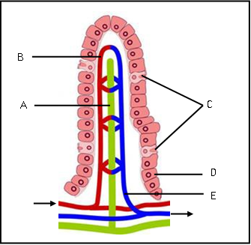
2.1 Provide an appropriate title for this diagram. (1)

_______________________________________
2.2 In which part of the digestive tract would this structure be found? (1)

______________________________________

2.3 Explain TWO structural adaptations of the part mentioned in 2.2 that enables it to perform its functions. (4)

____________________________________________________________________________________________________________________________________________
2.4 In which part (B or E) would you expect to find more nutrients? (1)

______________________

  - Provide labels for A to E. (5)
- ____
- ____
- ____
- ____
- ____
  - What structures would you expect to find on cells labelled D? (1)

___________________
  - Provide the letter of the structure where absorbed glucose and amino acids will be found. (1)

____________________
  - Is the absorption of glucose and amino acids active or passive? (1)

___________________
  - Give the letter for the structure into which fatty acids and glycerol are absorbed? (1)

____________________ (16)

Question 3
The diagram below shows a diagrammatic representation of the digestive system.

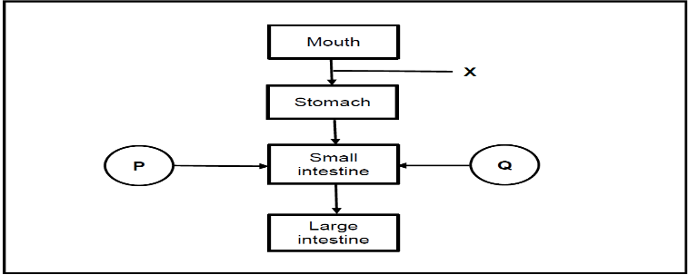
3.1Name the part of the alimentary canal represented by X. (1)
______________________________________________
3.2 By which process is food moved through structure X? (1)
______________________________________________
3.3 Describe the above mentioned process. (3)
________________________________________________________________________________________________________________________________________________________________________________________________________________________________________________________________________________________
3.4 Name the part of the alimentary canal where the digestion of proteins begins. (1)
___________________________ (6)
Question 4
4.1 Describe the digestion and absorption of food that contains only carbohydrates. (9)
________________________________________________________________________________________________________________________________________________________________________________________________________________________________________________________________________________________________________________________________________________________________________________________________________________________________________________________________________________________________________________________________________________________________________________
4.2 Describe the absorption of the products of carbohydrate digestion (6)
______________________________________________________________________________________________________________________________________________________________________________________________________________________________________________________________________________________________________________________________________________________________
Total marks: 45

