Province of the
EASTERN CAPE
EDUCATION

DIRECTORATE SENIOR CURRICULUM MANAGEMENT (SEN-FET)
HOME SCHOOLING SELF-STUDY WORKSHEET
SUBJECT | LIFE SCIENCES | GRADE | 12 | DATE | 3 June 2020
TOPIC | RESPONDING TO THE ENVIRONMENT: CAUSES AND TREATMENT OF HEARING DEFECTS |  |  | TERM 2 CONTENT
TIME ALLOCATION | 50 minutes | TIPS TO KEEP HEALTHY  1. WASH YOUR HANDS thoroughly with soap and water for at least 20 seconds. Alternatively, use hand sanitizer with an alcohol content of at least 60%.  2. PRACTICE SOCIAL DISTANCING – keep a distance of 1m away from other people.  3. PRACTISE GOOD RESPIRATORY HYGIENE: cough or sneeze into your elbow or tissue and dispose of the tissue immediately after use.  4. TRY NOT TO TOUCH YOUR FACE. The virus can be transferred from your hands to your nose, mouth and eyes. It can then enter your body and make you sick.  5. STAY AT HOME.
INSTRUCTIONS | Use Mind The Gap Study Guide and read:  Study the notes provided with this lesson  Answer the questions on the Worksheets below

1 | Give the correct biological term for each of the following descriptions. Write only the term next to the question number (1.1 to 1.3) in your ANSWER SHEET.
 | 1.1 | The part that prevents the sound waves from disturbing any new sounds that the pinna may receive | (1)
 | 1.2 | Small tubes inserted into the tympanic membrane to drain fluid from the middle ear | (1)
 | 1.3 | An electronic device that can bypass the damaged inner ear and is able to send impulses directly to the auditory nerve | (1)

2 | Two types of hearing loss occurs in humans:  Conductive hearing loss- occurs when sound vibrations cannot be conducted through the outer and middle ear  Sensorineural hearing loss- occurs when sound waves in the inner ear are not converted into nerve impulses or when impulses cannot be transmitted to the brain.  The diagram below shows a section through the human ear.
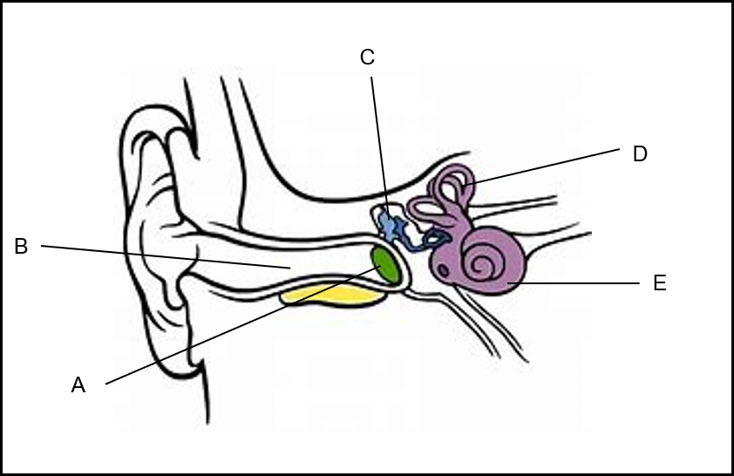
G
F
 | 2.1 | Provide the LETTER and NAME of the part of the ear where the following will be inserted:
 |  | (a) A grommet | (2)
 |  | (b) A cochlear implant | (2)
 | 2.2 | Give the LETTER and NAME of the part that:
 |  | - Transmits impulses to the brain | (2)
 |  | - Releases excess pressure in the middle ear part of the tympanic membrane | (2)
 | 2.3 | Give the LETTER of the TWO structures in the diagram of the ear that when damaged will result in the following:
 |  | - Conducive hearing loss | (2)
 |  | - Sensorineural hearing loss | (2)
 | 2.4 | Explain why hearing loss due to ear wax is usually temporary | (2)
 | 2.5 | Explain the consequence that will occur when the ligament attaching the malleus to the incus is damaged resulting in the separation of the bones | (4)
 |  |  | (18)
3 | The frequency of sound is measured in units called Herts(Hz)  Three learner’s hearing were tested by testing their range of sound that they can hear.  The results are recorded in the following table:
 |  | 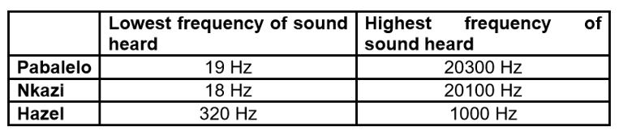
 | 3.1 | Use a pie chart to represent the lowest frequency of sound that can be heard by the three learners | (7)
 | 3.2 | Which learner most probably needs a hearing –aid? | (1)
 | 3.3 | Explain your answer in QUESTION 3.2 | (2)
 | 3.4 | Bats produce sounds between 30000 and 80 000 Hz. Explain why humans are not able to hear sound produced by bats | (2)
 |  |  | 33

