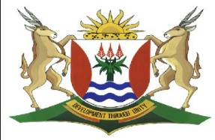
Province of the
EASTERN CAPE
EDUCATION

DIRECTORATE SENIOR CURRICULUM MANAGEMENT (SEN-FET)
HOME SCHOOLING: NOTES
ISIXHOSA ULWIMI LWASEKHAYA RADIO LESSON: JULY 2020
IDRAMA: BUZANI KUBAWO- WK TAMSANQA: Ibanga:12
Icwangciswe: Pakade G
ISIFUNDO SESI- 6: Imifanekiso engaphandle encwadini ihambelana njani nobuthumbu bencwadi?
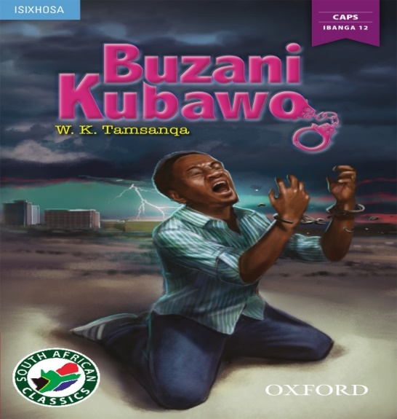
Emakuqapheleke kokokuba imifanekiso engaphandle kwiqweqwe lencwadi asiyomifanekiso eyenza incwadi ibukeke kodwa kukho intsingiselo nokrobiso olukula mifanekiso. Lonto ithetha ukuba isikrobisa kwizinto ezizakuthi zenzeke apha ebalini eli liqulathwe yincwadi.
Masitolike singqamanise isihloko, imifanekiso nezenzo okanye iziganeko eziqhubekayo ebalini.
- UMBILINI OKUNOMAMPONDOMISE XA ETHATHA ISIGQIBO SOKWAMKELA ISICELO SOTHANDO SIKAGUGULETHU.
- Uvalo ngumqondiso wokoyika/ wokubi okuza kuhla.
- Ngokwemifanekiso engaphandle kwiqweqwe lencwadi zeza ngqimba zamafu amnyama aqokelelanayo okulukrobiso kububi obuzayo obuza kukrazula intliziyo kuphele ulonwabo.

- ISIHLOKO SITYHILA NTONI?
Ukuvela kwesihloko sencwadi kwintlanganiso yamahlubi ngomlomo kaGugulethu
- Sityhila ingqumbo nokukrazuka kwentliziyo kaGugulethu ngokuthi anyanzelwe nguyise uZwilakhe ngokuba atshate intombi angayithandiyo uThobeka abe yena ethanda uNomaMpondomise.
- Le ngqumbo anayo uGugulethu izotywa nangamafu afingizayo amnyama abonisa ububi nobungozi obuza kutyhilwa ziziganeko ezisencwadini.

- IMIBANE EKRAZULA ISIBHAKABHAKA
Umbane unobungozi, uyangxwelerha xa uthe awabulala xa ubethile, umbane
uyabulala. Masiyityhile ngokweziganeko ezisencwadini imibane exananaze ibhala isibhakabhaka ebonwa kwiqweqwe lencwadi.
- Ukufa kukaMzamo ikholwane likaGugulethu kukugqekreza kwezulu yilaa mibane iqalisile ukubulala.
- Ukuzeyelisela kukaNomaMpondomise emlanjeni eMthatha wafa.
- Ukujuba kukamama kaNomaMpondomise uMaNyawuza afe ukufika kweendaba zokufa kukaNomaMpondomise.
- Ukufa kukaThobeka nabantwana abathathu bakhe ngokuxatyelwa ngezembe nguGugulethu.
- Ukugwetywa kukaGugulethu ngokuba uza kuxhonywa kukhokelele ekubeni unina uMaGaba azityise ityhefu wafa.
- Ukugwetywa kukaGugulethu ukuba axhonywe afe.
Zonke ezi ziganeko zityhilwa yila mibane ixananaze esibhakabhakeni kwiqweqwe lencwadi.
- INDODA EKHONKXIWEYO KUMFANEKISO ONGAPHANDLE

- Le ndoda lukrobiso kwisenzo sokubanjwa komntu oyindoda ngezenzo zolwaphulo mthetho, le ndoda ke nguGugulethu ngokubulala uThobeka nabantwana abathathu.

