LEARNER SUPPORT MATERIAL:

CIVIL TECHNOLOGY WOODWORKING: GRADE 12

TOPIC: GRAPHICS AS MEANS OF COMMUNICATION:

CONTENT

Graphics as Means of Communication (Generic)
Interpretation of advanced drawings related to the building industry
Interpretation of advanced texts:

- Site plan, floor plan and view of multiple storey building
- Basic symbols that relate to the building environment in accordance with the SABS for building drawing

TIP:
- Learn how to read and interpret building plans and the identification and interpretation of drawing symbols.
- Download from the internet building plans and interpret them, do more calculations involving area and perimeter of a room,
Graphics as Means of Communication (Speciﬁc)
Sketch of line charts of the following roof trusses:

- Lean-to roof
- Couple roof
- Close couple roof
- Color Tie roof
- South African roof truss (Howe roof truss)
- King post Cap

Graphics as Means of Communication – Roof (Speciﬁc)

Scale drawings of an isometric exploded view of a long-and short shoulder mortise and tenon joint (add for frames with a rebate): Scale drawing of an assembled isometric view of a long and short shouldered mortice and tenon joint (joint for rebated frames)

Sketches of line diagrams of the following roof trusses:
- Lean to roof
- Couple roof
- Closed couple roof
- Collar-tie roof
- South African roof (Howe)
- King post roof

EXAMPLE 1:

QUESTION 2: GRAPHICS AS METHOD OF COMMUNICATION (GENERIC)

2.1 FIGURE 2.1 below shows different drawings that appear on a building plan. Analyse the drawings and complete the table on ANSWER SHEET 2.1

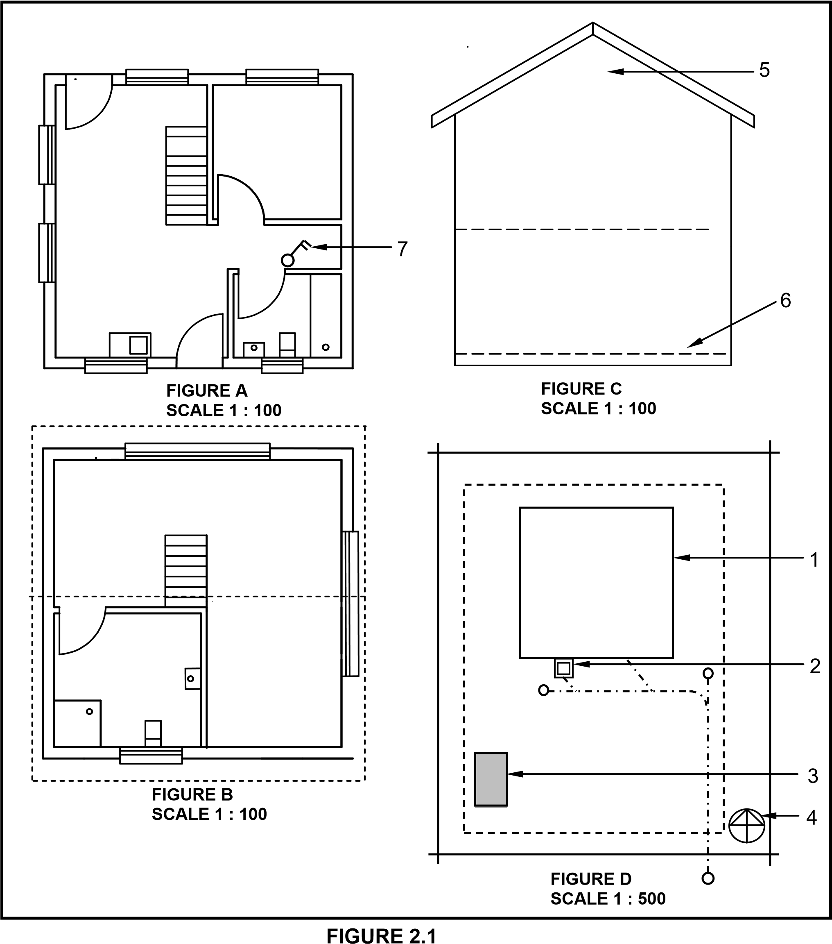

2.2 FIGURE 2.2 below shows an incomplete floor plan of a proposed dwelling.

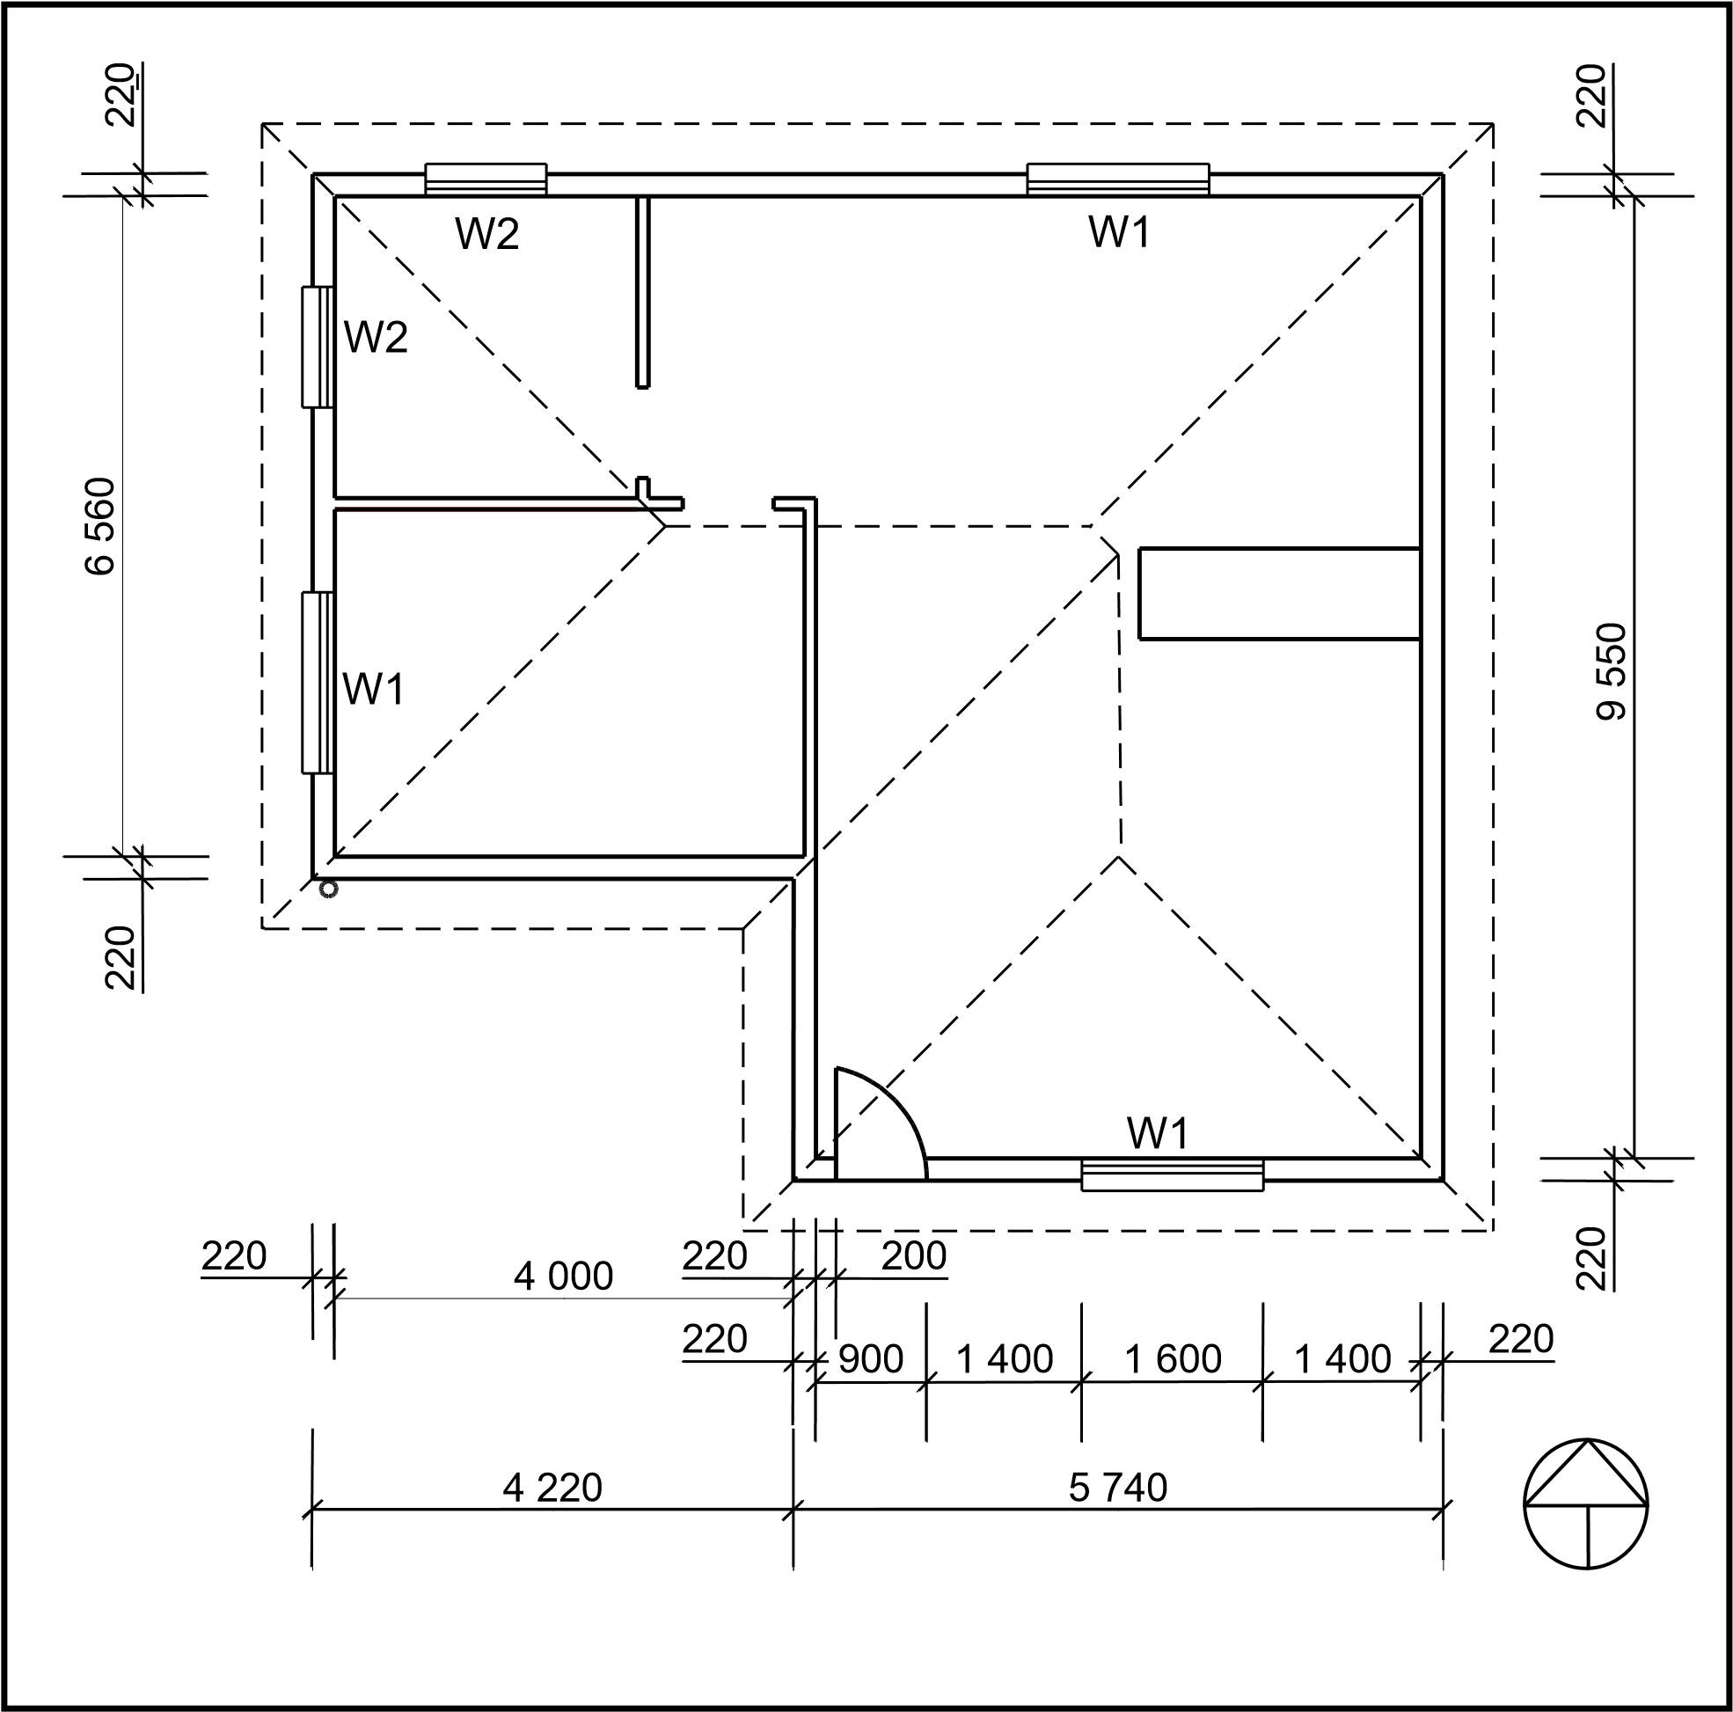

FIGURE 2.2

Study FIGURE 2.2 and develop and draw, on ANSWER SHEET 2.2, to scale 1 : 50, the SOUTH ELEVATION of the building. Use the following specifications. (Use the assessment criteria on ANSWER SHEET 2.2 as a guideline for your drawing.)

SPECIFICATIONS:

- The height between the natural ground level and the top level of the floor slab is 500 mm.
- The height between the floor slab and the underside of the wall plate is 2 600 mm.
- The roof is covered with corrugated galvanised sheeting and is finished with 220 mm wide fascia boards.
- Ridge capping is 100 mm high.
- Rainwater downpipes are 75 mm in diameter and 100 mm square gutters are used.
- A rainwater downpipe should be placed at the corner of the building, as indicated on the floor plan.
- The eaves overhang is 500 mm.
- The door opening is 2 100 mm high and 900 mm wide.
- The door step is 250 mm high.
- The building has a gable roof with a pitch of 30°.

The following must also be shown on the drawing:

- The method used to determine the roof height
- Window sills
- ONE rainwater downpipe

Windows and doors:

WINDOWS AND DOORS | WIDTH | HEIGHT
Window 1 (W1) | 1 600 | 1 200
Door openings 1 (D1) | 900 | 2 100

THREE marks will be allocated for the application of the scale.
Start the drawing from corner A, as indicated in the bottom left-hand corner of ANSWER SHEET 2.2. (25)
[40]

ANSWER: EXAMPLE 1

QUESTION 2: GRAPHICS AS METHOD OF COMMUNICATION (GENERIC)

NO. | QUESTIONS | ANSWERS | MARKS
1 | Identify FIGURE A. | Floor plan of ground floor | 1
2 | Identify FIGURE B. | Floor plan of first floor | 1
3 | Identify FIGURE D. | Site plan | 1
4 | What do the short-dashed lines in FIGURE B indicate? | The roof line of the building | 1
5 | What type of roof is used on this building? | Gable roof | 1
6 | Name the scale that was used to draw FIGURE B. | 1: 100 | 1
7 | Name the scale that was used to draw  FIGURE D | 1: 500 | 1
8 | On what side of the building is the bathrooms situated? | South side | 1
9 | What is indicated by number 1? | Proposed building | 1
10 | What is indicated by number 2? | Gully | 1
11 | What is indicated by number 3? | Existing building | 1
12 | What is indicated by number 4? | North direction | 1
13 | What is indicated by number 5? | Gable wall | 1
14 | What is indicated by number 6? | Finished floor level of ground floor | 1
15 | What is indicated by number 7? | One-way switch double pole | 1
 |  | TOTAL | 15

2.2 GRAPHICS AND COMMUNICATION (GENERIC)

ASSESSMENT CRITERIA | MARKS | LM
External Walls | 3
NGL (correctly indicated | 1
FFL (correctly indicated) | 1
Window | 1
Window sill | 1
Door opening | 1
Step | 1
Fascia board | 1
Barge board | 2
Roof (correctly drawn) | 3
Gutter | 1
Rain-water down pipe | 1
Ridge capping | 1
Determining roof height | 2
Any two labels | 2
Application of scale  One or two incorrect  = 3  Three or four incorrect  = 2  More than five incorrect  = 1  No measurement correct = 0 | 3
TOTAL | 25
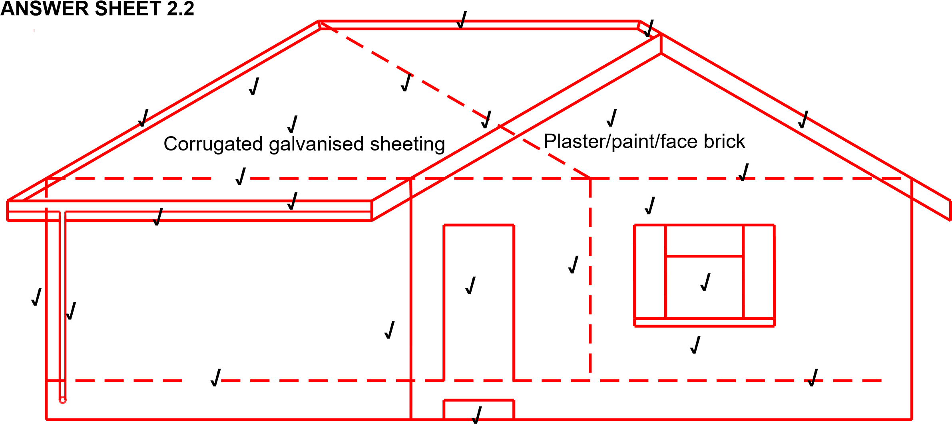

EXAMPLE 2:

QUESTION 2: GRAPHICS AS METHOD OF COMMUNICATION (GENERIC)

FIGURE 2 shows different drawings that appear on a building plan. Analyse the drawings and complete the table on ANSWER SHEET 2.

7  8  220  2 000  110  220 | 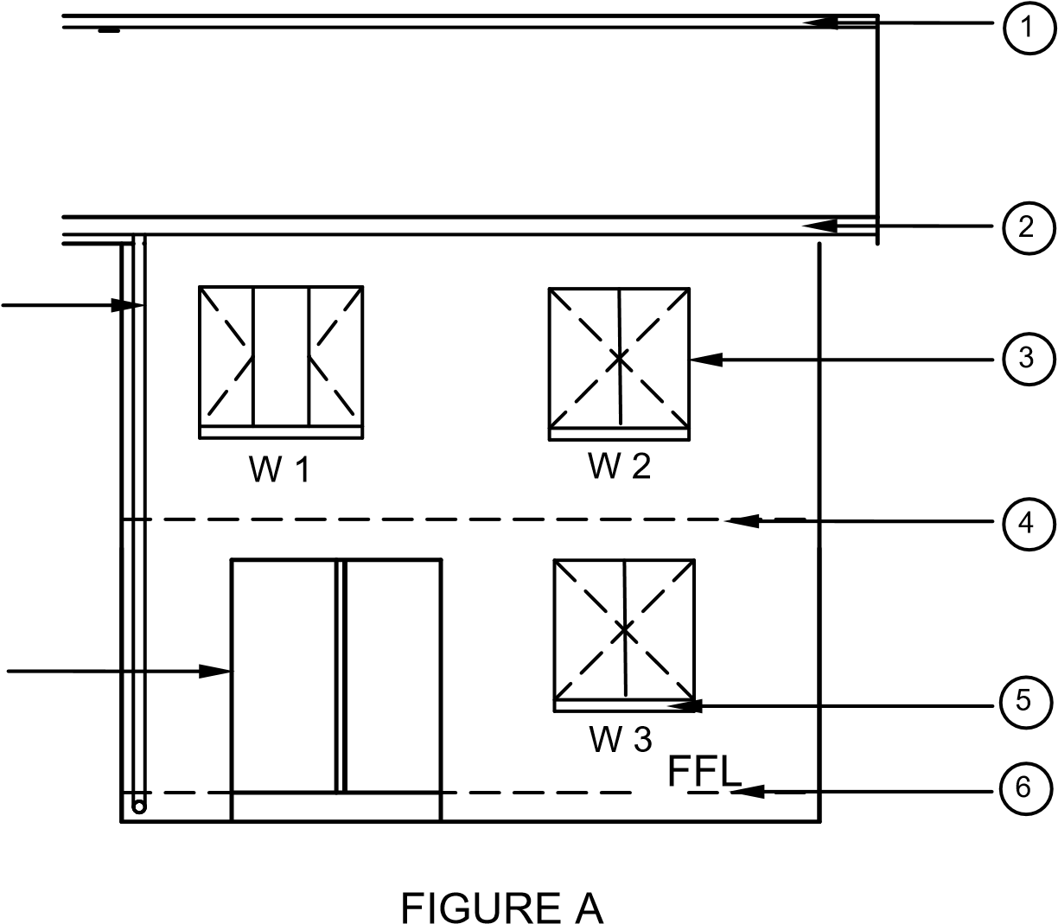  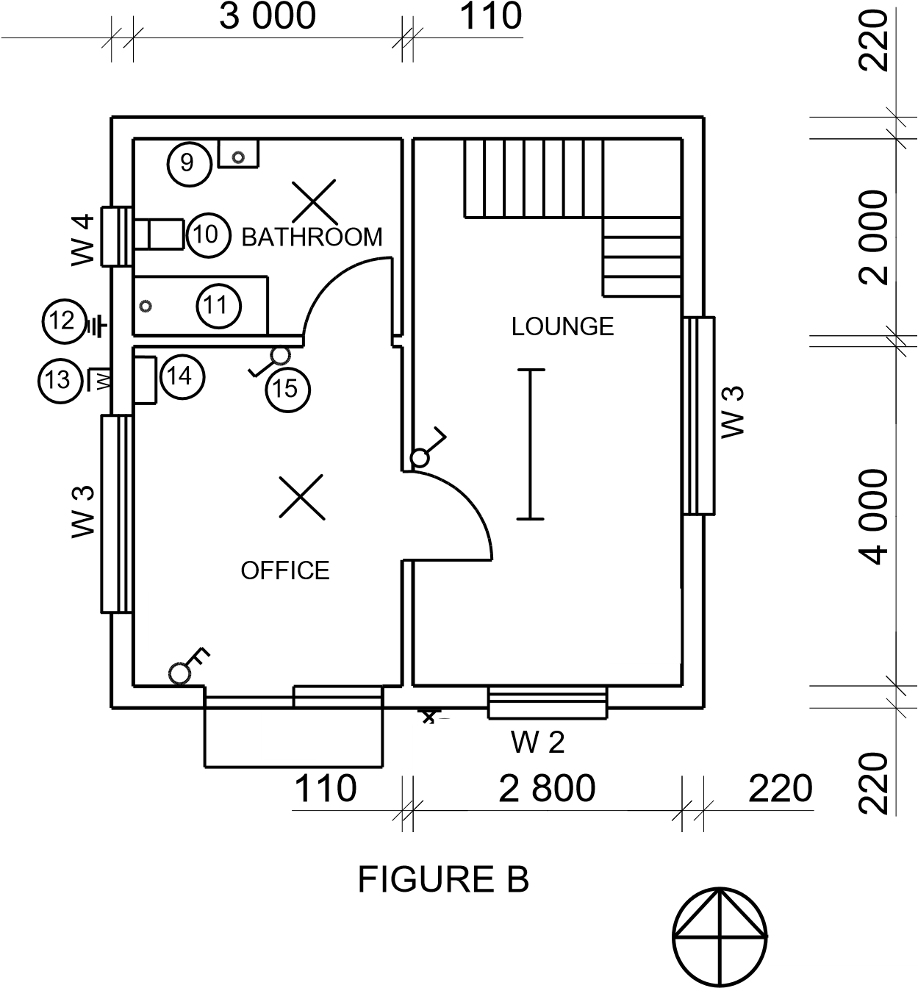 | NOTES:  Contractors must verify all dimensions and levels on site before commencing work. Architects to be  notified immediately of any discrepancies.  ARCHITECT'S SIGNATURE …………………. CLIENT'S SIGNATURE ……………….…….  The following must be placed in front of the sliding door:  1  :  10  Access to the first floor must be by means of a:
 |  | REVISION |  | DATE |  |  | DESCRIPTION
PRINTED BY: DATE OF PRINT:
NKOSI PRINTERS 2018/10/02
DRAWING TITLE:
SITE PLAN STAND 1843
PROJECT:
PROPOSED DWELLING ON STAND 1843,
DIEPRIVIER

PROJECT NO. DRAWING NO.
GR 557-102 557P9
 |  | DATE  25/4/2018 | DRAWN JP MALOI |  |  | CHECKED  P BRITZ |  | SCALE  1 : 100
REFERENCE CODE
QP 1 - 2018
 |  | WINDOW 2 |  |  | WINDOW 3
 |  | 900  1 200 |  |  | 2 000  1 200

FIGURE 2 [40]

NO. | QUESTIONS |  | ANSWERS EXAMPLE 2: | MARKS
1 | Identify FIGURE A. |  | South Elevation/Elevation | 1
2 | Identify FIGURE B. |  | Ground floor plan/floorplan | 1
3 | Identify number 4. |  | First floor level/Second floor level/Suspended floor/Floor level/ dash line/ FFL/Expansion joint | 1
4 | Identify number 5. |  | Window Sill | 1
5 | Identify number 9. |  | Hand wash basin/Wash basin/Washing basin/HWB/basin | 1
6 | Identify number 10. |  | Water closet/WC/Toilet pan | 1
7 | Identify number 11. |  | Bath/B | 1
8 | On what date was the plan printed? |  | 2018/10/02 | 1
9 | Who drew the building plan? |  | JP Maloi | 1
10 | Name the feature in the column for the notes in FIGURE 2 that must be installed in front of the sliding door. |  | Ramp | 1
11 | Name the feature in the column for the notes in FIGURE 2 that must give access to the first floor. |  | Staircase/Stairs/Stairway | 1
12 | Identify the type of roof that is used for the building in FIGURE A. |  | Gable roof | 1
13 | Explain the purpose of number 1. |  | To cover the opening/close the gap between the two slopes of the roof.  Prevent water and other elements from entering the roof.  ANY ONE OF THE ABOVE | 1
14 | Explain the purpose of number 2. |  | - To prevent water from falling onto the ground  - To collect rainwater  - To channel the rainwater into the downpipe  - To protect the wall from water  - To hide the rafters/finish off the roof  ANY ONE OF THE ABOVE | 1
15 | Explain the abbreviation FFL at number 6. |  | Finished floor level | 1
16 | Explain the purpose of number 7. |  | To channel the water from the gutter to the ground. | 1
17 |  | Explain the meaning of the arrow on the feature that must be installed in front of the sliding door. | It indicates the direction of the slope of the ramp/it indicates the slope. | 1
18 |  | Explain what is meant by 1: 10 indicated on the symbol in the notes. | It indicates the slope or the gradient of the ramp/for every 10 metres horizontally rises 1 metre vertically. | 1
19 |  | Which room will feature 15 serves? | The bathroom. | 1
20 |  | Explain the short-dashed lines on the windows. | - Indicates what direction the window is opening/window opening. ✓  - Indicates the location of the hinges.  - Indicates the location of the casement stay.  ANY ONE OF THE ABOVE | 1
21 |  | Deduce the height of window 2 from the window schedule. | 1,2 m or 1 200 mm ✓(Ignore units) | 1
22 |  | Deduce the width of window 3 from the window schedule. | 2 m or 2 000 mm ✓(Ignore units) | 1
23 |  | On what elevation of the building is the bathroom window situated? | Western elevation/Western side | 1
24 |  | Differentiate between component number 3 and component number 8. | 3 – window/window frame/reveal | 2
25 |  | Differentiate between the light in the lounge and the light in the bathroom. | frame stile/casement stile  8 – sliding door /door frame/ door/reveal /sliding door stile | 2
26 |  | Recommend a suitable floor covering for the bathroom. | The light in the lounge is a fluorescent light/1 x 40W/2x40/3x40 fluorescent light ✓ and the light in the bathroom is a normal ceiling light ✓ | 1
27 |  | Recommend an appropriate scale to which FIGURE A should be drawn, according to SANS. | Tile/ Vinyl flooring (Novilon)/  Coloured screed/Polished or stained concrete flooring/Water proof laminated floor/carpet. ✓  ANY ACCEPTABLE ANSWER | 1
28 |  | Recommend an alternative sanitary fitment to replace number 11 that will serve a similar purpose. | 1:50/100/200 | 1
29 |  | Calculate the internal area of the office in m². Show ALL calculations. | Shower  Positive marking  (220 + 3 000 + 110 + 2 800 + 220) x 2  = 6 350 x 2  =12 700 mm  (220 + 4 000 + 110 + 2 000 + 220) x 2  = 6 550 x 2  = 13 100 mm  12 700 + 13 100 mm  = 25 800 mm OR  = 25,8 m | 3
 |  |  | TOTAL | 40

EXAMPLE 3:

QUESTION 2: GRAPHICS AS MEANS OF COMMUNICATION (GENERICS)

FIGURE 2 on the next page shows different drawings that appear on a building plan.
Analyse the drawings and complete the table on ANSWER SHEET 2.

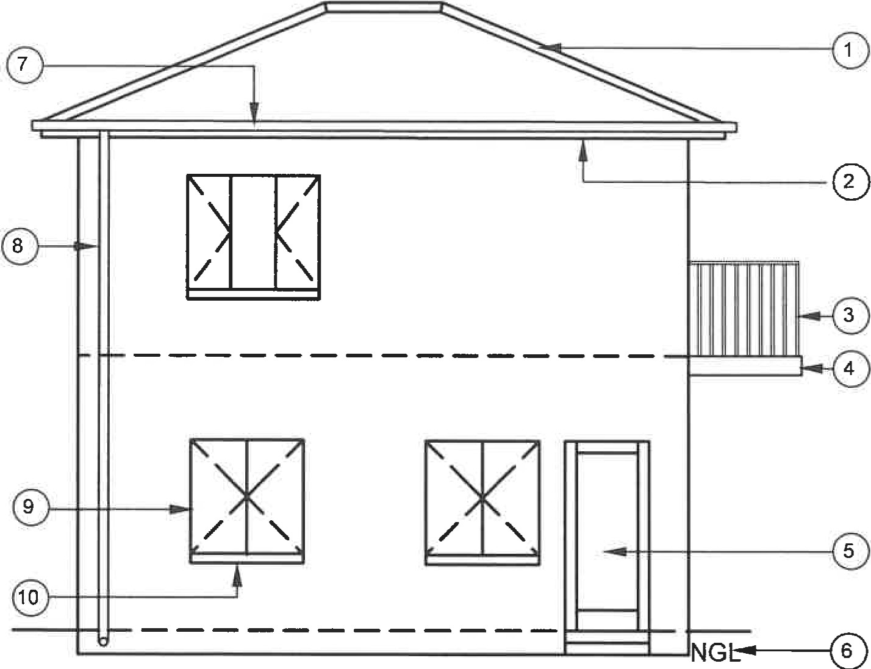  FIGURE A  SCALE 1: 100  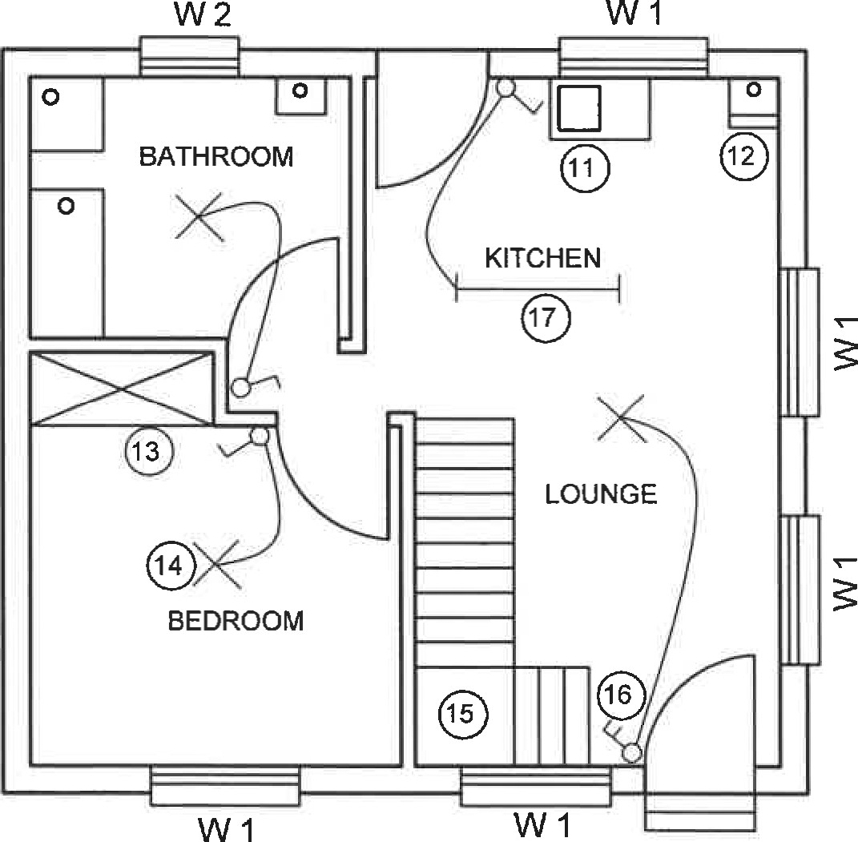  FIGURE B  SCALE 1: 100 | NOTE:  Contractors must verify alI dimensions and levels on site before commencing work. Architects must be notified of any discrepancies immediately.  Wall thickness: External = 220 mm  Internal = 1 10 mm  ARCHITECT'S  SIGNATURE.  CLIENT'S SIGNATURE.  The following electrical installation should be installed in the kitchen:  w  The following symbol shows the type of brick finishing that will be used for the building:  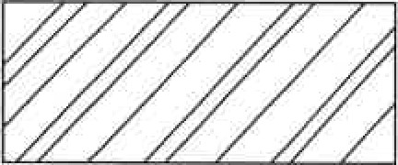
 | REVISION |  | DATE |  | DESCRIPTION
PRINTED BY: DATE OF PRINT.
DLAMINI PRINTERS 2019/04/01
 | DRAWING TITLE: SITE PLAN STAND 502
PROJECT:
PROPOSED DWELLING ON STAND 502,
DEO PARK
PROJECT NO. DRAWING NR.
GR 228-201 339P9
 | DATE  16/4/2019 | DRAWN  JP MBALI |  | CHECKED  P CARTER |  | SCALE  1: 100
REFERENCE CODE
QP 2-2019
 | WINDOW 1 |  |  | WINDOW 2
 | 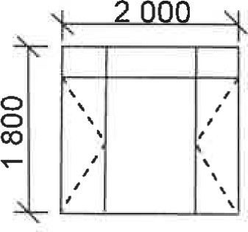 |  |  | 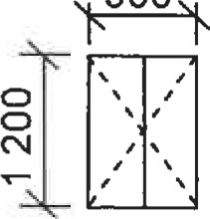900
FIGURE 2 [40]
QUESTION 2: GRAPHICS AS MEANS OF COMMUNICATION (GENERICS)
ANSWER: EXAMPLE 3:

NO. | QUESTIONS | ANSWERS | MARKS
1 | Identify the elevation in FIGURE A. | West Elevation | 1
2 | Identify the type of roof that is used on the building in FIGURE A. | Hipped roof | 1
3 | Identify number 1. | Ridge Capping/Ridge plate/Ridge tile/Hip cap | 1
4 | Identify number 4. | Balcony/Floor slab of  balcony/Cantilever/Concrete slab | 1
5 | Identify number 5. | External door/Entrance door/Door/Outside door | 1
6 | Identify number 7. | Gutter | 1
7 | Identify number 8. | Rainwater down pipe/RWDP/Down pipe | 1
8 | Identify number 12. | Wash trough/Wash tub | 1
9 | Identify number 13. | Built-in cupboard/BIC | 1
10 | Identify number 15. | Landing | 1
11 | Identify the company that printed the building plan. | Dlamini printers | 1
12 | Name a suitable material that can be used for the manufacturing of number 2. | Fibre cement/Galvanised sheeting/  Timber/Plastic/PVC/Polyvinylchloride | 1
13 | Name the drawing symbol in the column for the notes in FIGURE 2 that must be installed in the kitchen. | Electricity meter/Electrical meter/Watt meter/Prepaid meter | 1
14 | Name the drawing symbol in the column for the notes in FIGURE 2 that indicates the type of bricks for the building. | Face brick | 1
15 | Name a material that should NOT be used to manufacture the frame of number 9 for coastal areas. | Steel/Mild steel/Iron/Ferrous metals | 1
16 | Name a material that can be used to manufacture the sanitary fitting indicated by number 11. | Stainless steel/Plastic/Ceramic/  Granite/Acrylic/Fibre  Glass/Concrete | 1
17 | Who checked the building plan? | P Carter | 1
18 | How many types of windows are used in FIGURE B? | 2 | 1
19 | What does the abbreviation NGL at number 6 stand for? | Natural ground level | 1
20 | Give the reference code for this plan. | QP 2-2019 | 1
21 | Which room will electrical symbol 16 serve? | Lounge | 1
22 | Describe the purpose of number 3. | Prevent people from falling off/through. | 2
23 | Explain what the curved lines between the electrical installations in FIGURE B indicate. | Electrical wiring/Wiring/Electrical cable/Wiring from light switch to light/Shows which switch operates which electrical fitting. | 2
24 | Explain why the light switch is mounted on the outside of the bathroom. | To prevent steam/moisture entering the switch/To prevent electrical shock due to moisture/For safety purposes | 1
25 | Identify in FIGURE 2 which elevation does NOT have windows. | North elevation | 1
26 | Identify the thickness of the internal wall in FIGURE 2. | 110 mm | 1
27 | Differentiate between symbols 13 and 15 in terms of their purpose. | 13 – Built-in cupboard: to store items.  15 – Landing: to rest/safety feature/change of direction of stairs | 2
28 | Justify why FIGURE B is a ground floor plan. | Ground floorplan:  - does not indicate the roofline  - does not indicate the balcony  - indicate an entrance door to the house  - indicate a step at the entrance door  - the position of the windows and door correlate with the positions of the window and door on the west elevation | 1
29 | Predict what will happen if number 10 is NOT installed. | Water/Damp will penetrate into the wall. | 1
30 | Redraw the staircase in FIGURE B in the adjacent column and indicate the direction of the flight with arrows. | ✓  ✓  OR | 2
31 | Calculate the total length of the wall on the eastern side of the building.  Show ALL calculations. | 220 + 2 600 + 110 +  3 400 ✓ + 220  = 6 550 mm or 6,55 m  IF INCORRECT METHOD IS USED  TO CALCULATE THE ANSWER, USE THE FOLLOWING SLIDING SCALE:  - 4 MARKS WILL BE AWARDED IF ALL FIVE  VALUES ARE CORRECT  - 3 MARKS FOR FOUR VALUES CORRECT  - 2 MARKS FOR THREE VALUES CORRECT  - 1 MARK FOR 2 VALUES CORRECT | 6
 |  | TOTAL: | 40

EXAMPLE 4:
QUESTION 2: GRAPHIC COMMUNICATING, JOINING AND EQUIPMENT (GENERIC)

2.1 Indicate if the following statements, regarding site plans, are TRUE or FALSE.
Write only ‘true’ or ‘false’ next to the question number in your ANSWER BOOK.

2.1.1 Scale 1: 10 is used (1)

2.1.2 Ground contours are shown (1)

2.1.3 Layout of sewage is shown (1)

2.1.4 The proposed work is indicated in red (1)

2.1.5 Floor finishes of rooms are indicated (1)

2.2 FIGURE 2.2 on ANSWER SHEET A shows an incomplete floorplan of a flat to scale 1: 100. Complete the floorplan by using the following information:

2.2.1 Outside door at 2.2.A (2)

2.2.2 Window at 2.2.B (2)

2.2.3 Water closet at 2.2.C (2)

2.2.4 Washbasin at 2.2.D (2)

2.2.5 Wash tub at 2.2.E (2)

2.2.6 One-way switch single pole at 2.2.F (2)

2.2.7 Fluorescent light at 2.2.G (2)

2.2.8 Socket outlet at 2.2.H (2)

2.2.9 Grease trap at 2.2.I (2)

2.2.10 Wall-mounted light at 2.2.J (2)

2.2 Use the information on ANSWER SHEET A and complete the floorplan to scale 1: 100.

BA
THROOM

KITCHEN

ROOM

LIVING ROOM

.A
2.2

2.2
.B

2.2
.F

.H
2.2

.G
2.2

.E
2.2

.D
2.2

2.2
.C

.I
2.2

.J
2.2

2.3 Identify the different types of bolts in FIGURES 2.3.1, 2.3.2 and 2.3.3.

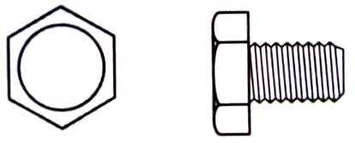 | 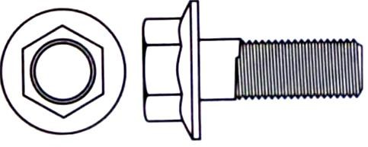 | 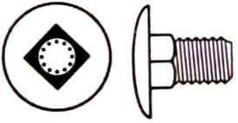
FIGURE 2.3.1 FIGURE 2.3.2 FIGURE 2.3.3 (3)

2.4 Answer the following questions on the tool in FIGURE 2.4.

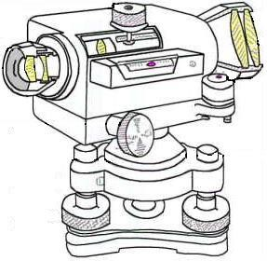

A

B

C

D

FIGURE 2.4

2.4.1 Identify the tool in FIGURE 2.4. (1)

2.4.2 Name ONE use of this tool. (1 x 1) (1)

2.4.3 Name the different parts A–D. (4 x 1) (4)

2.4.4 Name TWO uses of a laser level. (2)

2.5 Explain why the laser level should not be stored in extremely cold areas.

Refer to the moisture inside the tool. (2)

2.6 Explain the meaning of the following code for Rawl bolts: M08/25. (2)

[40]

ANSWER: EXAMPLE 4:

QUESTION 2: GRAPHICS, JOINING AND EQUIPMENT (GENERIC)

2.1
2.1.1 False (1)
2.1.2 True (1)
2.1.3 True (1)
2.1.4 True (1)
2.1.5 False (1)

2.2. FIGURE 2.2 on ANSWER SHEET A:

2.2.1 Outside door at 2.2.A (2)
2.2.2 Window at 2.2.B (2)
2.2.3 Water closet at 2.2.C (2)
2.2.4 Washbasin at 2.2.D (2)
2.2.5 Single sink unit at 2.2.E (2)
2.2.6 One-way switch-single pole at 2.2.F (2)
2.2.7 Fluorescent light at 2.2.G (2)
2.2.8 Socket outlet at 2.2.H (2)
2.2.9 Grease trap at 2.2.I (2)
2.2.10 Wall-mounted light at 2.2.J (2)

2.3. 2.3.1 Trim hexagon

2.3.2 Hex flange

2.3.3 Square shoulder screws (3)

2.4. 2.4.1 Dumpy level (1)

2.4.2 Any ONE use of this instrument:

Determine the difference in levels
Determining levels and slopes
Setting out buildings
Transferring levels and heights (1 x 1) (1)

2.4.3 A – Focusing knob

– Objective
– Foot piece
– Eye piece (4 x 1) (4)

2.4.4 (1) To obtain a level / horizontal (2) sight line / reading (2)

(1) If the moisture inside the level freezes and later reaches normal operating temperature, the moisture can condense (2) inside the tool, where it may
damage the circuit board (2)

M08 = Thread diameter
25 = Thickness (2)

[40]

