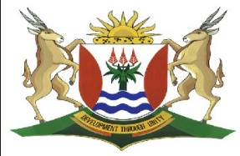
Province of the
EASTERN CAPE
EDUCATION

DIRECTORATE SENIOR CURRICULUM MANAGEMENT (SEN-FET)
HOME SCHOOLING: NOTES
ISIXHOSA ULWIMI LWASEKHAYA RADIO LESSON: 16 JUNI 2020
IDRAMA: BUZANI KUBAWO- TAMSANQA WK: Ibanga:12
Icwangciswe: Pakade G
Isifundo:
UVUTHONDABA
(Ikhangeleka isenzeka intando kaMaGaba noZwilakhe yokutshatisa uGugulethu noThobeka kodwa yabe ikukufingiza kwamafu akwiqweqwe lwencwadi ngaphandle)
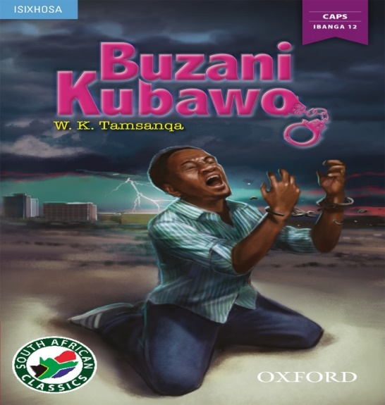
- UVUTHONDABA
Yincochoyi yempixano apho umlinganiswa avela elubala ngovakalelo lwakhe. Ngummandla kafayayo. Singathi njengokuba bekusonyukwa intaba ngoku kufikelelwe phezulu kwentaba apho bekusiyiwa khona. Umlinganiswa ngamnye uzincamile ukuba ingasuka ihle ehlayo inyuke enyukayo. Masiqwalasele ke ngoku okufumaneka kweli nqanaba ngokokunyanzelwa kukaGugulethu ukuba atshate noThobeka ukuba kuza kuzala nkomo ni.
- UZwilakhe uqhubele phambili engavananga nabantakwabo noGugulethu malunga nokutshatiswa kukaGugulethu ngenkani noThobeka angamthandiyo.
- UGugulethu utshatiswa noThobeka kanye ngeli xesha ebonakala ephila kwilizwe lakhe yedwa ngathi umkelwa zingqondo. Zwe elo kombuzayo nantoni na aphendula ngokuthi, “Buzani kubawo”.
- UGugulethu ube kuqhankqalazo nangomhla womtshato waqatshelwa ngumfundisi kodwa waqhuba nokubatshatisa. Umfundisi uluvezile uluvo lwakhe akuqaphela uGugulethu kuba xa afanele ukuphendula okanye ukulandela inkqubo yomtshato impendulo kaGugulethu ibiyileyo yesiqhelo ethi, “Buzani kubawo”.
- Le mpendulo imbangele umfundisi axhalabe esithi uqhelile ukutshatisa abantu kodwa uyaqala ukudibana nemeko enje, le into inento yayo kodwa wabatshatisa kunjalo. Lo mtshato uza kuzala iziphumo ezibi. Oku kubonakala ngokuba uGuguletu azibophe isandla ngathi wonzakele kuba engafuni kutyikitya azibophelele ngomtshato ongengowakhe kwaye angawufuniyo.
- Uthi akubuzwa ngumfundisi ukuba uyamthatha na uThobeka ukuba abe ngumfazi wakhe athi yena ukuphendula “Buzani kubawo”, nokutyikitya utyikityelwa nguyise uGugulethu.
- Kukulo mtshato apho kusweleka ikholwane likaGugulethu uMzamo ngokuhlatywa, nto leyo ebangela ukuba kuphele amathemba kuGugulethu.
- Ukufa kukaMzamo uGugulethu uqalisa ukusebenzisa amazwi athi, “Liqalisile! Liqalisile! Liyaduduma” oku kutyhila ukungxwelerheka/ukudandatheka komphefumlo kaGugulethu.
- UGugulethu ushiya ikhaya lakhe emva kwalo mtshato ayokuhlala eMthatha apho asebenza khona.
- Iphepha ndaba lisasaza iindaba zokufa kukaMzamo emtshatweni kaGugulethu
oko kubangele uNomaMpondomise amangalele uGugulethu ngokwaphula isithembiso somtshato ade wakhupha iinkomo zikaMcunukelwa ebuhlanti ngenxa yakhe.
- UNomaMpondomise uyazibulala ngokuzeyelisela emlanjeni. UMaNyawuza unina kaNomaMpondomise uyaquleka afe ngumothuko akuva ukuba intombi yakhe iswelekile.
- UGugulethu uhlala enxibe iimpahla ezimnyama eMthatha oko kwasweleka uNomaMpondomise ngelithi uzilile.
- UGugulethu akazange aphinde alubeke olwakhe unyawo kokwabo emva komtshato wakhe noThobeka.
- Oku kungabuyi kukaGugulethu kubangele ukuba uZwilakhe athumele abantakwabo ukuba balande kodwa akafuna uGugulethu ukubuya kwancameka.

Emakuqapheleke koku, oku kufa yilaa mibane siyibona kwiqweqwe lwencwadi, lifingize amafu aqokelelana azingqimba ngoku imibane iyakrazula yenza izigende nazi izidumbu zigeqeka.
Okungona kufiwayo uGugulethu ubonakala engekho zingqondweni esithi, “Liyaduduma! Lidlula nemiphefumlo. Buzani kubawo!

