Province of the
EASTERN CAPE
EDUCATION

DIRECTORATE SENIOR CURRICULUM MANAGEMENT (SEN-FET)
HOME SCHOOLING SELF-STUDY WORKSHEET ANSWER SHEET
SUBJECT | AUTOMOTIVE | GRADE | 12 | DATE | JUNE 2020
TOPIC | SYSTEMS AND CONTROL (AXLES, STEERING GEOMETRY  AND ELECTRONICS) (SPECIFIC) | TERM  REVISION | (Please tick) | TERM 3  CONTENT | (√ )

ANSWERS TO SELF – STUDY ACTIVITY
QUESTION 1
  - Purpose of the following alignment applications in vehicle:
    - To overcome the tendency of wheels with positive camber to point outwards.
    - To overcome the tendency of wheels with negative camber to point outwards.
    - To enable a vehicle to navigate a circle/curve effectively without skidding.
  - Camber
  - Functions of the following steering angles:
    - Camber angle brings the contact point of tyre directly on the road in order to achieve less steering effort.
    - Caster angle gives self-steering action to the steering and keeps the wheel in the straight-ahead position.
    - Kingpin inclination is designed to bring the front wheel back to the straight-ahead position after rounding a corner without any driver effort.
  - Factors to be considered before wheel alignment is checked or adjusted:

- Kerb mass must be checked against the manufacturer’s specifications
- Uneven wear on the tyres
- Tyre pressure
- Check wheel nuts with torque wrench
- Correct preload on the hub (wheel bearings) with torque wrench
- Check kingpin and bushes
- Suspension ball joints
- Check suspension bushes for excessive movement
- Steering box play whether secure on chassis
- Check the tie-rod ends
- Sagged springs
- Check shock absorbers (Any 4)
  - Types of wheel imbalance:
- Dynamic imbalance
- Static imbalance
QUESTION 2
2.1 Preliminary wheel alignment check:
- Kerb mass against the manufacturers specifications.
- Uneven wear on the tyres.
- Tyre pressure.
- Run-out on the wheels.
- Correct preload on the wheel bearings.
- Kingpins and bushes.
- Suspension ball joints for wear, locking and lifting.
- Suspension bushes for excessive free movement.
- Steering box play and whether secure on chassis.
- Tie-rod ends.
- Sagged springs, which include riding height.
- Ineffective shock absorbers.
- Spring U-bolts.
- Chassis for possible cracks and loose cross-members. (Any 5)
2.2 Toe-out on turns:
This toe-out effect in a turn gives a true rolling motion to the front wheels ✓ in a corner without scuffing.
2.3 Dynamic balance of the wheel and tyre assembly:
Dynamic balance of the wheel and tyre assembly refers to the equal distribution of all weights around the axis of rotation in all rotation parts.
2.4 Reasons of the speed control system:
- The speed control system is to control the throttle opening electronically.
- To keep the vehicle speed constant.
2.5 Disadvantages of the speed control:
- The system is expensive.
- High maintenance costs if the system becomes faulty.
2.6 Diode:
The function of the diode is to permit current to flow in only one direction ✓ and to block it from flowing in the opposite direction.

2.7 Advantages of an electric fuel pump:
- Immediate supply of fuel when the ignition switch is turned on.
  - Low operational noise.
  - Less discharge pulsation of fuel.
  - Compact and light design.
  - Prevents fuel leak and vapour lock.
(Any 2)

2.8 Aspects that an injector needs to fulfil:
• Precise fuel flow rate
• Good linearity
• Wide active range
• Good spray characteristics
• No leakage
• Silent operation
• Durability
• To cope with different needs for different engines

(Any 2)

2.9 Ackerman principle:
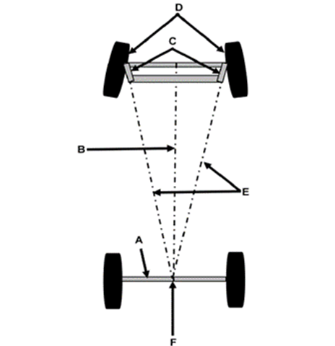

2.6.1 Ackerman angle steering principle / geometry.
2.6.2 Parts:
A – Rear axis
B – Longitudinal axis
C – Steering arms
D – Front wheels
E – Extended centre lines from steering arms
F – Intersection
2.6.3 If the centre lines of the steering arms are extended ✓ they will intersect on the longitudinal axis of the vehicle.

