Province of the
EASTERN CAPE
EDUCATION

DIRECTORATE SENIOR CURRICULUM MANAGEMENT
(SEN-FET)
HOME SCHOOLING SELF-STUDY WORKSHEET
SUBJECT | Life Sciences | GRADE | 12 | DATE | 26 May /2020
TOPIC | Reflex action,Reflex arc CNS disorders, Stem cell use to treat injuries | TERM 1  REVISION |  | TERM 2 CONTENT
TIME ALLOCATION | 30 min | TIPS TO KEEP HEALTHY  1. WASH YOUR HANDS thoroughly with soap and water for at least 20 seconds. Alternatively, use hand sanitizer with an alcohol content of at least 60%.  2. PRACTICE SOCIAL DISTANCING – keep a distance of 1m away from other people.  3. PRACTISE GOOD RESPIRATORY HYGIENE: cough or sneeze into your elbow or tissue and dispose of the tissue immediately after use.  4. TRY NOT TO TOUCH YOUR FACE. The virus can be transferred from your hands to your nose, mouth and eyes. It can then enter your body and make you sick.  5. STAY AT HOME.
INSTRUCTIONS | Use the following resources to complete the worksheet:  - Textbook  - Virtual lesson on Reflex action, reflex arc, CNS disorders and stem cell use to treat injuries  - PowerPoint Presentation on Reflex action, reflex arc, CNS disorders and Stem cell use to treat injuries

Question 1
1.1. | Give the correct Biological term for each of the following descriptions
 | 1.1.1 | The microscopic gap between consecutive neurons. | (1)
 | 1.1.2 | Undifferentiated cell that can develop into any tissue or organ | (1)
 | 1.1.3 | An automatic response to a stimulus, which is not under conscious control. | (1)
 | 1.1.4 | A disorder that is characterized by degeneration of the brain and loss of memory | (1)
 | 1.1.5 | Neuron that conducts impulses to the Central Nervous System. | (1)
 | 1.1.6 | The nervous pathway transmitting the impulses that results in a reflex action. | (1)
 |  |  | [6]
1.2 | The diagram below represents TWO pathways, A and B, which a nerve impulse may follow in the human body.
 | 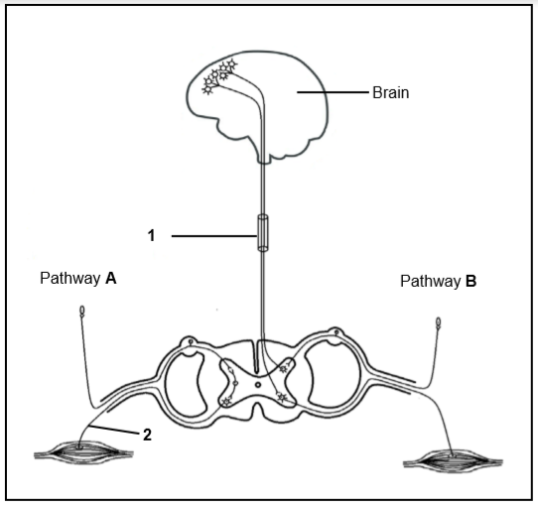
 | 1.2.1 | Which pathway, A or B, represents a reflex? | (1)
 | 1.2.2 | Give a visible reason in the diagram for your answer to QUESTION 1.2.1 | (1)
 | 1.2.3 | Describe the importance of a reflex action in the human body. | (3)
 | 1.2.4 | Identify the part of the nervous system represented by 1 | (1)
 | 1.2.5 | Describe how the person would be affected if the axon of neuron 2 was cut | (2)
 | 1.2.6 | Describe pathway B | (6)
 |  |  | [14]

[TOTAL: 20]

