TECHNICAL SCIENCES TERM 2 WORKSHEET
ELECTRONIC PROPERTIES OF MATTER
1.1 | Define the term doping. | (2)

1.2 | Silicon is listed as an intrinsic semiconductor. Justify this statement. | (2)

1.3 | A learner in a school laboratory adds boron to pure silicon to have a better conductor of electricity.

 | 1.3.1 | Which type of semiconductor is manufactured by this learner during the process above? | (1)

 | 1.3.2 |  | A diode is a simple semiconductor device. How does a diode conduct electric current? | (1)
2.1 | Name the two mostly used semiconductor material |  |  | (2)
2.2 | What is meant by tetravalent atom? |  |  | (2)
2.3 | Give one example of an industry were semiconductors are used. |  |  | (1)
2.4 | An intrinsic semiconductor silicon is doped with pentavalent phosphorus
 | 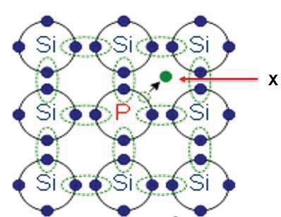
 | 2.4.1 | Name the type of semiconductor produced in the process above. |  | (1)
 | 2.4.2 | What do you understand by the term intrinsic semiconductor? |  | (2)
 | 2.4.3 | Write down the particle represented by the letter X. |  | (1)
3.1 | The diagram below represents a p-n junction diode.
 | 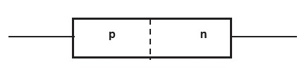
 | 3.1.1 | Draw a diagram showing a p-n junction diode connected to a battery so that the junction is forward biased. |  | (2)
 | 3.1.2 | Explain the working of p-n junction when it is in the forward biased mode. |  | (3)
4.1 | Explain the difference between an n-type and a p-type semiconductor. |  |  | (4)
4.2 | Silicon is a well known semiconductor.
 | 4.2.1 | Write down the number of valence electrons of silicon. |  | (1)
 | 4.2.2 | Write down the names and number of valence electrons of two elements that can be used to dope the silicon to create a n-type semiconductor. |  | (2)
 | 4.2.3 | Write down the names and number of valence electrons of two elements that can be used to dope the silicon create a p-type semiconductor. |  | (2)

SOLUTIONS
1.1 | Doping is the process of adding impurities to intrinsic semiconductors. ✓✓ | (2)
1.2 | Silicon is a pure semiconductor as impurity atoms must be added to improve conductivity or a pure semiconductor which is undoped. ✓✓ | (2)
1.3.1 | P-type semiconductor ✓ | (1)
1.3.2 | A diode allows current flow in one direction only ✓ | (1)
2.1 | Silicon and Germanium✓✓ | (2)
2.2 | An atom with four valence electrons in its outermost shell (valence shell)✓✓ | (2)
2.3 | In the manufacturing of electronic components.✓ | (1)
2.4.1 | n-type✓ | (1)
2.4.2 | A pure semiconductor is called an intrinsic semiconductor.✓✓ | (2)
2.4.3 | An electron✓ | (1)
3.1.1 | 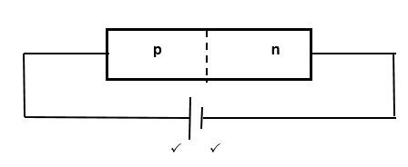 | (2)
3.1.2 | -the free electrons in the n-type material will be repelled by the negative terminal voltage supply.✓

 | -the electrons will move and break through the junctions and start flowing towards the positive terminal and it seems as if the holes are moving towards negative terminal.✓  -the junction region becomes smaller and the break over voltage is overcome and the diode will begin to conduct.✓ | (3)
4.1 | n-type semiconductor: Has been doped with a substance with more valence electrons than the semiconductor, providing free electrons.✓✓  p-type semiconductor: Has been doped with a substance with less valence electrons than the semiconductor, which leaves vacant spots, called holes. These holes are regarded as positive and can accept electrons.✓✓ | (4)
4.2.1 | Silicon – 4 valence electrons✓ | (1)
4.2.2 | Arsenic – 5 Valence electrons,✓ Antimony- 5 valence electrons✓ | (2)
4.2.3 | Gallium – 3 valence electrons,✓ Boron – 3 valence electrons  | (2)

