Province of the
EASTERN CAPE
EDUCATION

DIRECTORATE SENIOR CURRICULUM MANAGEMENT (SEN-FET)
HOME SCHOOLING SELF-STUDY WORKSHEET
SUBJECT | ECONOMICS | GRADE | 12 | DATE | 04/06/2020
TOPIC | MICROECONOMICS | TERM 1  REVISION |  | TERM 2 CONTENT | X
TIME ALLOCATION | 30 MINUTES MARKS: 40 | TIPS TO KEEP HEALTHY  1. WASH YOUR HANDS thoroughly with soap and water for at least 20 seconds. Alternatively, use hand sanitizer with an alcohol content of at least 60%.  2. PRACTICE SOCIAL DISTANCING – keep a distance of 1m away from other people.  3. PRACTISE GOOD RESPIRATORY HYGIENE: cough or sneeze into your elbow or tissue and dispose of the tissue immediately after use.  4. TRY NOT TO TOUCH YOUR FACE. The virus can be transferred from your hands to your nose, mouth and eyes. It can then enter your body and make you sick.  5. STAY AT HOME.
INSTRUCTIONS | INSTRUCTIONS AND INFORMATION  - Answer ALL questions in the ANSWER BOOK  - Number the answers correctly according to the numbering system used in this question paper.  - Write the question number above each answer.  - Leave 2–3 lines between subsections of questions  - Write neatly and legibly.

QUESTION 1 40 MARKS − 30 MINUTES

1.1 | Answer the following questions.
 | 1.1.1 | List TWO types of monopolies. |  | (2)
 | 1.1.2 | What will the effect be if a firm in a perfect market decides to increase the price of its product? |  | (2)
1.2 | Study the information below and answer the questions that follow.
THE DEMAND CURVE OF AN OLIGOPOLISTIC FIRM
The demand curve of an oligopolistic firm was developed in 1939 by the American economist Paul Sweezy.
The kinked demand curve illustrates the importance of interdependence and uncertainty in an oligopolistic market and explains why there is a degree of price stability in such a market.
Each firm will face a market demand curve with two segments for its product. The two segments are elastic and inelastic.

 | 1.2.1 | Who developed the theory on the demand curve of an oligopolistic firm? |  | (1)
 | 1.2.2 | What is the demand curve of an oligopolist firm called? |  | (1)
 | 1.2.3 | Briefly explain an inelastic demand. |  | (2)
 | 1.2.4 | Explain mutual dependence as a characteristic of oligopoly. |  | (2)
 | 1.2.5 | Draw a fully labelled kinked demand curve. |  | (4)
1.3 | Study the information below and answer the questions that follow.
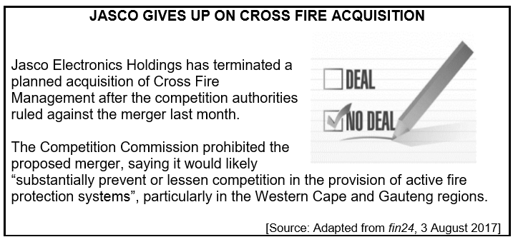
 | 1.3.1 | Which authority did not allow the merger of Jasco and Cross Fire? |  | (1)
 | 1.3.2 | What was the reason for the denial of the merger? |  | (1)
 | 1.3.3 | Explain any other TWO objectives of the Competition Policy, other than the one in the extract. (2 x 2) |  | (4)
 | 1.3.4 | In your opinion, how will the economy benefit from fair competition? (2 x 2) |  | (4)
1.4 | Distinguish between the short and long term/run. (2 x 4) |  |  | (8)
1.5 | Explain with the aid of a well-labelled graph, the effect of providing subsides to producers as a form of government intervention during market failure. |  |  | (8)
 |  |  |  | [40]

