

**GRADE 1**

**ENGLISH FIRST ADDITIONAL LANGUAGE WORKSHEET**

**TERM 3WEEK 24-28 August 2020**

**Theme: Reading is fun**

**Name ----------------------------------------------------**

**Grade ----------------------------------------------------**

**Date -----------------------------------------------------**



1. **Listening & Speaking**

Think about the book Bohlale got and the great pictures it had. Talk about the pictures you liked the most in the book you read.



1. **Phonics**

**Complete the words by adding ‘qu’ sound**

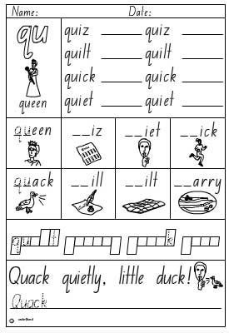

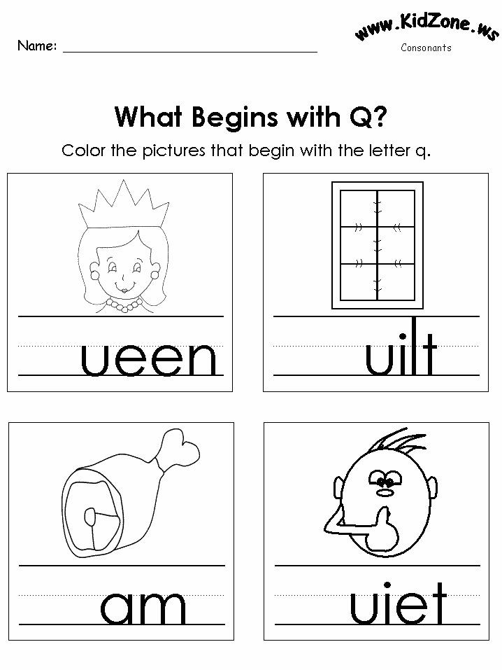

Writing

Think about times you read story books at home. Who do you like to read your stories with. Complete the sentence below.



I like to read with ----------------------------------------------------------------------------------------------------------------------------------------------------------------------.

Reading

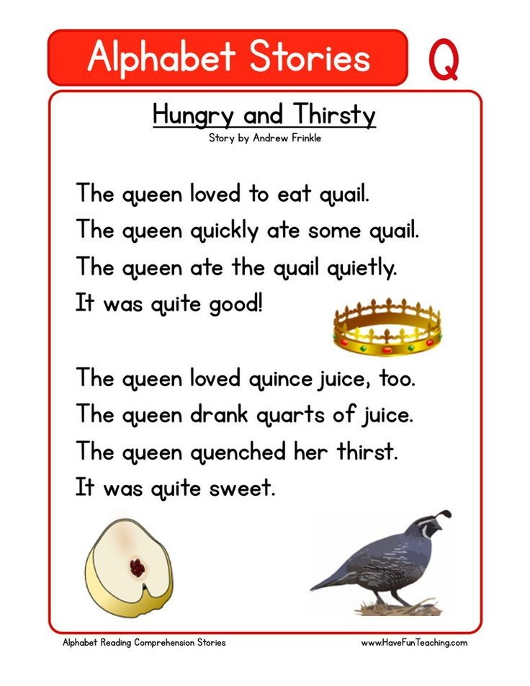

Sounds

|  |  |  |  |
| --- | --- | --- | --- |
| h | u | r | e |
| i | b | m | n |
| a | d |  |  |

Phonics word list

|  |  |  |  |  |
| --- | --- | --- | --- | --- |
| **qu**iet | **qu**ilt | **qu**izz | **qu**estion | **qu**een |
| **qu**ack | **qu**ick |  |  |  |

|  |
| --- |
|  |

Vocabulary words list

|  |  |  |  |
| --- | --- | --- | --- |
| book | fun | read | parents |
| page | turn | title | page number |
| gift | in love | dream | carry |

**Sight words list**

|  |  |  |  |
| --- | --- | --- | --- |
| next | work | pull | beetroot |