Name:
Grade: 1
Date:
Topic: Looking after facilities

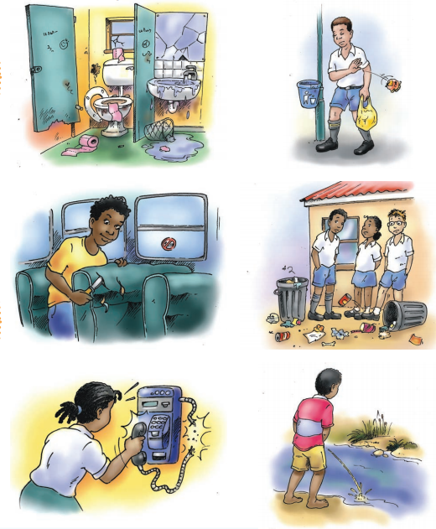
Look at these facilities in your community
Talk with your friend about the correct way of using them. Make sure there is social distance between you and your friend .

