**Date: 11 to 15 May 2020**

|  |  |  |  |  |
| --- | --- | --- | --- | --- |
| **SUBJECT** | **MATHEMATICS** | **GRADE** | **1** | **TERM 2** |
| **TIME ALLOCATION**  **1 hour** | **5** minutes for counting each day  **10** minutes for mental mathematics each day.  **45** minutes for the concept each day | **TIPS TO KEEP HEALTHY**  1. **WASH YOUR HANDS** thoroughly with soap and warm water for at least 20 seconds. Alternatively, use hand sanitizer with an alcohol content of at least 60%.  2. **PRACTICE SOCIAL DISTANCING** keep a distance of 1m away from other people.  3. **PRACTISE GOOD RESPIRATORY HYGIENE**: cough or sneeze into your elbow or tissue and dispose the tissue immediately after use.  4. **TRY NOT TO TOUCH YOUR FACE.** The virus can be transferred from your hands to your nose, mouth and eyes. It can then enter your body and make you sick.  5. **STAY AT HOME.** | | |
| **INSTRUCTIONS** | Use worksheets below  Use DBE workbook  Use relevant resources from home with caution |

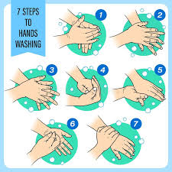 

**Day 1 and 2 Capacity and volume**

**Activity 1 Counting**

**Count real objects up to 20 (use any objects from home)**

**Count forwards in 1s and 2s from 0 to 40**

**Count backwards in 1s and 2s from 40 to 0**

**Count in 1s from 13 to 40**

**Count in 2s from 28 to 38**

**Count in 1s from 27 to 33**

**Activity 2 (a) Mental Mathematics**

|  |  |
| --- | --- |
| Which is less | Answer |
| 1. 3 or 8? |  |
| 1. 1 or 9? |  |
| 1. 2 or 10? |  |
| 1. 5 or 6? |  |
| 1. 9 or 0? |  |
| Which is more | Answer |
| 1. 4 or 7? |  |
| 1. 6 or 10 |  |
| 1. 9 or 6 |  |
| 1. 5 or 8? |  |
| 1. 7 or 0? |  |
| 1. 10 or 0? |  |

**Activity 2 (b) Mental Mathematics**

|  |  |  |
| --- | --- | --- |
|  | **What is?** | **Answer** |
| 1. | 1 more than 5? |  |
| 2. | 3 more than 2? |  |
| 3. | 6 more than 4? |  |
| 4. | 2 more than 7? |  |
| 5. | 0 more than 1? |  |
| 6. | 4 more than 1? |  |
| 7. | 5 more than 3? |  |
| 8. | 7 more than 1? |  |
| 9. | 10 more than 0? |  |
| 10. | 9 more than 1? |  |

**Activity 3**

**Circle the object that can hold more**

|  |  |
| --- | --- |
|  |  |
|  |  |
|  |  |

**Activity 4**

**Circle the objects that can hold less**

|  |  |
| --- | --- |
|  |  |
|  |  |
|  |  |

**Activity 5**

**Tick all the containers that are full**

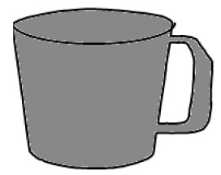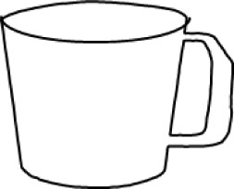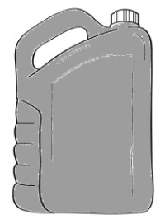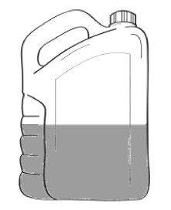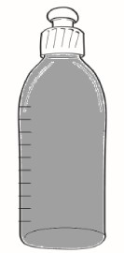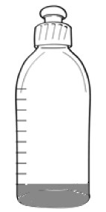

**Activity 6**

**DBE Workbook pages 78, 79, 84 and 85**

**Day 3 Addition up to 10 (Counting on strategy)**

**Activity 1 Counting**

Count real objects up to 20 (use any objects from home)

Count forwards in 1s and 2s from 0 to 40

Count backwards in 1s and 2s from 40 to 0

Count in 1s from 13 to 40

Count in 2s from 28 to 38

Count in 1s from 27 to 33

**Activity 2 Mental Mathematics**

**Use your number board that you designed in our last activity or refer to the one below**

|  |  |  |  |  |  |  |  |  |  |
| --- | --- | --- | --- | --- | --- | --- | --- | --- | --- |
| 1 | 2 | 3 | 4 | 5 | 6 | 7 | 8 | 9 | 10 |
| 11 | 12 | 13 | 14 | 15 | 16 | 17 | 18 | 19 | 20 |
| 21 | 22 | 23 | 24 | 25 | 26 | 27 | 28 | 29 | 30 |
| 31 | 32 | 33 | 34 | 35 | 36 | 37 | 38 | 39 | 40 |
| 41 | 42 | 43 | 44 | 45 | 46 | 47 | 48 | 49 | 50 |

* Point to any number that is more than 7
* How many more is your number is than 7? ________
* What number comes before your number? __________
* What is your number? ___________
* Point to any number that is less than 20
* How many less is your number is than 20? _______
* What number comes before your number? _______
* What is your number? _______
* I have a number that is smaller than 20, it is 3 more than 15.
* What is my number? _______
* Make your own games using more than, less than

**Activity 3 use a crayon to add 3 more objects**

|  |  |  |
| --- | --- | --- |
| **Objects** | **Draw 3 more** | **How many together?** |
| 0 0 0 0 0 |  |  |
| 0 0 0 |  |  |
| 0 0 0 0 0 0 0 |  |  |
| 0 |  |  |
| 0 0 0 0 |  |  |

**Activity 4 Count on, write the number**

**3 +** 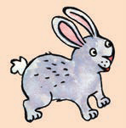   = _________

**5 +**      = _________

**4 +**  ****= ____________

**6 +**   = __________

**2 +**  __________

**7 +**    = _________

**Activity 5**

**DBE pages 94, 95**

**Day 4 Building up numbers**

**Activity 1 Counting**

Count real objects up to 20 (use any objects from home)

Count forwards in 1s and 2s from 0 to 40

Count backwards in 1s and 2s from 40 to 0

Count in 1s from 13 to 40

Count in 2s from 28 to 38

Count in 1s from 27 to 33

**Activity 2 Mental mathematics**

Circle the bigger number

* 8, 6, 2, 0, 3
* 3, 10, 8, 5, 4
* 8, 3, 10, 5, 7, 2
* 9, 3, 4, 8, 7, 2
* 0, 9, 10, 3, 4, 8
* 8, 3, 4, 2, 9
* 0, 10, 5, 8, 3
* 5, 9, 7, 3, 2
* 5, 9, 7, 10, 0
* 3, 4, 8, 0, 7

**Activity 2 (b) Mental Mathematics for 10 minutes**

Order these numbers from smallest to biggest

* 8, 3, 4, 2, 9 ___________________________________________________________
* 0, 10, 5, 8, 3

___________________________________________________________

* 5, 9, 7, 3, 2

__________________________________________________________

* 5, 9, 7, 10, 0

__________________________________________________________

* 3, 4, 8, 0, 7

___________________________________________________________

**Activity 3**

Write number sentence and give the correct answer

1.      +   =

**_______________________________ __________ = ______**

1.     + ******** = _________

**_____________________ + __________________ = _____________**

1.  +  = _____

**_____ + _____ = ______**

1.  +  = ______

**________________________________ + ______________= ________**

1.  +  = ______

**_____ + ___________________________________________________ = ________**

**Activity 4**

**Lets build 10**

* 1 + 9 = 10
* ___________________
* ___________________
* ___________________
* ___________________
* ___________________

**Activity 5**

Use playing cards or any objects to build 10 in many different ways

**Day 5 Geometric patterns**

**Activity 1 Counting**

Count real objects up to 20 (use any objects from home)

Count forwards in 1s and 2s from 0 to 40

Count backwards in 1s and 2s from 40 to 0

Count in 1s from 13 to 40

Count in 2s from 28 to 38

Count in 1s from 27 to 33

**Activity 2 Mental mathematics**

Circle the bigger number

|  |
| --- |
| 8, 6, 2, 0, 3, 10, 8, 5, 4, 8, 3, 10, 5, 7, 2, 9, 3, 4, 8, 7 |

How many

* 8s? _______
* 4s? _______
* 3s? ________
* 9s? ________

Which numbers are repeated 2 times? ______

**Activity 3 Geometric patterns**

1. **Copy this pattern**

2. **What is next?**

|  |  |
| --- | --- |
| _____ |  |
| ______ |  |
| _________ |  |

**Activity 4**

**DBE Workbook pages 136, 137**