Name:
Date:
Grade: 2
Topic: Working with soil

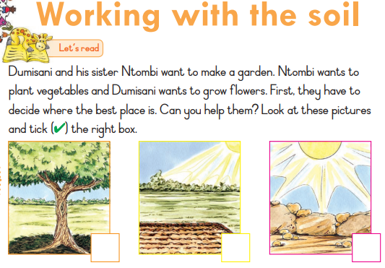

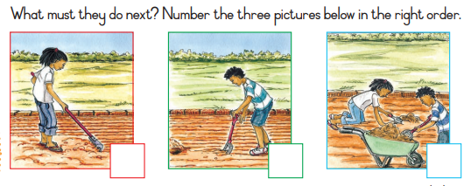
Answer the following questions
1. Who want to grow flowers?
2. Who want to make a vegetable garden?

