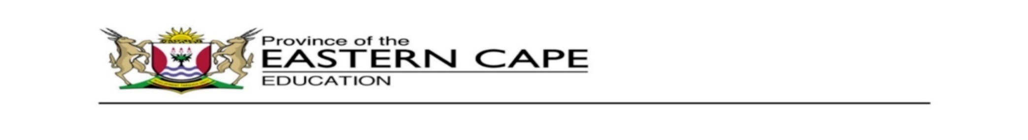

**DIRECTORATE: PRIMARY CURRICULUM MANAGEMENT**



|  |  |
| --- | --- |
| **17 - 21 AUGUST IBANGA 2** | |
| **Isakhono: Ukuphulaphula nokuthetha** |  |
| Jonga umfanekiso ongezantsi uze uphendule le mibuzo ilandelayo.   |  | | --- | |  |  1. Ucinga ukuba lingantoni ibali? 2. Ibizwa ngokuba yintoni le ndawo ame kuyo utata? 3. Inokuba ucinga ntoni lo tata? Nika isizathu sempendulo yakho. |  |
| **Isakhono: Isandi - dl** |  |
| Funda la magama, kwenziwe upelo**.**   |  | | --- | |  |  1. **edl**elweni 2. **dl**ula 3. i**dl**avu 4. isi**dl**o 5. isi**dl**ele   Bhalakule migca ilandelayo amanye amagama anesandi u**- dl**  6. _______________  7. _______________  8. **_______________** | Uluhlu lwama-gama |
| **Isakhono: Ukubhala ngesandla** |  |
| Bhala phezu kwala machaphaza.  ddddddd  dl dl dl  dlula isidlele idlakadlaka  Amathole ayadloba. | Ikhadi elibonisa ukubha  la ngesandla. |
| |  |  | | --- | --- | | **Isakhono: Ukubhala** |  | |  |
| 1. Khangela la magama angezantsi ebhokisini uze uwabiyele.  |  |  |  |  |  |  | | --- | --- | --- | --- | --- | --- | | Amagama axwesileyo | bodwa | enkosi | icawe | igadi | iholo | | Amagama ahlileyo | futhi | guqa | ibhasi |  |  |     2. Biyela igama elifanelekileyo kwisivakalisi ngasinye.  a) Usana (ludlala, ludlula) ngonopopi walo.  b) Ndibone imoto (idlala, idlula) ngendlela.  c) Nditye (isidlo, isidlele) sam kusasa.  3. Bhala la magama alandelayo ngendlela echanekileyo.   |  |  |  |  |  | | --- | --- | --- | --- | --- | | dle | i | le | si | isidlele | | be | i | ho |  |  | | zi | ntli | yo | i |  | | phe | i | pha |  |  | | ni | ca | e | we |  | | si | lo | i | ko |  | | bha | si | i |  |  | |  |
| |  |  | | --- | --- | | **Isakhono: Ukufunda** |  | |  |
| |  | | --- | | Umnqathe omkhulukazi  Umfama uNqaba wayelime imifuno esitiyeni sakhe. Yayilungile imifuno.  Wavuka ekuseni uNqaba wafaka iibhutsi, eza kuvuna. Wavuna zonke iitumato. Wavuna yonke ilethisi. Wavuna zonke iitapile. Wavuna iminqathe ... yonke, hayi!  Mnqathe uthile wawubambelele! Wazama uNqaba, watsala watsala! Wawumkhulu kakhulu umnqathe! Wabiza unkosikazi uNqaba ukuze bazame ukuwutsala. Wabambelela kuNqaba esinqeni unkosikazi, batsala. Wala umnqathe, wala!  Babiza unyana wabo ukuze bazame futhi. Wabambelela kumbhinqo kanina unyana, batsala. Wala umnqathe, wala!  Babiza ihagu ukuze bazame ukutsala nayo. Yema ngamanqina ayo ihagu yabambelela kunyana, batsala. Wala umnqathe, wala!  Babiza ikati ukuze bazame. Yatsiba ikati yabe sele kuhagu, batsala. Wala umnqathe, wala!  “Kudala sitsala. Mkhulu lo mnqathe! Babediniwe.  Ikati yabiza impuku ukuba babuye bazame. Impuku yeza izimisele yabambelela kukati. Bonke bazame, bazame, batsaaaaa-la...  Watsaleka umnqathe! “Bizani mna nanini na! Kucacile nina nonke, akukho zenu, watsho ngokuzithemba umpuku. | |  |

