Date: 28 to 29 April 2020

SUBJECT | Mathematics | GRADE | 2 | Concept: Numbers 41 to 50 (term 2 content)
TIME ALLOCATION  1 hour a day | 5 minutes for counting each day  10 minutes for mental mathematics  45 minutes for the concept each day. | TIPS TO KEEP HEALTHY  1. WASH YOUR HANDS thoroughly with soap and warm water for at least 20 seconds. Alternatively, use hand sanitizer with an alcohol content of at least 60%.  2. PRACTICE SOCIAL DISTANCING keep a distance of 1m away from other people.  3. PRACTISE GOOD RESPIRATORY HYGIENE: cough or sneeze into your elbow or tissue and dispose of the tissue immediately after use.  4. TRY NOT TO TOUCH YOUR FACE. The virus can be transferred from your hands to your nose, mouth and eyes. It can then enter your body and make you sick.  5. STAY AT HOME.
INSTRUCTIONS | Use worksheets below  Use DBE workbook  Use relevant resources from home with caution

Activity 1 counting (for 5 minutes)
Count forwards in 1s and 2s from 30 to 70
Count backwards in 1s and 2s from 70 to 30.
Count in 5s from 0 to 40.
Activity 2 (a) Mental Mathematics (10 minutes)
What is 1 less than |  | Answer |  | What is 1 more than |  | Answer
1. | 40 |  |  | 1. | 22
2. | 50 |  |  | 2. | 12
3. | 44 |  |  | 3. | 47
4. | 32 |  |  | 4. | 1
5. | 19 |  |  | 5. | 46

Activity 2 (b) Mental Mathematics
 | What is 2 more than: | Answer |  |  | What is 2 more than: | Answer
1. | 40 |  |  | 1. | 35
2. | 32 |  |  | 2. | 28
3. | 45 |  |  | 3. | 18
4. | 12 |  |  | 4. | 3
5. | 23 |  |  | 5. | 19

Activity 3
41, 42, 43, 44, 45, 46, 47, 48, 49, 50,
Look and say the numbers above
Answer the following questions;
- Circle the biggest number.
- Put a cross on the smallest number.
- Which number is between 43 and 45? __________________________
- Which number is one less than 48? ____________________________
- Which number is one more than 49? ____________________________
- Which number is two less than 43? ______________________________
- Which number is two more than 41? _____________________________
- Which two numbers are between 46 and 49? ______________________
- Which number comes after 44? _________________________________
- Which number comes before 50? ________________________________
Activity 4
What number is shown by these base ten blocks
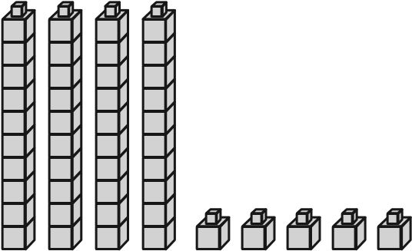 = ___________

= _____________
= _____________

= _________________
Activity 5
- Circle the odd numbers
41, 42, 43, 44, 45, 46, 47, 48, 49, 50,
- Arrange these numbers from the smallest to the biggest:
50, 45, 49, 41. ___________________________________
- Give four numbers that are smaller and five numbers that are bigger than 45.
41, 42, 43, 44, 45, 46, 47, 48, 49, 50,
_________________________ ____________________________
- Complete the pattern: 0, 5, ____, 15, 20, _____, _____, ______, ______, ______, 50.

Activity 6 Read and solve this word problem
My mother gave me 2 more marbles than my sister. My sister has 45 marbles. How many marbles do I have?

Activity 7
DBE workbook pages 70 and 71.

Date: 30 April 2020

SUBJECT | Mathematics | GRADE | 2 | Concept: Mass (term 2 content)
TIME ALLOCATION  1 hour | 5 minutes for counting  10 minutes for mental mathematics  45 minutes for the concept | TIPS TO KEEP HEALTHY  1. WASH YOUR HANDS thoroughly with soap and warm water for at least 20 seconds. Alternatively, use hand sanitizer with an alcohol content of at least 60%.  2. PRACTICE SOCIAL DISTANCING keep a distance of 1m away from other people.  3. PRACTISE GOOD RESPIRATORY HYGIENE: cough or sneeze into your elbow or tissue and dispose of the tissue immediately after use.  4. TRY NOT TO TOUCH YOUR FACE. The virus can be transferred from your hands to your nose, mouth and eyes. It can then enter your body and make you sick.  5. STAY AT HOME.
INSTRUCTIONS | Use worksheets below  Use DBE workbook  Use relevant resources from home with caution

Activity 1 counting (for 5 minutes)
Count forwards in 1s and 2s from 30 to 70
Count backwards in 1s and 2s from 70 to 30.
Count in 5s from 0 to 40.
Activity 2 mental Mathematics (for 10 minutes)

 | What is 3 more than: | Answer |  |  | What is 3 more than: | Answer
1. | 40 |  |  | 6. | 12
2. | 3 |  |  | 7. | 30
3. | 23 |  |  | 8. | 27
4. | 14 |  |  | 9. | 44
5. | 45 |  |  | 10. | 31

Activity 3
Make a balancing scale. Use a hanger from which you hang yoghurt tubs on either side.

- Put a table spoon on one side
- Estimate the number of beans that can balance it.
- Use the table below to record your measurement using non- standard measure
- Talk about which is lighter or heavier
 | Mass in beans
 | I estimate | I measure | Difference
Table spoon
Pencil
Toothbrush
Cup
?
?

Activity 4
Standard measures Kilograms (kg)
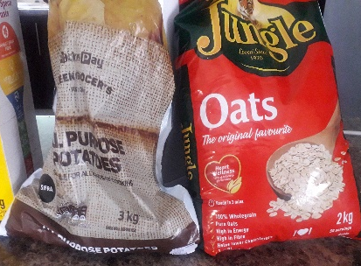
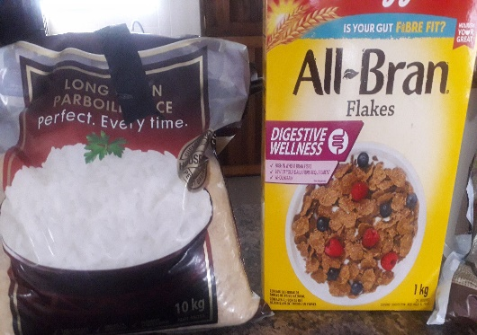
- Which product is heavier? ______________________
- Which is lighter? ______________________________
- What is the mass of these items altogether? ______________________________
- What is the mass of oats and potatoes altogether? _________________________
- What is the mass of rice? __________________________
Activity 5
Use a bathroom scale to get the mass of each member of the family.
What is your mass in kg?
Activity 6
DBE workbook page 93

