**GRADE: 2 MATHEMATICS Name: ____________________**

**Date: 25 to 29 May 2020**

|  |  |
| --- | --- |
| **TIME ALLOCATION (1 hour)**   * **5** minutes for counting each day * **10** minutes for mental mathematics each day. * **45** minutes for concept of the day. | **TERM 2 CONTENT** |
| **TIPS TO PARENT**   * Use worksheets below * Use DBE workbook * Use relevant real objects from home with caution. * Use correct mathematical language as indicated in the worksheets and DBE Workbook.     Maths: DBE LEARNER WORKBOOK English Grade 2 Book 2 | WCED ePortal | **TIPS TO KEEP HEALTHY**  1. **WASH YOUR HANDS** thoroughly with soap and warm water for at least 20 seconds. Alternatively, use hand sanitizer with an alcohol content of at least 60%.  2. **PRACTICE SOCIAL DISTANCING** keep a distance of 1m away from other people.  3. **PRACTISE GOOD RESPIRATORY HYGIENE**: cough or sneeze into your elbow or tissue and dispose the tissue immediately after use.  4. **TRY NOT TO TOUCH YOUR FACE.** The virus can be transferred from your hands to your nose, mouth and eyes. It can then enter your body and make you sick.  5. **STAY AT HOME.**  Cartoon Washing Hands Stock Illustrations – 1,188 Cartoon Washing ... **C:\Users\School EC\AppData\Local\Microsoft\Windows\INetCache\Content.MSO\82EAADC.tmp** |

**Day 1 2s PATTERN**

**Activity 1 Counting**

**Count real objects up to 20 (use any objects from home like beans, stones, bottle tops etc.)**

**Count forwards 2s, 5s and 10s from 0 to 100**

**Count backwards 2s, 5s and 10s from any number between 100 to 0**

**Activity 2 (a) Mental Mathematics**

|  |  |
| --- | --- |
| Double | Answer |
| 1. 4 |  |
| 1. 9 |  |
| 1. 6 |  |
| 1. 3 |  |
| 1. 1 |  |

**Activity 2 (b) Mental Mathematics**

|  |  |
| --- | --- |
| Half of | Answer |
| 1. 16 |  |
| 1. 4 |  |
| 1. 20 |  |
| 1. 12 |  |
| 1. 18 |  |

**Activity 3**

**Look at the following number board and answer the accompanying questions.**

|  |  |  |  |  |  |  |  |  |  |
| --- | --- | --- | --- | --- | --- | --- | --- | --- | --- |
| 1 | 2 | 3 | 4 | 5 | 6 | 7 | 8 | 9 | 10 |
| 11 | 12 | 13 | 14 | 15 | 16 | 17 | 18 | 19 | 20 |
| 21 | 22 | 23 | 24 | 25 | 26 | 27 | 28 | 29 | 30 |

1. Complete the pattern by colouring the multiples of **2**

2. Fill in the omitted numbers in a pattern

12, 14, ____, ____, 20, _____, ____, _____, 28, ______.

3. 7, ______, 11, _______, _______, 17.

**Activity 4**

**Looking at the hops on the following number lines, write the pattern represented**

a)

16 18 20 22 24

Counting forwards in __________ from _________ to ____________

b)

13 15 17 19 21 23

Counting forwards in _______ from __________ to ______________

**Activity 5**

**DBE Workbook pages 94 and 95**

**Day 2 GROUPS OF 2**

**Activity 1 Counting**

**Count real objects up to 20 (use any objects from home like beans, stones, bottle tops etc.)**

**Count forwards in 2s, 5s and 10s from 0 to 100**

**Count backwards in 2s, 5s, and 10s from any number between 100 and 0**

**Activity 2 Mental Mathematics**

|  |  |  |  |  |  |  |
| --- | --- | --- | --- | --- | --- | --- |
|  | **What is?** | **Answer** |  |  | **Add 2** | **Answer** |
| 1. | 2 more than 12? |  | 6. | 19 |  |
| 2. | 8 more than 7? |  | 7. | 7 |  |
| 3. | 9 more than 10? |  | 8. | 13 |  |
| 4. | 6 more than 8? |  | 9. | 16 |  |
| 5. | 5 more than 15? |  | 10. | 9 |  |

**Activity 3**

**Look at picture below and answer questions that follow**

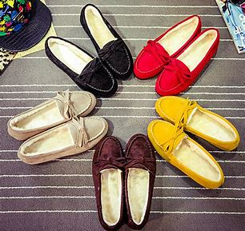



1. How many shoes are there? Count in twos. _____________________
2. Write the number sentence ____________________________________
3. How many groups of 2? _____________________________________
4. Double the number of black shoes

_____________________________________

**Activity 4**

I have 8 groups of 2 muffins on a tray, how many cupcakes are there altogether? ____________________________________

**Activity 5**

Dad has 28 balls. How many groups of 2 will he make?

_________________________________________________________________________________________________________________________________________________________________________________

**Day 3 MONEY**

**Activity 1 Counting**

**Count real objects up to 20 (use any objects from home like beans, stones, bottle tops etc.)**

**Count forwards in 2s, 5s and 10s from 0 to 150**

**Count backwards in 2s, 5s, and 10s from any number between 150 and 0**

**Activity 2 Mental Mathematics**

Give the number between (when counting in 2s)

* 13 and 17
* 9 and 13
* 10 and 14
* 8 and 12
* 2 and 6
* 13 and 15
* 15 and 13
* 10 and 6
* 11 and 7
* 20 and 16

**Activity 3**

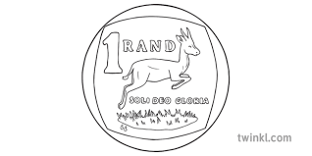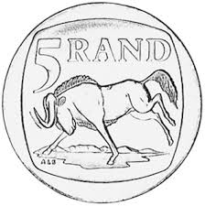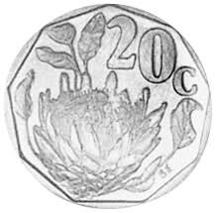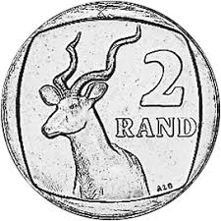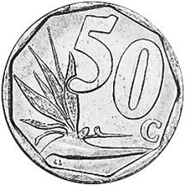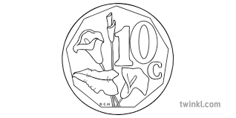

1. Add all the coins above ______________________________________________
2. Share the money equally between 2 children

_______________________________________________

1. Will there be any money left? ________________________

**Activity 4**

|  |
| --- |
|  |

**Break down this money into 4 different ways**

**____________________________________________________________________________________________________________________________________________________________________________________________________________________________________________**

**Activity 5**

1. **Share equally R9 among you and 2 children**

**____________________________________________________**

**____________________________________________________**

1. **Share equally R17 among 3 friends**

**__________________________________________________________________________________________________________________________________________________________________**

**Activity 6**

**DBE Workbook pages 100 to 101**

**Day 4 and 5 MONEY PROBLEMS**

**Activity 1 Counting**

**Count real objects up to 20 (use any objects from home like beans, stones, bottle tops etc.)**

**Count forwards in 2s, 5s and 10s from 0 to 150**

**Count backwards in 2s, 5s, and 10s from any number between 150 and 0**

**Activity 2 Mental Mathematics**

What is

* 20c + 20c + 20c? _____
* R1 + 50c + 10c? _____
* R2+ R5 + R10? _____
* 50c + 50c + 50c? _____
* R2, 30 + 20c + 10c? ______

Order these numbers from the smallest to the biggest

* R9, R14, R7, R16, R17 _________________________
* R15, R18, R9, R13, R8 __________________________
* R10, R14, R5, R13, R11 ________________________
* R12, R18, R20, R9, R15 ________________________
* R6, R14, R17, R8, R13 __________________________

**Activity 3**

1. **Joe spent 30c on sweets that cost 10c each. How many sweets did he buy? Show your calculations**

|  |
| --- |
|  |

1. **Sike’s taxi fare is R7, 50. How much change does she get when paying with R10? Show your calculations**

|  |
| --- |
|  |

1. **Miya spent R26,00 on food. She had R50. How much does she have?**

**Show your calculations**

|  |
| --- |
|  |

**Activity 4**

**DBE Workbook pages 102 and 103**