Date: 28- 29 April 2020

SUBJECT | Mathematics | GRADE | 3 | Concept: Numbers 301 to 500 (term 2 content)
TIME ALLOCATION  1 hour | 5 minutes for counting  10 minutes for mental mathematics  45 minutes for the concept each day | TIPS TO KEEP HEALTHY  1. WASH YOUR HANDS thoroughly with soap and water for at least 20 seconds. Alternatively, use hand sanitizer with an alcohol content of at least 60%.  2. PRACTICE SOCIAL DISTANCING keep a distance of 1m away from other people.  3. PRACTISE GOOD RESPIRATORY HYGIENE: cough or sneeze into your elbow or tissue and dispose of the tissue immediately after use.  4. TRY NOT TO TOUCH YOUR FACE. The virus can be transferred from your hands to your nose, mouth and eyes. It can then enter your body and make you sick.  5. STAY AT HOME.
INSTRUCTIONS | Use worksheets below  Use DBE work book  Use relevant resources from home with caution
Activity 1 (counting) 5 minutes
Count forwards in 100s from 0 to 500
Count backwards in 10s from 100 to 0

Activity 2 (a) Mental Mathematics (orally for 10 minutes)
 | Give the number/s between: | Answer |  |  | Give the number/s between: | Answer
1. | 457 and 460 |  |  | 6. | 51 and 54?
2. | 300 and 298? |  |  | 7. | 500 and 497?
3. | 51 and 54? |  |  | 8. | 487 and 490
4. | 207 and 204? |  |  | 9. | 124 and 126?
5. | 45 and 48? |  |  | 10. | 101 and 98?

Activity 2 (b) Mental Mathematics (written for 10 minutes)
 | Arrange these numbers from the biggest to the smallest | Answer |  |  | Arrange these numbers from the biggest to the smallest | Answer
1. | 78, 105, 98, 305, 2 |  |  | 5. | 154, 210, 87, 95
2. | 89, 54, 102, 305 |  |  | 6. | 45, 78, 102, 421
3. | 368, 500, 487, 120 |  |  | 7. | 87, 35, 201, 50, 62
4. | 78, 54, 105, 307 |  |  | 8. | 78, 105, 48, 352

Activity 3 Example of using base 10 blocks
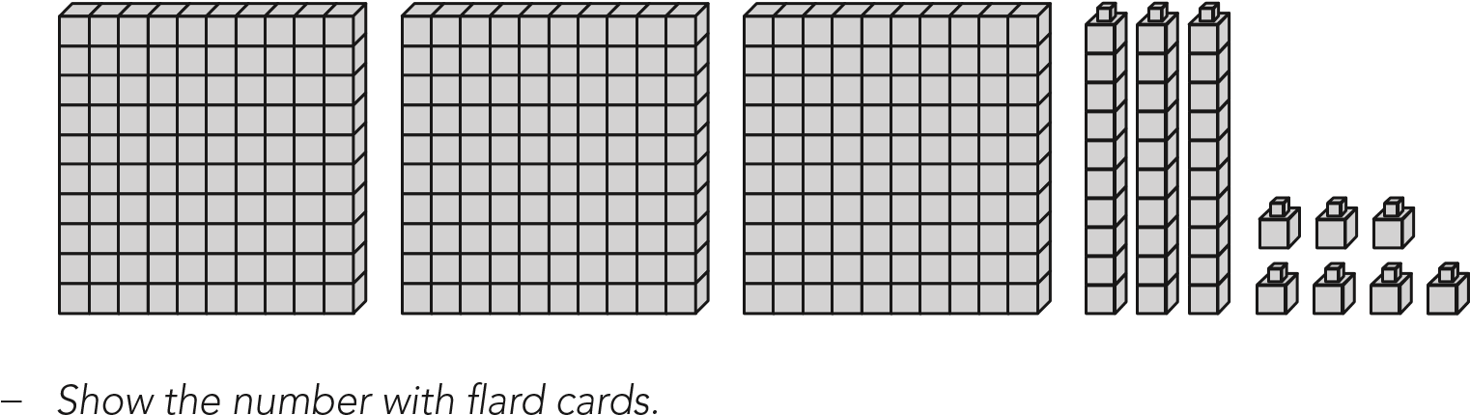
3 | 0 | 0 |  | 3 | 0 |  | 7 |  | 3 | 3 | 7

Write the correct numbers (shown by the base blocks) on the empty boxes

Activity 4
Compare these numbers what is equal and what is bigger or smaller?
For example: 348 and 392
- hundreds are equal (300),
- the other one has 4 tens (40) and the other has 9 tens (90)
- 392 is bigger than 392
405 and 290
- __________________________________________________
- __________________________________________________
- __________________________________________________
460 and 350
- _______________________________________________
- ________________________________________________
- _________________________________________________
Activity 5
Write number sentences
- 300 and 80 and 1 _______________________
- 400 blocks, 20 blocks and 9 blocks _______________________________
- 200 and 4 ___________________________
Activity 6
Write number names for these number symbols
- 233 _________________________________________________________
- 264 _________________________________________________________
- 208 _________________________________________________________
Activity 7
DBE workbook pages 100 and 101.

Date: 30 April 2020

SUBJECT | Mathematics | GRADE | 3 | Concept: Ordinal numbers 200- 500 (term 2 content)
TIME ALLOCATION  1 hour | 5 minutes for counting  10 minutes for mental mathematics  45 minutes for the concept each day | TIPS TO KEEP HEALTHY  1. WASH YOUR HANDS thoroughly with soap and water for at least 20 seconds. Alternatively, use hand sanitizer with an alcohol content of at least 60%.  2. PRACTICE SOCIAL DISTANCING – keep a distance of 1m away from other people.  3. PRACTISE GOOD RESPIRATORY HYGIENE: cough or sneeze into your elbow or tissue and dispose of the tissue immediately after use.  4. TRY NOT TO TOUCH YOUR FACE. The virus can be transferred from your hands to your nose, mouth and eyes. It can then enter your body and make you sick.  5. STAY AT HOME.
INSTRUCTIONS | Use worksheets below  Use DBE work book  Use relevant resources from home with caution
Activity 1 (counting) 5 minutes
Count forwards in 10s from 0 to 500
Count backwards in 10s from 100 to 0
Activity 2 Mental Mathematics (oral)
- How many months are there in a year?
- Which is the fourth month of the year?
- Which is the 7th month of the year?
- Who is the 1st child in your home?
- Who is second child in your home?
Activity 2 (b) Mental Mathematics (oral)
- Which animal is the first?
- Which animal is the 2nd?
- Which animal is the last?
- Which animal is standing between the horse and the rooster?
Activity 3
Use the number grid below to answer these questions
201 | 202 | 203 | 204 | 205 | 206 | 207 | 208 | 209 | 210
211 | 212 | 213 | 214 | 215 | 216 | 217 | 218 | 219 | 220
221 | 222 | 223 | 224 | 225 | 226 | 227 | 228 | 229 | 230
231 | 232 | 233 | 234 | 235 | 236 | 237 | 238 | 239 | 240
241 | 242 | 243 | 244 | 245 | 246 | 247 | 248 | 249 | 250
251 | 252 | 253 | 254 | 255 | 256 | 257 | 258 | 259 | 260
261 | 262 | 263 | 264 | 265 | 266 | 267 | 268 | 269 | 270
271 | 272 | 273 | 274 | 275 | 276 | 277 | 278 | 279 | 280
281 | 282 | 283 | 284 | 285 | 286 | 287 | 288 | 289 | 290
291 | 292 | 293 | 294 | 295 | 296 | 297 | 298 | 299 | 300

- What is the first number?
- What is the second number?
- Colour red 10th, 20th, 30th 40th and 50th numbers.
- What is the 10th number after 260?
Activity 4
301, 302, 303, 304, 305, 306, 307, 308, 309, 310
- What is the fifth number?
- What is ninth number?
- What could be the 30th number?
Activity 5
420, 421, 422, 423, 424, 425, 426, 427, 428, 429, 430
- What is the 3rd number after 421?
- What is 8th number?
- What numbers are between the fourth and the 10th numbers?
Activity 6
DBE workbook pages 82 and 83.

