**Date: 20- 24 April 2020**

|  |  |  |  |  |
| --- | --- | --- | --- | --- |
| **SUBJECT** | Mathematics | **GRADE** | **1** | **Concept: Numbers 6 and 7 (term 2 content)** |
| **TIME ALLOCATION** | 5 minutes for counting  10 minutes for mental mathematics  45 minutes for each number from 6 to 7 | **TIPS TO KEEP HEALTHY**  1. **WASH YOUR HANDS** thoroughly with soap and water for at least 20 seconds. Alternatively, use hand sanitizer with an alcohol content of at least 60%.  2. **PRACTICE SOCIAL DISTANCING** – keep a distance of 1m away from other people.  3. **PRACTISE GOOD RESPIRATORY HYGIENE**: cough or sneeze into your elbow or tissue and dispose of the tissue immediately after use.  4. **TRY NOT TO TOUCH YOUR FACE.** The virus can be transferred from your hands to your nose, mouth and eyes. It can then enter your body and make you sick.  5. **STAY AT HOME.** | | |
| **INSTRUCTIONS** | Use worksheets below  Use DBE workbook  Use relevant resources from home with caution |

**Activity 1 (counting) 5 minutes**

Count real objects forwards in 1s and 2s from 0 to 20

Count real objects backwards in 1s and 2s from 20 to 0.

|  |  |
| --- | --- |
| **Objects** | **How many?** |
|  |  |
|  |  |
|  |  |

**Activity 2 Mental Mathematics for 10 minutes**

|  |  |  |  |
| --- | --- | --- | --- |
| **Which is less?** | **Answer** | **Which is more?** | **Answer** |
| **1 or 9?** |  | **10 or 9?** |  |
| **7 or 5?** |  | **6 or 8?** |  |
| **3 or 10?** |  | **5 or 1?** |  |
| **4 or 6?** |  | **4 or 0?** |  |
| **8 or 2?** |  | **2 or 7?** |  |

**Activity 3**

**     **

* Count how many strawberries
* Can you describe the number 6 (what can you say about 6?)

(6 is 1 more than 5, 2 more than 4 etc.)

**Activity 4**

**Number symbol 6**

* Say **‘6’** for 3 times
* Point number 6
* Look at how the number 6 is written
* Use your finger to trace it correctly

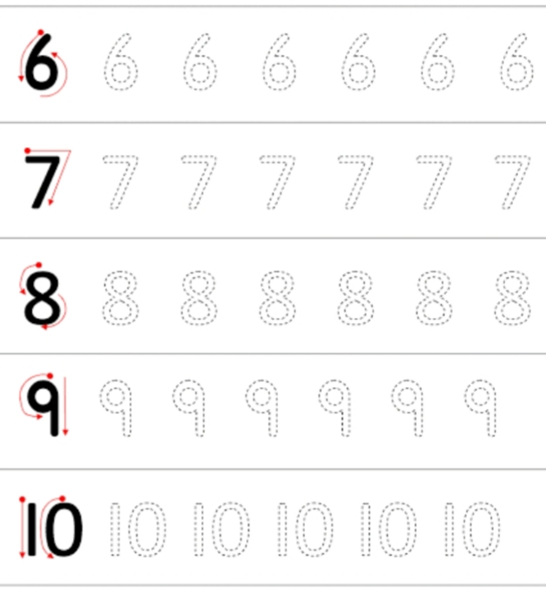

* Write 6 on the air
* Write 6 on the sand
* Use your pencil to trace number 6 (above)

**Activity 5**

**Number name Six**

* Look and say six for 3 times
* Point to the number name six
* Look at how six is written

**Six Six Six Six**

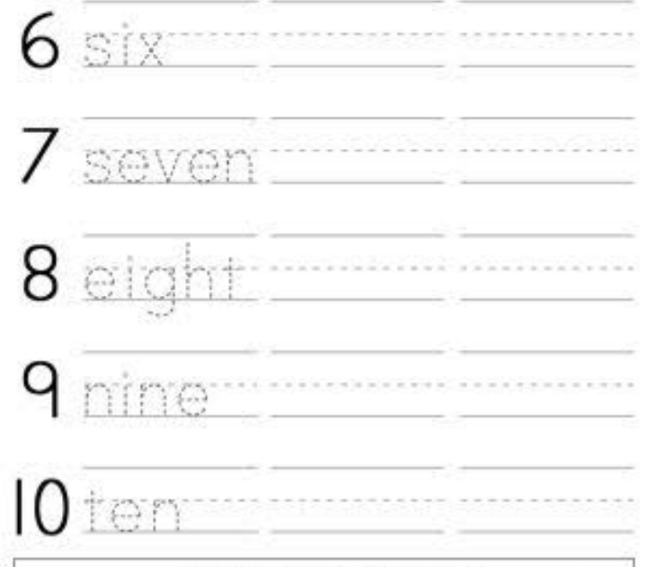

* Write the number name six on the air
* Write it on the sand
* Write it on your paper

**Activity 6**

Use your own objects and paper to do this activity

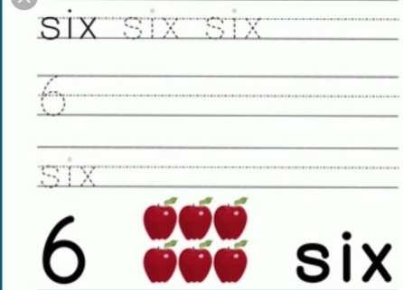

**Activity 7**

**DBE work book pages 70, 71**

**Activity 8**

**      **

* Count how many strawberries
* Can you describe the number 7 (what can you say about 7?)

(7 is 1 more than 6, 3 more than 4 etc.)

**Activity 9**

**Number symbol 7**

* Say **‘7’** for 3 times
* Point number 7
* Look at how the number 7 is written
* Use your finger to trace it correctly



* Write 7 on the air
* Write 7 on the sand
* Use your pencil to trace number 7 (above)

**Activity 10**

**Number name Seven**



* Look and say seven for 3 times
* Point to the number name seven
* Look at how seven is written

**Seven Seven Seven Seven**

* Write the number name seven on the air
* Write it on the sand
* Write it on your paper

**Activity 11**

* Use your own objects and paper to do this activity

**7**          **Seven**

**Activity 12**

**DBE workbook pages 72, 73**

**Date: 22- 24 April 2020**

|  |  |  |  |  |
| --- | --- | --- | --- | --- |
| **SUBJECT** | Mathematics | **GRADE** | **1** | **Concept: Numbers 8, 9 and 10 (term 2 content)** |
| **TIME ALLOCATION** | 5 minutes for counting  10 minutes for mental mathematics  45 minutes for each number from 8 to 10 | **TIPS TO KEEP HEALTHY**  1. **WASH YOUR HANDS** thoroughly with soap and water for at least 20 seconds. Alternatively, use hand sanitizer with an alcohol content of at least 60%.  2. **PRACTICE SOCIAL DISTANCING** – keep a distance of 1m away from other people.  3. **PRACTISE GOOD RESPIRATORY HYGIENE**: cough or sneeze into your elbow or tissue and dispose of the tissue immediately after use.  4. **TRY NOT TO TOUCH YOUR FACE.** The virus can be transferred from your hands to your nose, mouth and eyes. It can then enter your body and make you sick.  5. **STAY AT HOME.** | | |
| **INSTRUCTIONS** | Use worksheets below  Use DBE workbook  Use relevant resources from home with caution |

**Activity 1 (counting) 5 minutes**

Count real objects forwards in 1s and 2s from 0 to 20

Count real objects backwards in 1s and 2s from 20 to 0.

|  |  |  |
| --- | --- | --- |
| **Objects** | **How many?** | **Number name** |
|  |  |  |
|  |  |  |
|  |  |  |

**Activity 2 (a) Mental Mathematics for 10 minutes**

**Draw less**

|  |  |  |
| --- | --- | --- |
|  | **5 less** |  |
|  | **2 less** |  |
|  | **1 less** |  |

**Activity 2 (b)**

* **Which number is 1 more than 5? __________________**
* **Which number is 2 more than 4? __________________**
* **Which number is 3 less than 4? ____________________**
* **Which number is 3 more than 4? ___________________**
* **Which number is 3 less than 10? ___________________**

**Activity 3 Number 8**

**       **

* Count how many watches
* Can you describe the number 8 (what can you say about 8?)

(8 is 1 more than 7, 2 more than 6 etc.)

**Activity 4**

**Number symbol 8**

* Say **‘8’** for 3 times
* Point number 8
* Look at how the number 8 is written
* Use your finger to trace it correctly



* Write 8 on the air
* Write 8 on the sand
* Use your pencil to trace number 8 (above)

**Activity 5**

**Number name eight**

* Look and say eight for 3 times
* Point to the number name eight
* Look at how eight is written

**Eight eight eight eight**



* Write the number name eight on the air
* Write it on the sand
* Write it on your paper

**Activity 6**

DBE workbook pages 74 and 75

**Activity 7**

Number 9

**…………………………………**

* Count how many books _____________________
* How many more books do we need to make 9 books? _________________

** **

* Count how many books now ___________________
* There are 9 books

What can you tell about 9?

**Activity 8**

**Number symbol 9**

* Say **‘9’** for 3 times
* Point number 9
* Look at how the number 9 is written
* Use your finger to trace it correctly



* Write 9 on the air
* Write 9 on the sand
* Use your pencil to trace number 9 (above)

**Activity 9**

**Number name nine**

* Look and say nine for 3 times
* Point to the number name nine
* Look at how nine is written
* **Nine nine nine nine**



* Write the number name nine on the air
* Write it on the sand
* Write it on your paper.

**Activity 10**

DBE workbook pages 76 and 77.

**Activity 11**

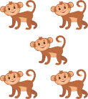

* Count and circle 10 animals
* How many more animals are out of the circle?

**Activity 12**

**Number symbol 11**

* Say **‘10’** for 3 times
* Point number 10
* Look at how the number 10 is written
* Use your finger to trace it correctly



* Write 10 on the air
* Write 10 on the sand
* Use your pencil to trace number 10 (above)

**Activity 12**

**Number name ten**

* Look and say ten for 3 times
* Point to the number name ten
* Look at how ten is written

**Ten ten ten ten**



* Write the number name ten on the air
* Write it on the sand
* Write it on your paper.

**Activity 13**

**DBE workbook pages 80 and 81.**