GRADE R THEME: SIGHT DATE: 18-22/05/2020
Keep yourself healthy
- Wash your hands before you eat with soap and water for at least 20 seconds.
- seconds.
- Frequently clean the toys/resources used by children.
- Practice social distancing at all times.
- When sneezing /coughing use your elbow/tissue and dispose it.

MATHEMATICS | ACTIVITY | GRADE R  DBE WORKBOOK 2
 | ACTIVITY 1 COUNTING NUMBERS, OPERATIONS & RELATIONSHIPS
Reinforce the knowledge gained of the meaning of the number 4
- Rote count from 1-7 (rhymes and songs)
- Count everyday objects up to 4
- Count forwards and backwards up to 4.

 | ACTIVITY 2 NUMBERS SYMBOLS AND NAMES
- Show the child a flash card with number symbol 4. Let him match the number symbol with the number name four.
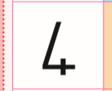
- Let the child make the number 4 from modelling clay.

 | ACTIVITY 3 NUMBERS SYMBOLS AND NAMES
 | Use page 35 of the DBE Workbook 2.  Colour in 4 flowers and use different crayons. | 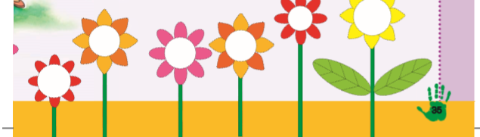
 | ACTIVITY 4 NUMBERS,OPERATIONS AND RELATIONSHIPS
 | Use page 40 of the DBE Workbook 2.  - Count the items and colour in the corresponding number of dots.  - Trace the correct number using your finger. | 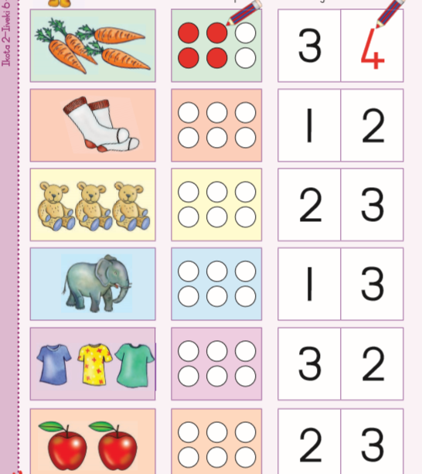
HOME LANGUAGE | ACTIVITY 1 LISTENING AND SPEAKING
 | Rhyme: Do the following rhyme with the child  I have two eyes  How about you  I have two eyes  How about you  I have two eyes  What about you  Blink with your eyes like I do | .
 | ACTIVITY 2 LISTENING AND SPEAKING
DBE Workbook page 34
- Begin by letting him/her to look at the picture and use the following guiding questions:
- What can you see in the picture?
- How may dogs can you see behind the tree?
- What else can you see?
- What do you see in the tree?
- Name the part of the body that help us to see words when ‘’reading’’a book.
- Let the child tell his/her own story and listen attentively.
 | ACTIVITY 2 EMERGENT WRITING
- The child traces the letter with his/her finger.
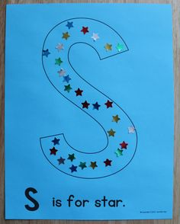
- Practice the letter ‘’s’’ using the bottle tops/stones/beads/wool/strings.
- Practice ‘’writing’’ the letter ‘’s’’ in a sand tray.
 | ACTIVITY 3 PHONEMIC AWARENESS
The (s) sound:
- The child must make the sound /s/ clearly and tell her /him to watch your mouth as you make the sound.
- Teach the child an action associated with the sound /s/ (she must use her/his body)
- Ask the child to listen what sounds do you hear in the beginning of these words:
Socks, stars, salt, soap,sun,seal. Refer to page 9 DBE Workbook 2
- Let the child give 3 examples of the words that start with ‘’s’’.
- Identify the ‘’s’’ sound from the environment.

LIFE SKILLS | ACTIVITY 1 BEGINNING KNOWLEDE AND PERSONAL WELL-BEING
Discussion
- Discuss with the child the weather of the day; sunny/windy/rainy.
- Talk about the body part “eyes” that let us see different things.
- What do you do with your eyes? I see with my eyes.
- How do we protect our eyes?
 | ACTIVITY 2 PERFORMING ARTS
Help the child in doing the rhyme (include actions).
I have two eyes
How about you
I have two eyes
How about you
I have two eyes
What about you
Blink with your eyes like I do

 | DBE workbook 2 page 36  Match the actions to the correct sense and find the stickers.. | 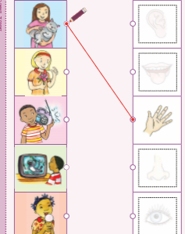

Ukuzigcina ukhuselekile
- Hlamba iizandla rhoqo ngamanzi nesepha phambi kokutya
- Ngalo lonke ixesha coca izinto zakho zokudlala/izixhobo zokufunda.
- Gada umgama phakathi kwakho nomntu okufutshane kuwe.
- Xa uthimla/ukhohlela sebenzisa itshefu/iphepha lokufinya uze ulilahle wakuqiba.

MATHEMATIKA | UMSEBENZI | INCWADI YOKUSEBENZA YESI-2
 | UMSEBENZI 1 UKUBALA AMANANI IOPERAYISHINI NOLWALAMANO
Ukubethelela ingqiqo yenani u- 4
- Qikelela uze ubale usuke ku-1 ukuya ku-7(usebenzisa isicengcelezo/ingoma yokubala)
- Yazi, uqaphele isimboli zamanani, uqaphele namagama amanani ukusuka ku1-4
- Bala usiya phambili usuke ku 1ukuya ku 4
- Bala ubuya umva usuke ku 4-1

 | UMSEBENZI 2 ISIMBOLI YENANI NEGAMA LENANI
- Bonisa umntwana isimboli yenani u-4. Nxulumanisa isimboli u-4 negama lenani u-ne.
- Umntwana makakhe inani u-4 esebenzisa umdongwe.

 | UMSEBENZI ISIMBOLI YENANI NEGAMA LENANI
Sebenzisa iphepha 35 le ncwadi yokusebenzela yesi-2 DBE.

Faka umbala kwizinto ezine usebenzise iikhrayoni ezohlukileyo.

 | UMSEBENZI 1 UKUBALA AMANANI IOPERAYISHINI NOLWALAMANO
Sebenzisa iphepha 40 le ncwadi yokusebenzela yesi-2 DBE.

- Bala izinto ,ufake umbala kumachokoza alingana nenani elichanekileyo
- Cinezela inani elichanekileyo usebenzisa umnwe wakho.
ISIXHOSA | UMSEBENZI 1 UKUPHULAPHULA NOKUTHETHA
 | Isicengcelezo: Ncedisa umntwana ekwenzeni isicengcelezo/iculo.  Ndinamehlo amabini  Anjani awakho  Ndinamehlo amabini  Anjani awakho  Ndinamehlo amabini  Anjani awakho  Qhwanyaza ngamehlo akho njengam | .
 | UMSEBENZI 1 UKUPHULAPHULA NOKUTHETHA
 | Sebenzisa iphepha 34 le ncwadi yokusebenzela yesi-2 DBE  - Qala ngokunika umntwana ithuba lokuqwalasela umfanekiso uze usebenzise le mibuzo ikhokhelayo:  - Ubona ntoni emfanekisweni?  - Zingaphi izinja ozibonayo emva komthi?  - Yintoni enye oyibonayo?  - Ubona ntoni emthini?  - Chaza ilungu elisincedisa ekubeni sikwazi ukubona amagama xa ‘’sifunda’’.  - Nika umntwana ithuba lokubalisa elakhe ibali ummamele ngenyameko. | 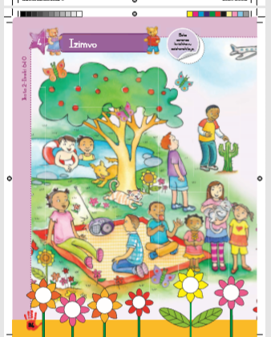
 | UMSEBENZI 2 UKUBHALA OKUPHUHLISWAYO
- Umntwana makasebenzise umnwe wakhe ukucinezela unobumba u ‘’a’’ enga uyabhala.
- Makakhe unobumba u ‘’a’’ ngeziciko zebhotile/amatye/amaso/iwulu/intambo
- Makazame ‘’ukubhala’’ unobumba esebenzisa itreyi yesanti.
 | UMSEBENZI 3 IZANDI
Isandi u’’a’’:
- Umntwana makenze isandi u/a/ ngokucacileyo ekuqwalasele emlonyeni indlela osibiza ngayo isandi.
- Fundisa umntwana indlela engqinelana nesandi /a/ (makasebenzise umzimba wakhe)
- Yalela umntwana amamele isandi asiva ekuqaleni kwalamagama:
Amakhwenkwe,amanzi,amahobe.
- Makanike imizekelo emithathu yamagama aqala ngo ‘’a’’.
- Makaqaphele isandi u ‘’a’’ kwintlalo yakhe.

IZAKHONO ZOBOMI | UMSEBENZI 1 ISIHLOKO: UKUBONA ULWAZI OLUSISISEKO
Ingxoxo
- Xoxa nomntwana ngemozulu yosuku/kushushu/kuyanetha /kunomoya.
- Xoxa ngamalungu omzimba “amehlo” asenza sibone izinto ezahlukeneyo.
- Wenza ntoni ngamehlo akho? Ndiayabona ngamehlo am.
- Singawakhusela njani amehlo ethu?
UMSEBENZI 2 UBUGCISA OBENZIWA EQONGENI
Ncedisa umntwana ekwenzeni isicengcelezo/iculo.
Ndinamehlo amabini
Anjani awakho
Ndinamehlo amabini
Anjani awakho
Ndinamehlo amabini
Anjani awakho
Qhwanyaza ngamehlo akho njengam
Sebenzisa incwadi yesi-2 yokusebenzela iphepha 36 (DBE)

Krwela umgca ukuze utshatise isenzo kunye nezivo oza kuzisebenzisa

