IBANGA - 5
INOVELI
IMIZUZU: 30
Bhota mfundi-ntsapho
Qaphela:

- Injongo yesifundo: Ufundisa abafundi indlela yokufunda inoveli ngononelelo bafumane ulwazi ngomxholo wenoveli

- Okuqulathwe yitekisi:

- Isihloko senoveli
- Imifanekisi kwinoveli
- Umxholo obhaliweyo wenoveli
- Imibuzo ebuzwa kumfundi mayibonakalisa amazinga okuqiqa ngokukaCAPS ( iphepha 95-96)

UTATA UFUMENE UMSEBENZI OMTSHA

Isahluko sokuqala: Isigqibo

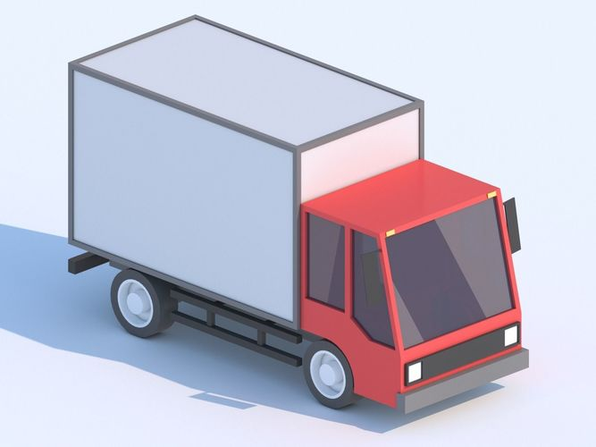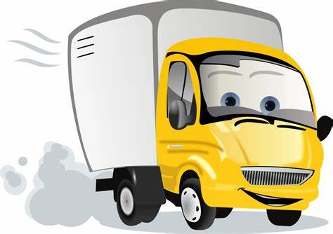
Utata ufumene umsebenzi omtsha wobunqununu besikolo phezu kolwandle eHlamvana eSajonisi, kude kakhulu nelali yam iMgagasi eGcuwa. Qho ngeeCawa bekufuneka athathe inqwelo yakhe enjenjeya ukuya eSajonisi eshiya yonke into ngasemva kuba eya kubuya ngolwesiHlanu. Ubuye umbone ngeCawa ukuba akonwabanga kuba kufuneka ashiye izinto abe ezenza engazigqibanga.
Ngenye imini ndamva ethetha nomama esithi “ MaZulu ndigqibe kwelokuba ndifune inxiwa eBholani kwilali yaseHlamvana ukuze sihambe sonke siye kuhlala khona.” Umama wothuka wabuza imibuzo, kodwa utata wayiphendula yonke. Inene utata wasibiza silusapho lwakhe wasixelela ukuba uza kwakha ikhaya lethu elitsha eBholani eSajonisi. Ndaqala ndavuya kodwa ndathi ndakucinga ngabahlobo bam endiza kubashiya ngasemva lwaphela ulonwabo ndabanexhala lokuba ndiza kuba lilolo eBholani.
Usuke utata wamana engabuyi ngeempelaveki koko umama ahambe aye eBholani abuye ngeCawa kuba eza kulungisa izinto zethu zesikolo. Le nto yokuba utata emana engabuyi yathatha ithuba elingangonyaka. Kuthe kweyoMqungu ngonyaka ka-2017 utata wabuya ngolwesiHlanu wasibiza sonke wasixelela ukuba kufike ixesha lokuba sihambe eMgagasi siye kuhlala kwikhaya lethu elitsha eBholani. Savuya sivuyela ukubona indawo entsha kodwa saphinda safikelwa luloyiko lokuba sizibuza ukuba azi yindawo enjani na.
Ngentsasa yangoMgqibelo umhla wama-28 ngenyanga yoMqungu kwafika iilori ezinkulu ezimbini kwathiwa masilayishe impahla yendlu neempahla zethu zokunxiba. Zange zonele impahla zasekhaya kwezo nqwelo, kwaze kwafuneka ukuba zimana zithuthwa kuloo veki zade zagqitywa.
Isahluko sesibini : Ilali yasebholani

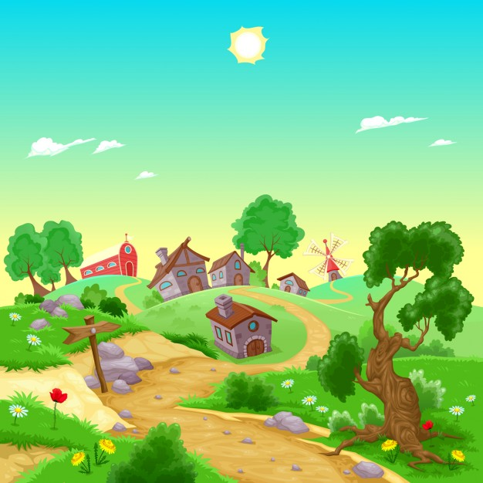
Ngexesha sithutha sisiya kuhlala eBholani saphelekwa ngutata omncinci nomalume nabo bethwele ezinye izinto ngeeveni zabo. Sasizibuza ukuba yintoni na edale utata athathe isigqibo sokushiya izizalwane zakhe eGcuwa akhethe ukuya kuma kwelamaMpondo indawo ekude kangako.
Sadlule iidolophu ezintathu phambi kokuba sifike eBholani kwilali yaseHlamvana. Sadlula iDutywa, uMthatha neLibode saze sathi xa sikude kufuphi nedolophu yaseSajonisi saphambuka eThombo sijonge elwandle. Wonke umntu wayeza kuqala ukuyibona le ndawo ngaphandle kukatata nomama. Sathi sakungena eThombo utata wayolatha ilali ephezu kwenduli esithi yiBholani ke leya. Ilanga lalo mini lalipholile kukho impepho yomoya etsho kamnandi esuka elwandle.
Le lali yaseBholani imi phezu kwelali yaseDumasi kumhlaba wamaNcamani. Intloko yayo iqamele ngentaba uMahintsho zaze iinyawo zayo zanabela kumfula iMbazwa kunye nomfula iTyuwa. Le yilali evelele uhola wendlela osuka kwidolophu yaseMthatha usiya eSajonisi. IBholani inemizi engemininzanga kuyaphi. Eyona nto ebalaseleyo kule lali ziziqhamo ezikhoyo kumzi nomzi. Yonke imizi yale lali inomthi webhanana nowegwava kwakunye neminye ke efana nemithi yee-orenji, iimengo iipesika njalo njalo.
Iigadi zalapha zonke zinombona omtsha kwaye ilali ingqongwe sisinga, amasimi kunye namatyholo. Xa ulahla amehlo jikelele kule ndawo kuhle kuluhlaza kukho imifula exhase le lali, umfula iMbazwa otyekezela elwandle kunye nomfula iTyuwa otyekezela eMngazi umlambo omkhulu ophaya emazantsi elali. UMngazi wondla zonke ezo lali zamaNcamani wenza loo majikojiko apha phakathi kwazo uze uye kutyekeza elwandle.
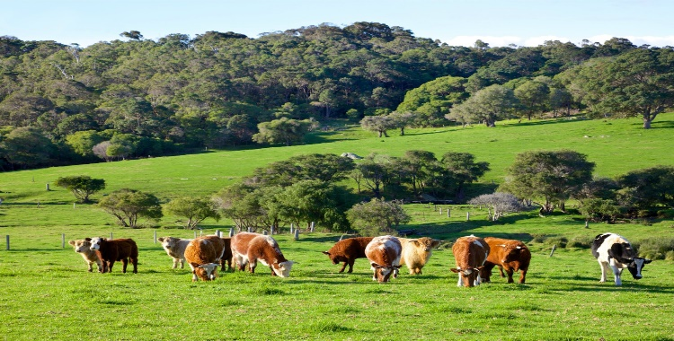

Imfuyo yalapha ziibhokhwe ezityebe kunene ezitya kuloo matyholo kunye neenkomo ezitya ingca ende yale ndawo. Iigusha esiziqhele eMgagasi azibonakali kwaphela. Wena wakhe wawubona umfanekiso welali ezotywe encwadini yayinjalo ke le lali.

Isahluko 3: Ikhaya lethu elitsha

Sahamba kuloo majikojiko endlela aphezu komfula uThuthumelana ukusuka eThombo sisiya eBholani sade safika ezinyaweni zale lali iqabela induli. Kwakukuhle kuluhlaza yaka yimithi neentyatyambo. Iintaka zehlobo zazintyiloza kamnandi. Sasigqitha ebantwini basijonge kuba iinqwelo zethu zazibonakala ukuba zezabantu abathuthayo.
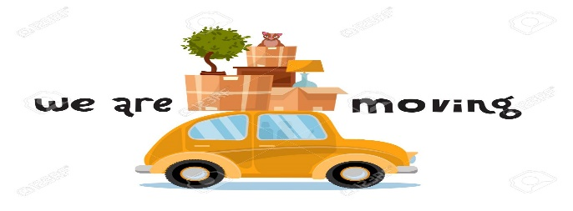
Yavakala enye inkwenkwe isithi, “Akusiyiyo imoto katitshala omkhulu nale?” “Yiyo” wangqina ugxa wakhe. Mna no-Avela wokuqala ekhaya no-Abongile igqibelo sasikhwele kule moto katata kunye nomama. Sithe xa siza kunyuka induli utata wasikhombisa umzi othe ngcu phezu kwayo wathi nalo ke ikhaya lenu elitsha.
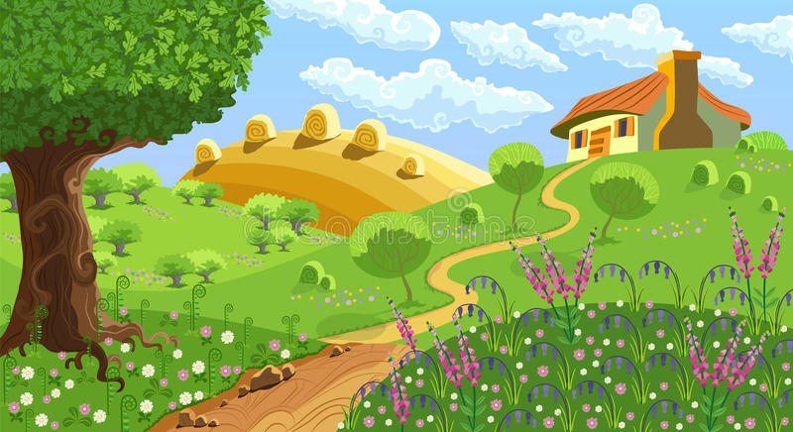
Wathi akusalathisa loo mzi ophezu kwenduli umhle ndonwaba ndivuyiswa yinto yokuba ndiza kuhlala kwindawo entle olo hlobo. Ikhaya lethu elitsha lalikude kufuphi namasimi abonakala elinyiwe. Kwakukho amanye anombona otyiwayo kodwa kubonakala into yokuba kwamanye kutyalwa ngokutsha ezinye izityalo. Xa ulahla amehlo ngaphesheya kweli khaya wawubona obo buhle bamasimi kunye nesinga esibekwe ngononophelo olukhulu.
Ndabuka iintyantyambo zendalo ezazisikhokela ukuya kungena kwelo pomakazi lendlu elikhaya lethu elitsha. Yafika imoto yemisa phambi kwendlu sehlika sajikeleza sibuka ubuhle bendalo. Sithe sisabuka ndeva umama ekhwaza, “Anga” “mama” ndasabela ndibaleka ndisiya kuye. Wandixelela ukuba masizilungiselele kuba yena no-Abongile nam siza kulungisa ukutya ngeli xesha otata no-Avela bengenisa imithwalo ngaphakathi.
Sangena ngaphakathi kwelo pomakazi lendlu sacela kumama ukujikeleza nje sibone onke amagumbi sandule ke ukulungisa ukutya. Wavuma umama esithi maze sikhawuleze kuba abantu balambile. Wenza umtsi wamnye u-Abongile wangena kwelinye igumbi elalikufutshane nelokuhlamba wathi thina siza kulala apho. Sawabuka onke amagumbi ngokukhawuleza saza saya kumama ekhitshini ngethemba lokuba kwakuthi xa sele kutyiwe siphinde siwabuke kakuhle.
Yangeniswa imithwalo kwatyiwa kwapakishwa loo mpahla yayithwelwe ziinqwelo kakuhle ngokweendawo zayo.
Emva kokufunda le noveli ingentla, phendula le mibuzo ilandelayo isekelwe kuyo;

- Chaza igama lelali abasuka kuyo aba bathuthayo ekuthethwa ngabo apha. (1)
- Ingaba yintoni esona sizathu esidala ukuba bathuthe? (2)
- Bhala phantsi amagama abalinganiswa abakhoyo kweli bali babe bane. (4)
- Thelekisa ubuhle bendawo ohlala kuyo nale ndawo bathuthela kuyo o-Anga . (3)
- Bhala phantsi amagama eedolophu abagqitha kuzo o-Anga xa besiya eBholani.
(3)
- Ingaba ikhona idolophu okanye iidolophu awakha wazibona kwezi kuthethwa ngazo kulo mbuzo ungasentla? Cacisa. (2)
- Yintoni igqibelo? (1)
- Ingaba uyayithanda le ndawo bathuthela kuyo o-Anga? (1)
- Xhasa impendulo yakho yombuzo ongasentla (2)
- Khetha igama elifanelekileyo libe linye kula adweliswe ngezantsi kulo
mbuzo. Ikhaya elitsha lika-Anga kuthiwa lalimi phezu- (1)
- Komlambo
- Liwa
- Ndlela
- Nduli
[20]

***************************

