IBANGA - 6
IIKHATHUNI
IMIZUZU: 30
Bhota mfundi-ntsapho
Qaphela:

- Injongo yesifundo: Ufundisa abafundi indlela yokufunda ikhathuni

- Okuqulathwe yitekisi:

- Isihloko seKhathuni
- Imifanekisi ekwikhathuni
- Umxholo obhaliweyo kwikhathuni
- Imibuzo ebuzwa kumfundi mayibonakalisa amazinga okuqiqa ngokukaCAPS ( iphepha 95-96)

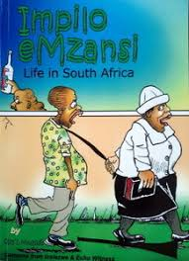

- Sithini isihloko sale khathuni
- Leliphi eli lizwe kuthethwa ngalo apha?
- Yintoni le kuthethwa ngayo apha kwikhathuni?
- Xa ujonge apha kwikhathuni, ingaba ikhona na imvisiswano kwesi sibini? Utsho kuba kutheni?
- Ingaba esi sibini sonwabile kusini na? Nika isizathu sempendulo yakho.
- Wena ungazama kanjani ukuphelisa ukuhlukumezwa kootata ngoomama

**********************************

