Province of the

EASTERN CAPE
EDUCATION

Steve Vukile Tshwete Education Complex • Zone 6 Zwelitsha 5608 • Private Bag X0032 • Bhisho 5605
REPUBLIC OF SOUTH AFRICA

CHIEF DIRECTORATE – CURRICULUM MANAGEMENT

GRADE 12 LEARNER SUPPORT PROGRAMME

REVISION AND REMEDIAL TEACHING INSTRUMENT:
ANTWOORDE

SUBJECT: PHYSICAL SCIENCES – FIRST PAPER
FISIESE WETENSKAPPE – EERSTE VRAESTEL

June 2009

This document consists of 8 pages.

SECTION A
QUESTION/VRAAG 1: ONE WORD ITEMS
1.1 | Power / Drywing ✓ [2.1 A] | (1)
1.2 | Series / Serie ✓ [2.1 A] | (1)
1.3 | Electric Field / Elektriese Veld ✓ [2.1 A] | (1)
1.4 | Monochromatic / Monochromaties ✓ [2.1 A] | (1)
1.5 | Photon / Fotone✓ [2.1 A] | (1)
 |  | [5]

QUESTION/VRAAG 2: FALSE ITEMS
2.1 | During inelastic collision in a closed system momentum is always conserved./ Momentum bly altyd behoue tydens ŉ onelastiese botsing. ✓✓ [2.3 A] | (2)
2.2 | In this investigation Deon concludes that the mass of Q is greater than the mass  of P. In hierdie ondersoek kom Deon tot die gevolgtrekking dat die massa van Q groter is as die massa van P.✓✓ [1.2 C] | (2)
2.3 | Photo electric effect is the phenomenon best suited to explain particle nature  of light./ Die foto-elektriese effek is die verskynsel wat die deeltjie geaardheid van lig die beste verduidelik..✓✓ [2.1 A] | (2)
2.4 | The magnitude of the induced emf in a coil directly proportional to the rate of  change of magnetic flux linkage./Die grootte van die geïnduseerde emk spoel is direk eweredig aan die tempo van magnetiese vloed verandering..✓✓[2.2 A] | (2)
2.5 | The electrical resistance of a conductor decreases as the thickness of the wire  increases./Die elektriese weerstand van ŉ geleier neem af soos die dikte van die geleier toeneem..✓✓ [2.2 A] | (2)
 |  | [10]

QUESTION/VRAAG 3: MULTIPLE-CHOICE QUESTION/S

3.1 | D ✓✓ [2.3 B] | (2)
3.2 | B ✓✓ [2.1 A] | (2)
3.3 | C ✓✓ [2.3 C] | (2)
3.4 | C ✓✓ [2.1 B] | (2)
3.5 | A ✓✓ [2.3 C] | (2)
 |  | [10]
 | TOTAL SECTION A: 25
SECTION B
QUESTION/VRAAG 4
 | p_{before =} p_{after}
4.1 | m₁v_{1i} + m₂v_{2i} = (m₁ + m₂) v_{f} ✓
 | ✓ ✓ ✓
 | (0,15)(25) + (1,1)(0) = (0,15 + 1,1)v_{f}
 | ✓ ✓
 | V_{f} = 3 m.s⁻¹ to the left / na links [2.3 C] |  |  | (6)
4.2 | Principle of conservation of momentum. / Beginsel van Behoud van Momentum✓✓ [2.1 A] |  |  | (2)
4.3 | F = Δp  Δt
= m(v_{f} – v_{i} ) ✓
Δt
✓ ✓
= 0,15(0 – 25)
0,001 ✓
 | = 3750 N ✓ [2.3 C] |  |  | (5)
4.4 | (E_{p} + E_{k} )_{top} = (E_{p} + E_{k})_{bottom}
 | mgh + ½mv_{i}² = mgh + ½mv_{f}² ✓
✓ ✓ ✓ ✓
(1,25)(9,8)h + ½(1,25)(0²) = (1,25)(9,8)(0) + ½(1,25)(3²)
 | ∴h = 0,46 m ✓ [2.3 C] |  |  | (6)
 | ✓ ✓
4.5 | Kinetic energy transformed to other forms of energy, e.g. friction, sound, heat etc.  Energie omgesit in ander vorms van energie, bv.wrywing, klank, hitte ens  [2.3 B] |  |  | (2)
 |  |  |  | [21]

QUESTION/VRAAG 5

5.1 | During the combustion of fuel, gas is formed which is ejected from the rocket. The gas exerts a force on the rocket ✓. This force is equal in magnitude but in the opposite direction✓ to the force exerted on the gas by the rocket. ✓ / Tydens die verbranding van die brandstof, word gas gevorm wat uit die vuurpyl geforseer word. Die gas oefen ŉ krag uit op die vuurpyl. Hierdie krag is gelyk in grootte maar in die teenoorgestelde rigting as die krag wat deur die gas uitgeoefen word. [1.4 B] | (4)
5.2 | v_{f} = v_{i} + a∆t✓
✓ ✓
= 0 + (40x10)
 | = 400m.s⁻¹✓ [2.3 C] | (4)
5.3 | v_{f}² = v_{i}² + 2a∆y ✓  0² = 400² + 2(-9,8) ∆y✓  ∆y = 8163 m ✓ ✓  Height above earth / Hoogte bokant aarde = 8 163 + 2 000 = 10 163 m ✓  [1.3 C] | (5)
5.4  5.4.1 | shape✓✓/ Vorm.  labelling of axes✓ / benoeming van asse.  Heading – Position-time graph/ Displacement-time graph✓ / Posisie-Tyde grafiek / Verplasing-Tyd grafiek
 | 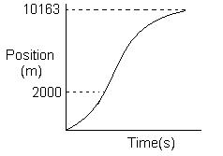 [1.2 D] | (4)
5.4.2 | shape✓✓ / Vorm  labeling of axes✓ / benoeming van asse.  Heading-Velocity-time graph✓ / Snelheid-Tyd grafiek
 | 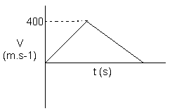 [1.2 D] | (4)
 |  | [21]
QUESTION/VRAAG 6

6.1 | The work done by the net force on an object is equal to the change in its  energy. ✓✓  Die werk verig deur die netto krag op ŉ voorwerp is gelyk aan die  verandering in sy energie. [2.1 A] | (2)
6.2 | W_{net} = ΔE_{k} + ΔE_{p}✓  = (½ mV_{f}² – 0) + (mgh_{f} – 0)  = ( ½ x 500 x 4²) ✓ + ( 500 x 9,8 x 40) ✓  = 4 000 + 196 000  = 200 000 J✓  P = W/t✓  = 200 000/60✓  = 3333,33 W✓ [1.3 C] | (7)
 |  | [9]

QUESTION/VRAAG 7
7.1 | 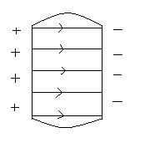  Direction✓ / rigting  Parallel & straight✓ / Parallel en reguit  Slightly bent at both sides ✓ / Effens gebuig aan die kante  [2.1B] |  | (3)
 | ✓ ✓ ✓ ✓
7.2 | F = qE = (3,8 x 10⁴ )( -8,5 x 10⁻⁹) = 3,23 x 10⁻⁴ N away from X / weg van X af  [2.3 B] |  | (4)
 | ✓ ✓ ✓ ✓
7.3 | W = QV = (8,5 x 10⁻⁹)(2400) = 2,04 x 10⁻⁵ J [2.3 C] |  | (4)
7.4 | W = 2,04 x 10⁻⁵ ✓  2  = 1,02 x 10⁻⁵ J ✓ [2.3 C] |  | (2)
 |  |  | [13]
QUESTION/VRAAG 8
8.1 | C = ε_{o}A ✓  d  ✓ ✓  0,04x 10⁻⁶ = 8,85 x 10⁻¹² x A  2x10⁻⁴ ✓  A =0,04x 10⁻⁶ x 2x10⁻⁴  8,85 x 10⁻¹²  = 0,9m²✓ [1.3 C] |  | (5)
8.2 | Double the area of the metal plates ✓✓  / Verdubbel die oppervlakte van die metaalplate.  Halve the distance between the plates ✓✓/ Halveer afstand tussen die plate  [2.2 B]  Use better dielectric / Gebruik beter diëlektrikum (Any 2 / Enige 2) |  | (4)
 | ✓ ✓
8.3 | Capacitors can be recharged and can supply energy faster. /  Kapasitors kan herlaai word en kan energie vinniger verskaf. [3.2 B] |  | (2)
 |  |  | [11]

QUESTION/VRAAG 9
 | ✓ ✓
9.1 | More electrical energy converted to light energy and less to heat energy in  energy-saving bulbs. /  Meer elektriese energie word omgesit in ligenergie en minder na hitte-energie in energie-besparings gloeilampe. [3.2 A] |  |  |  | (2)
9.2 | Total energy consumed = 60 x 6 x 4 x 30 ✓  Totale energie verbruik 1000  = 43,2 kWh✓ [2.3 C] |  |  |  | (2)
9.3 | Cost / Koste = 43,2 x R0.60 = R25,92 ✓ [2.3 C] |  |  |  | (1)
9.4 | Total energy consumed = 18 x 6 x 4 x 30 ✓  Totale energie verbruik 1 000  = 12,96 kWh ✓ [2.3 C] |  |  |  | (2)
9.5 | Cost / Koste = 12,96 x R0,60 = R7,78 ✓ [2.3 C] |  |  |  | (1)
9.6 | Energy saved / Energie bespaar = 43,2 – 12,96 = 30,24 kWh ✓✓ [2.3 C] |  |  |  | (2)
 |  |  |  |  | [10]
QUESTION/VRAAG 10
✓ ✓
10.1 |  | Mechanical energy is converted to electrical energy / meganiese energie is  omgesit na elektriese energie. [1.2 B] |  |  | (2)
 |  | ✓ ✓
10.2 |  | AC generator/ WS generator; slip ring for each side of the loop / sleepring vir  elke kant van die winding. [1.2 B] |  |  | (2)
10.3 |  | P to/na Q ✓ [1.2 B] |  |  | (1)
10.4 |  | 10.4.1 | 12V ✓ [1.2 B] |  | (1)
 |  | 10.4.2 | 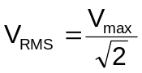✓  = 12 /✓  = 8,49 V ✓ [2.3 C] |  | (3)
 |  | 10.4.3 | 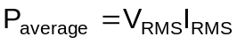✓  20 = 8.49 x I_{RMS}✓  I_{RMS} = 20 / 8.49  = 2,36 A ✓  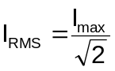✓  2.36 = 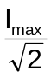  I_{max} = 2,36 x 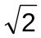✓  = 3,34 A ✓ [1.3 C] |  | (6)
 |  |  |  |  | [15]

QUESTION/VRAAG 11
✓
✓
11.1 | 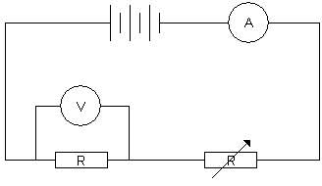 [1.1B]  ✓  ✓ |  |  | (4)
11.2 | Ohm’s law / Ohm se wet ✓ [1.2B] |  |  | (1)
11.3 | 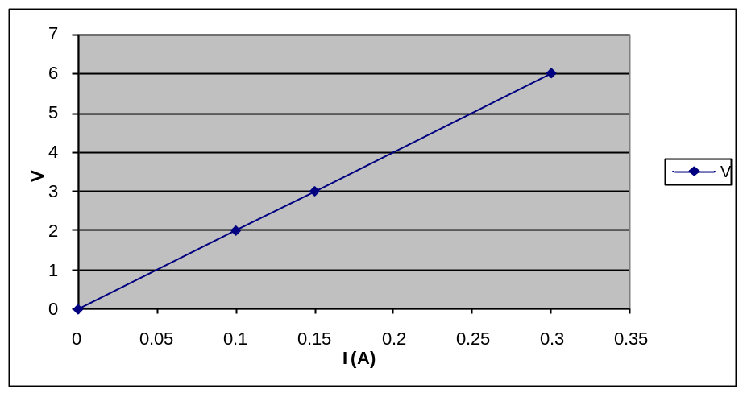  ✓✓  Labeling Axis✓ [1.2C] |  |  | (3)
11.4 | R = V/I ✓  = 6 / 0,3 ✓  = 20 Ω ✓ [2.3C] |  |  | (3)
 |  |  |  | [11]

QUESTION/VRAAG 12
12.1 | What is the relationship between the frequency of the incident light falling on the cathode of the photo electric cell and the number of photo electrons emitted?✓✓ Wat is die verwantskap tussen die frekwensie van die invallende lig op die katode van die foto-elektriese sel en die aantal foto-elektrone wat vrygestel word? [1.1 B] |  | (2)
12.2 | Threshold frequency / Drumpel frekwensie ✓✓ [2.1 A] |  | (2)
12.3 | Light meter / Ligmeter. ✓  Measures the intensity of the light./Meet die intensiteit van lig. ✓✓ [3.2 C] |  | (3)
12.4 | hf_{x} = W_{o} + E_{k} ✓  ✓ ✓ ✓  (6,63 x 10⁻³⁴) f_{x} = (6,63 x 10⁻³⁴ x 4,59 x 10¹⁴) + (1,83 x 10⁻¹⁹)  f_{x} = 4,87 x 10⁻¹⁹  6,63 x 10⁻³⁴  = 7,35 x 10¹⁴ Hz ✓ [1.3 C] |  | (5)
12.5 | E_{k}  (J)  ✓✓ [1.2D] |  | (2)
 | Intensity of incident light (Watt) Intensiteit van invallende lig (Watt) |  | [14]
 | TOTAL SECTION/TOTAAL AFDELING B: |  | 125
 | GRAND TOTAL/GROOTTOTAAL: 150

