

**DIRECTORATE: Primary Curriculum Management**

Steve Vukile Tshwete Complex • Zone 6 • Zwelitsha • Eastern Cape Private Bag X0032 • Bisho • 5605 • REPUBLIC OF SOUTH AFRICA Tel: +27 (0)40 608 4713 • Fax: +27 (0)40 608 4657 • Website: [www.ecdoe.gov.za](http://www.ecdoe.gov.za)

|  |  |
| --- | --- |
| **REVISION NOTES** | |
| **SUBJECT** | **SOCIAL SCIENCES – HISTORY** |
| **GRADE** | **7** |
| **TERM** | **2** |
| **TOPIC** | **THE TRANSATLANTIC SLAVE TRADE** |
| **CONTENT** | 1. **West Africa before the European slave trade** 2. **The nature of slavery in West Africa before Europeans** 3. **Slavery in the America South** |

**UNIT 1**

|  |
| --- |
| **SOCIAL SCIENCES – HISTORY TERM 2** |
| **Topic : The Transatlantic slave trade** |
| **Content : West Africa before the European slave trade** |
| **Key concepts:**   * **The story of slave trade and hardships suffered by slaves from one group of people by another** * **In West Africa the Africans that caught and sold other Africans as slaves did so for a profit** |

West Africa before the European slave trade

* First Europeans – arrived in West Africa in the 1400’s.
* In the 14th century there were powerful civilizations in Africa. These included the Kingdom of Mali, Ghana and Songhai Empire.
* These powerful and advanced kingdoms had become so wealthy through trade.
* The West African Kingdoms mined gold, salt and copper.
* These goods were traded for goods from Europe that were supplied by traders who travelled from North Africa.
* They were also traded for goods from the East traded by the Arab traders.
* The Arab traders also travelled to the Kingdom of West Africa in search of slaves
* Societies were highly advanced with strong political control.
* Powerful armies conquered neighboring communities and incorporated them into their territories.
* The Islamic learning centre in Timbuktu was famous throughout the world.
* The Trans-Saharan Arab slave trade began before Islam was a widely accepted religion.
* Arabs bought slaves in West Africa - took them to Iraq, Iran, Kuwait, Turkey, Pakistan
* and India.
* Arabs enslaved between 11 and 18 million Africans over a few hundred years.

**Activity 1**

**West Africa before the European slave trade**



1.1 What, in the drawing, gives an impression of authority. Mention four items. (4)

...........................................................................................................................................................................................................................................................................................................................................................................................................................................................................

2. What can you conclude about how the slaves felt from their facial expressions? (4)

....................................................................................................................................................................................................................................................................................................................................................................................................................................................................................................................................................................................................................................

3. Compare the clothing of the slaves and the Arabs. What is the same and what is different? (2)

...........................................................................................................................................................................................................................................................................................................................................................................................................................................................................

4. How do you know that the Arabs were afraid that the slaves were going to run away? (4)

..........................................................................................................................................................................................................................................................................................................................................................................................................................................................................

5.Some historians say the slave trade overall improved the standard of living in West

Africa. Do you agree? Justify your answer. (6)

**UNIT 2**

|  |
| --- |
| **SOCIAL SCIENCES – HISTORY TERM 2** |
| **Topic : The Transatlantic slave trade** |
| **Content : The nature of slavery in West Africa before Europeans** |
| **Key concepts:**   * **What is slavery?** * **The slave traders sold slaves for profit** * **The plantation slave owners and slave trades made a profit from the raw materials that was the product of slave labour** * **The meaning of the Transatlantic trade route** |

What is slavery?

A slave is someone who is forced to work for another person.

A slave is not paid for the work he /she does.

A slave has no rights when it comes to working hours or living conditions.

A slave is made to work by threat of violence or punishment.

Noting the above information, one can define slavery as a system or condition in which human beings are owned by other people (slave owners). Slave owners regarded the enslaved person as a property that could be sold for profit against his /her will.

Slavery in West Africa before European involvement

Slavery was part of the West African society. Before European traders went to Africa about 3 500 years ago; Egyptians used slaves to build their pyramids. Owning slaves was a symbol of wealth and status. In African society, land was seen as belonging to everyone, so owning large amounts of land did not symbolize man’s success and wealth. A man with a large household that included many slaves was the one considered a wealthy man.

In West Africa people became slaves for a number of reasons. For example, they became slaves:

When they had been chased out of their areas.

When they had too many debts and could not repay them.

When they had been punished for being criminals.

When they hoped to eventually serve as soldiers

The type of slavery in West Africa before the arrival of Europeans is called Domestic slavery. It is domestic slavery because these slaves were from West Africa and were familiar with customs, culture and language of the people for whom they worked.

*West African slaves before Europeans had slave rights*

* A slave owner was expected to provide an acceptable food and housing for their slaves.
* A slave was allowed to get married
* A child born to a slave would not be regarded as a slave.
* Slaves could inherit possessions from their owners.
* Slaves could own other slaves.
* A slave could be released from slavery

The effect of the Arab trade on West African(domestic) slavery

When the West Africans saw that the Arabs were keen to buy slaves, the nature of slavery changed. Domestic slavery continued, but there was a huge growth in the buying and selling of slaves as a way of making profit. This system became known as chattel slavery Chattel slavery is a system where an enslaved person is owned forever and whose children’s children are automatically enslaved. This type of slavery was supported and made legal by European governments and the monarchs.

Slaves who were sold to the Arab traders were captured from other Kingdoms.They were taken by force from tribes that were defeated in clashes or from tribes whose leaders refused to pay tribute to West African rulers. These slaves were then sold to Arab traders for exchange for goods from the East. The Arab traders took the African slaves to Iraq, Kuwait, Pakistan and India.

The Transatlantic trade route

European countries set up a three- stage trading system across the Atlantic Ocean

* European countries sent manufactured goods to trading ports on the West Coast of Africa in return for slaves.
* The slaves were shipped across the Atlantic Ocean to the colonies in America.
* The ships returned to Africa carrying raw materials needed by European factories. These included sugar, tobacco and cotton

**Activity 2: The nature of slavery in West Africa before the Europeans**

2.1How and when did the Egyptians use slaves?

................................................................................................................................................................................................................................................................................................................................................................................................................................................... (2) 2.2 From where did the West African tribes get slaves? ...................................................................................................................................................................................................................................................................................................................................................................................................................................................(2)

*2.*3 Why was it important for West Africans to own slaves?

.................................................................................................................................................................................................................................................................................................................................................................................................................................................. (2)

2.4 Write a paragraph about the work and rights of slaves in West Africa before the

European traders arrived.

.................................................................................................................................................................................................................................................................................................................................................................................................................................................................................................................................................................................................................................................................................................................................................................................................................................................................................................................................................................................................................................................................................................................................................................................................................. (6)

2.5 Give the definition of the concept “slavery”.

.........................................................................................................................................................................................................................................................................................................................................................................................................................................................................................................................................................................................................................................................................................................................................................(3)

2.6 What do you understand about the concept “Transatlantic trade route”?

........................................................................................................................................................................................................................................................................................................................................................................................................................................................................................................................................................................................................................................................................................................................................................(3)

**UNIT 3**

|  |
| --- |
| **SOCIAL SCIENCES – HISTORY TERM 2** |
| **Topic : The Transatlantic slave trade** |
| **Content : Slavery in the American South** |
| **Key concepts:**   * **A slave was just a property and had no rights** |

|  |  |  |  |
| --- | --- | --- | --- |
| **KEY WORDS** | | | |
| **Plantations** | **Colony** | **Captured** | **Auctioned** |
| Large farms used to grow sugar, cotton or tobacco | A colony was a piece of land or a smaller country taken by force and controlled by a larger or bigger country | To keep a person as a prisoner/ to get control of a person or place | sold at a public meeting/place to a person who offer the most money |
| **Cotton** | **Sugar - cane** | **Indigo plant** | **Molasses** |
| Fabric for clothing | small sugar granules | A plant A pant with a dark purple blue colour used to colour fabrics. | dark brown syrup left after making sugar |
| Property | Settlers | America South | Dealers |
| Something that one owns | People who went to live in a colony | Colonies that were established by Settlers in North America | People who buy and sell things |

*Background information*

3.1 European interest in the West African slave trade

During the 15 century European explorers claim to have found many “new lands” around the world.

* Christopher Columbus had found land on the continent of America.
* The Portuguese explorers had investigated the west coast of Africa.
* Portuguese explorers had sailed around the tip of Africa.
* The Dutch had established a very powerful trading company, the VOC, they used the sea route to the East.
* The British had set up a powerful trading company known as the British East India Company

N.B We are saying these lands are claimed to be “new lands” because, although they were new discoveries to the Europeans there were people who, already were living in those lands

During the 16 century, the European countries sent setllers to these “new lands “to establish colonies on behalf of the European colonies. Settlers from England went to North America and set up colonies there. These colonies became known as the America South.A colony was a piece of land or a smaller country taken by force and controlled by a larger or bigger country. Owning a colony made it possible for the European countries to control the trading ports that bring wealth to the European countries wealth.

*3.2. The* European countries had been through Industrial revolution

What was the industrial Revolution?

This was a time or a period in history when many countries started to mass produce goods. The production of goods became more important than farming. During the Industrial Revolution, people moved away from farms into towns. The focus of the economy was no longer on farming but on industry and the production of goods. New factories were set up for the production of goods. Goods were made by machine not by hand and the production time was quicker and the age of mass production began. One of the industries that grew the fastest was the textile industry in Britain. This new textile industry did, however face new challenges. One of them was that British cotton growers struggled to produce large amounts of raw cotton needed by factories.

3.3 Plantations, tobacco, rice, sugar cane and cotton

To cope with the high demand of raw materials needed by factories Britain turned to her colonies, Americas in particular. Americas had more available land and better climate to grow crops than Britain. This meant that the colonies would be the ideal places to produce raw materials such as cotton so Europeans, set up plantations in her colonies. Plantations were large farms used to grow sugar, cotton, tobacco and cotton. The suitable climate and soil in the southern states of North America made it possible for farmers to establish huge plantations of: Tobacco, cotton, rice, indigo and sugar cane.

3.4 Reasons for using slave labour

The plantation owners could not do all the farming themselves, and many of them never done farming before, so they needed labourers to work on these plantations.

The plantations in American colonies could not be farmed by Americans as many of them had either been killed or forced to flee when Europeans arrived. The European countries therefore looked to Africa for labourers. Getting slaves from Africa instead of using native Americans would be better as slaves would not have to be paid (cheap labour). This cheap labour allowed plantation owners to make huge profits

3.5 How slaves were captured, sold and transported from West Africa

European slave traders did not capture slaves in Africa themselves ,they bought them from African traders .Africans captured and enslaved people in tribal wars/raids. Some were condemned criminals who owed money, others were those people who were accused of witchcraft

3.5.1 Captured Africans became part of a network called the **Triangular trade:**

* First leg of triangle - ships carried European goods to Africa to be exchanged for slaves.
* Second leg **-** Africans were brought to the Americas to be sold.
* Third leg - American products were carried to Europe.

3.5.2 The Second leg (Middle Passage)

This was the most terrifying period as it shows how slaves were sold and transported to their new owners. Captive Africans were chained together around the neck and forced to take a long walk to the coast. The journey lasted three to six weeks. Ten to twenty percent of the captured slaves did not survive. Those who were fortunate were cramped into dark quarters below ship’s decks where they could neither sit nor stand.

*3.6 Slave markets*

When slave ships arrived in America, the slaves were taken to slave markets where they were auctioned like cattle to the slave dealers The slave’s teeth and eyes were examined to see if they were healthy. Slave traders rub fat over them to make their skin shine. Young, strong, pretty slaves were sold at high prices. Slaves who had something wrong or a disability were sold at low prices. Slaves that previously worked on plantations with skills or could read and write, sold well. Once they were bought, slaves became the property of their new owners. The cruel thing about auctions was that a family could be sold to different buyers and this means there was a possibility of never seeing each other again. Slave trade destroyed families as little children could part with their mothers forever

3.7 *Number of slaves that were taken to America*

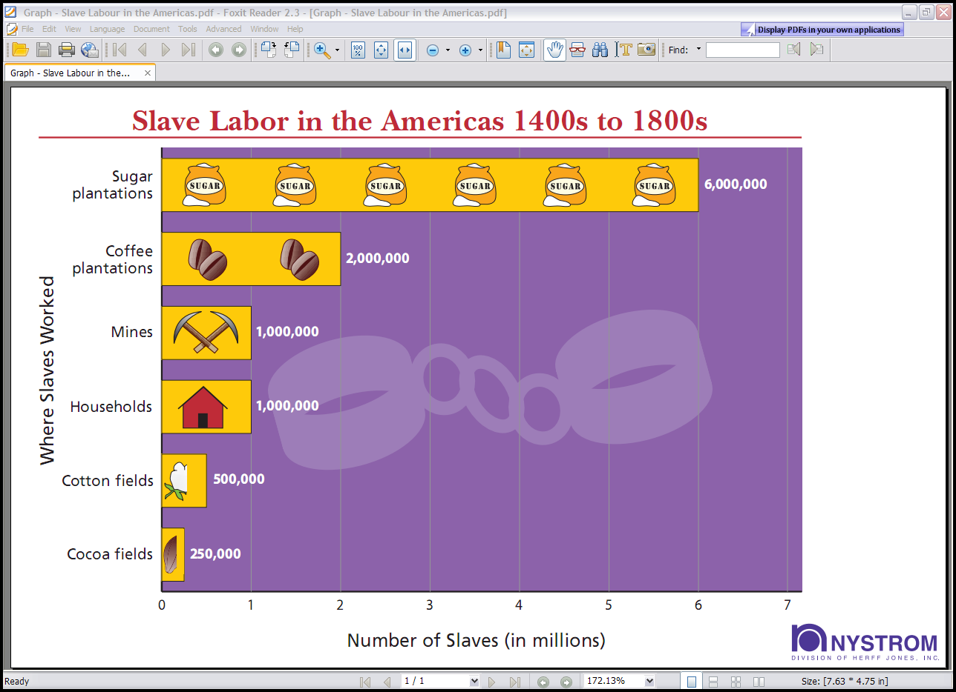

*3.8 What happened to the raw materials that were taken to America*

Britain loaded most raw materials from America on merchant ships and transported them to British factories. They transported raw materials such as Cotton. Indigo plant, Sugar cane, Molasses, different types of alcohol and Tobacco leaves. Britain sold the manufactured goods back to America, and West Africa exchanged them for more slaves. Slaves work hard, get little or nothing for labour, have no money to buy products from England. Raw agricultural produce from plantations where slaves work was transported to Europe. European countries export goods made from raw agricultural produce back to the America.

**Activity 3: How slaves were transported**

A slave’s journey from West Africa to an American plantation was a long and painful experience.” Do you agree or disagree with this statement? Give reasons for your

answer.

................................................................................................................................................................................................................................................................................................................................................................................................................................................................................................................................................................................................................................................................................................................................................................................................................................................................................................................................................................................................................................................................................................................................................................................................................ (15)

**Activity 4: Slave markets – Slave auction**

4.1 Why were slaves’ teeth and eyes examined at auctions?

...................................................................................................................................................................................................................................................................................................................................................................................................................................................(1)

4.2 Why do you think slave traders wanted the slaves’ bodies to shine?

................................................................................................................................................................................................................................................................................................................................................................................................................................................. (2)

4.3 Is the statement, “Slave mothers sometimes never saw their children again”, true or

false? Give a reason for your answer.

...................................................................................................................................................................................................................................................................................................................................................................................................................................................................................................................................................................................................... (3)

4.4 Being enslaved denies people their human rights. Name two things done to slaves which

denied them their human rights.

...................................................................................................................................................................................................................................................................................................................................................................................................................................................................................................................................................................................................... (4)

*.*

4.5 Make an anti-slavery poster to get a message across to plantation owners that slavery is

cruel and that it should be stopped. (10)

**Activity 5: Slave trading**

5.1 Explain what Triangular Trade means; write down what was exported from

and imported to the three countries involved.

....................................................................................................................................................................................................................................................................................................................................................................................................................................................................................................................................................................................................................................................................................................................................................................................................................................................................................................................................................................................................................................................................................................................................................................................................................................................................................................................................................................(10)

5.2 Write a paragraph describing how you would cope in the conditions at the bottom of a

slave ship.

.....................................................................................................................................................................................................................................................................................................................................................................................................................................................................................................................................................................................................(10)