Exemplar Term 3 Summative Task
History Grade 8
Summative Assessment: Mineral Revolution in South Africa
Term 3 Total: 50
Question 1:
  - Refer to Source 1A:

1.1.1 What was the Hut Tax? 1x1 (1)
1.1.2 Extract information from Source 1A to explain why the Mine Managers Association
supported the introduction of a Hut Tax. 1x2 (2)
1.1.3 How could African men be granted a reduction in the amount of Hut Tax they had to
pay? 1x2(2)
1.1.4 Using your own knowledge, identify and explain TWO other reasons men might
Choose to go and work on the mines. 2x2(4)

  - Refer to Source 1B:

1.2.1 Identify two results of the migrant labour system that you can see in the photo. 2x2(4)

  - Refer to Source 1C:

1.3.1 What does Source 1C suggest about the impact of migrant labour on African family
Life? Use evidence from the source to support your answer. 2x2(4)
1.3.2 Discuss the usefulness of this poem for someone researching the migrant labour
system. 2x2(4)

  - Refer to Source 1D:

1.4.1 How did the African migrant workers on the mines benefit from the Migrant system?
2x1(2)
1.4.2 What were the “Reserves” mentioned in the Source? 1x2(2)
1.4.3 Why do you think African men left the reserves to go work on the mines? 2x1(2)

Question 2:

2.1 Define the following historical terms:

2.1.1 Rand Lords
2.1.2 Compounds
2.1.3 Migrant Labour
2.1.4 Trade Unions
2.1.5 Pass system 2x5(10)

2.2 Indicate if the following statements are TRUE or FALSE:

2.2.1 The discovery of gold was one of the causes of the Anglo Boer War 1899-1902.
2.2.2 Gold was first mined in Kimberley during the 1860’s.
2.2.3 As a form of protest towards unfair treatment of Indian labourers, Ghandi launched a
violent protest campaign known as Satyagraha.
2.2.4 Gold diggers were also known as “prospectors”.
2.2.5 The Union of South Africa was formed on 31 May 1910.
5x1(5)
Question 3:

3.1 Use all the Sources and your own knowledge and write a paragraph explaining how the
migrant labour system affected
a) The miners
b) The women left at home in the rural reserves
c) The mine owners. (8)

TOTAL: [50]

ADDENDUM:

SOURCE 1A:
In 1893, a committee of the Mine Managers Association made the following suggestion. It has been adapted from the original text to make it easier to read:
“Hut tax should be raised to an amount of 14 Shillings per year (R 10 000 today) so that more Africans will be encouraged to seek work as migrant workers on the mines. This tax should be payable in coins only. Each African who can prove that he has worked for six months in the year should be allowed a reduction in his Hut tax.”

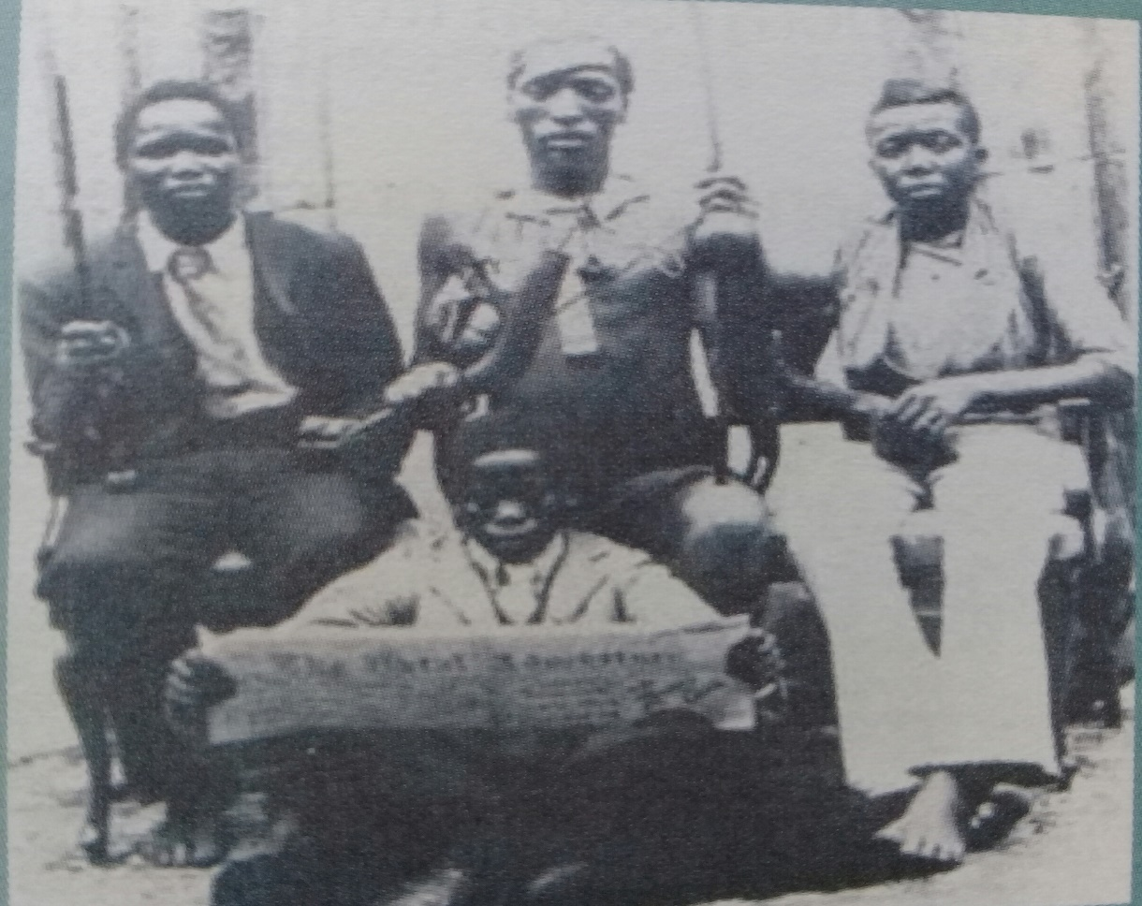
SOURCE 1B:
Three generations of an African family.

SOURCE 1C:
This Sotho poem is about fathers leaving their family when they went to the mines:
“In the midst of trouble and sorrow
We left our children at home
Children full of tears,
Crying father is gone, is gone
God, help our father to return.
In the midst of trouble and sorrow
We left our wives at home to take care of our own.
Wives full of tears,
Crying my husband is gone, is gone.
Swallowed by the earth, some never to return.”

SOURCE 1D:
Brought in from the reserves in their youth and shipped back in their old age, the migrant labourer do not cost the mining industry a lot in welfare costs. This has to be paid by the poverty-stricken reserves. The mine owners only pay what they have to so that the workers can make a living. The rest goes to the mine owners as profit. The migrant labourers from the reserves provide the town’s labour power without having any social, economic or political benefits that they should get because their work creates wealth. Subsequently, they earned no pension and had no voting rights.

MEMORANDUM
History
Grade 8 Term 3 Summative Assessment: The Mineral Revolution in South Africa
Total: 50

Question 1:
    - Hut tax was a property tax levied against huts owned by Africans in Tribal Reserves. 1x1
1.1.2 They supported the introduction of the Hut tax because it would require Africans to
pay the tax in coins which they would have to earn on the mines as a salary. It
would therefore ensure a steady flow of cheap labour to the mines. 1x2(2)
1.1.3 If Migrant Labourers could prove that they were employed on the mines for six months
then a reduction in the Hut tax would be allowed. 1x2(2)
1.1.4 The Tribal reserves were poverty stricken and often experienced droughts that
decimated crop production. Working as Migrant labourers they could earn a small salary,
escape their tribal existence and experience life in the cities.
(Any RELEVANT response) 2x2(4)

1.2.1 Migrant labourers that became westernized wearing European style clothing and
becoming more literate. 2x2(4)

1.3.1 It broke up the traditional family structure. Women had to do the work of their husbands
in the Tribal reserves. Children grew up without a father at home and it created
emotional stress for the children and wives. Many husbands also never returned from
the mines due to disease or accidental deaths suffered in the mines.
(Any RELEVANT response) 2x2(4)
1.3.2 It is a Primary source that originated at the time that Migrant labour was introduced in
South Africa. It provides insight into the emotional impact that it had on African family
life. 2x2(4)
1.4.1 They earned a salary and gained valuable work related skills as miners. Some improved
their level of literacy and they became more westernized. 2x1(2)
1.4.2 The Tribal Reserves were the original Tribal land owned by Africans in the rural areas.
The colonial authorities turned the Tribal land into Reserves where Africans were taxed
so that the colonial authorities could benefit financially.
(Any RELEVANT response) 1x2(2)
1.4.3 It offered them an opportunity to earn a salary and break away from their poverty
stricken tribal existence. It would also provide an opportunity to gain valuable labour
skills. 2x1(2)
Question 2:
2.1.1 Rand Lords were the wealthy mine owners of the Witwatersrand.
2.1.2 Compounds were the enclosed living areas for Migrant workers on the mines.
2.1.3 Migrant labour is a labour system where workers work on the mines on a rotational
basis of six months per year.
2.1.4 Trade Unions are organized labour organizations fighting for the rights of workers.
2.1.5 The Pass system was a segregation policy devised to restrict the movement of African
labourers so that they could not leave the mines without a valid pass.
5x2(10)
2.2.1 True
2.2.2 False
2.2.3 False
2.2.4 True
2.2.5 True 5x1(5)

Question 3: Paragraph-type question

Africans were lured to the mines with the promise of money and prosperity. They were also compelled to be part of the Migrant labour system due to the implementation of the Hut tax. Migrant labourers were also able to gain valuable skills on the mines. They became more westernized and literate. Many also died on the mines due to disease and accidents. Migrant labourers earned few benefits and had no pension or voting rights. Women left behind on the Tribal reserves had to take care of their families and raise their children in the absence of a father figure. Women had to work on the land and raise crops and take care of livestock. Mine owners became wealthy and were known as Randlords. Their wealth was built on the cheap labour of Migrant workers. (Any RELEVANT response) (8)

Level 1 type answer | No attempt to answer the question.  Question is recognizable in answer and is based on an elementary use of evidence from the sources. | 0  1 - 2
Level 2 type answer | Question was partially addressed using some evidence from the sources. | 3 - 5
Level 3 type answer | Question was fully answered using all the sources as well as own knowledge. | 6 - 8

TOTAL: [50]

