GRADE(S) | 12 (SUITABLE FOR 10 &11)
WORKSHEET | 1
SUBJECT | ENGLISH HOME LANGUAGE (FET)
WEEK | 13-14
TOPIC | SUMMARY WRITING SKILLS
SUBMITTED BY | S.P. NDLOVU
DISTRICT | O.R. TAMBO INLAND DISTRICT

POINTS TO REMEMBER WHEN WRITING A SUMMARY
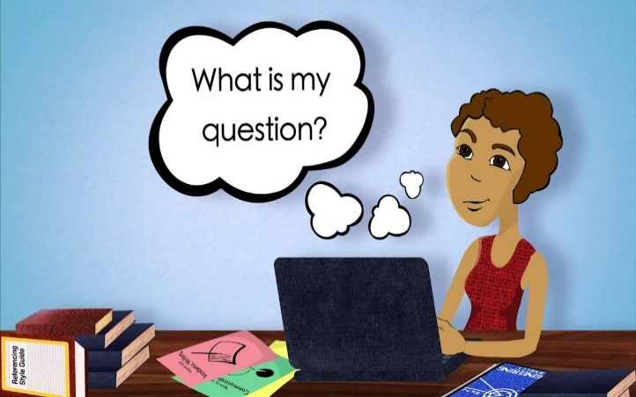

STEPS TO FOLLOW | GOOD ADVICE
- Read the instructions carefully. | Take note of how many words you can use in your summary. (80-90 words)
- Read the passage at least twice. | Read it quickly the first time, then slowly and carefully the second time around. While doing this, underline the key words and main points in pencil. Make one main idea per paragraph to begin with.
- Write a rough draft in your own words, from memory, without referring to the original text. | - Do not repeat any information.  - Do not include any quotes or direct speech.  - Leave out descriptions and details.  - Use short but full sentences.
- Count the words you have used. | - If you have used a few words, check if you have included everything important. If not so, elongate your summary.  - If you have used many words, go back and make sure that you omit examples, explanations and irrelevant or less important information.
- Edit your summary. | Still working on the draft version, correct spelling and, especially, sentence construction.
- Write out a neat final version. | Include the word count at the end. Count carefully, and state the exact number of words you used.

SUMMARY TASK
Refer to the following TEXT which gives you tips on how to make the temporary transition of learning from home due to schools closing early in response to the COVID-19 pandemic. In your own words, summarise those tips.

Your summary should:
• be made up of a single paragraph
• include 7 tips to help you learn better from home (found in the text)
• be written in your own words
• be no longer than 90 words
• include the word count
• be conscious of spelling, grammar and sentence construction
• NOT include a title
Failure to follow any of the above instructions could result in a loss of marks.

Home-based Learning During a Crisis

1. | This article is designed to help you transition to virtual schooling due to schools closing early in reaction to the COVID-19 pandemic.
2. | It can be confusing and unsettling when your regular routine is disrupted. Trying as much as possible to maintain your normal routine is key to a successful transition in any situation.
3. | You were given your educational material, assignments and any other key information or instructions by your teachers prior to the closure of schools, so make sure you have everything you need.
4. | It is recommended that you continue to get up and get dressed as you normally would on any other school day. Start your 'classes' at the same time you usually would and stop studying at the time your classes would normally end.
5. | In addition to your normal routine, it is important that you do your subjects in the same order that you normally would at school. This will keep you in the correct mindset for school as much as possible during this change, and make it easier for you to transition back to your regular routine.
6. | It is tempting to oversleep and look at this period of home-bound learning as a vacation. Don't fall into that trap! You are responsible for the material assigned during the ‘Lockdown’ period and if you do not complete it, you are going to be behind when the schools re-open.
7. | Challenge yourself to remain focused and disciplined to get your work done each day just as if you were at school. It can be easy to get distracted by TV or the internet, but save those things for when you need a break.
8. | Continue communication with your teachers. Just as you are working from home, your teachers are there to guide and assistant you. It is their job to help you to learn even if it must be in a virtual environment.
9. | Learning from home offers you a much more intensive learning environment. Remember to get up every 45-50 minutes to stretch and get some water or snacks. This will keep you alert and in tip-top learning form.
10. | All the best of luck with this new learning experience. Embrace it, enjoy it.  [Adapted from: https://childmind.org : Accessed online on 23/03/2020]

USE THE FOLLOWING TABLE FOR YOUR KEY POINTS
Quotation | Own Words

Use your key points to write the actual summary. Make sure you use the given tips and follow all instructions.

