Province of the
EASTERN CAPE
EDUCATION

DIRECTORATE SENIOR CURRICULUM MANAGEMENT (SEN-FET)
HOME SCHOOLING SELF-STUDY ANSWER SHEET
SUBJECT | ECONOMICS | GRADE | 12 | DATE | 15/04/2020
TOPIC | MICROECONOMICS MARKS: 40 | TERM 1  REVISION |  | TERM 2 CONTENT | X

QUESTION 1:
1.1 | Answer the following questions.
 | 1.1.1 | Name any TWO characteristics of monopolistic competition.
 |  | - Large number of producers  - Differentiated product  - Free market entry  - Producers have little control over price / price setter  - Incomplete market information  - Non-price competition and branding  - Collusion not possible  - Hybrid market structure  (Accept any other correct relevant response) (2x1) | (2)
 | 1.1.2 | Why would a lack of information to entrepreneurs lead to market failure?
 |  | - A lack of information regarding cost and availability of the factors of production will result in a misallocation of resources / will result in inefficiency in production  (Accept any other correct relevant response) (1x2) | (2)
1.2 | Data response
 | 1.2.1 | Identify the quantity the firm will produce at equilibrium point
 |  | - 180 | (1)
 | 1.2.2 | What curve represents the market price for the perfect competitor?
 |  | - AR/MR/dd
 |  |  | (1)
 | 1.2.3 | Briefly describe term normal profit
 |  | - The minimum earning required to prevent an entrepreneur from leaving the market / where total cost is equal to total revenue (Accept any other correct relevant response). (1x2) | (2)
 | 1.2.4 | What would the impact on the market be if many firms leave this industry?
 |  | - The supply curve in the market will shift to the left / decrease in supply  - Market price will increase  - (Accept any other correct relevant response). | (2)
 | 1.2.5 | Redraw the above graph and insert the average variable cost curve (AVC) to clearly indicate the shut-down point.  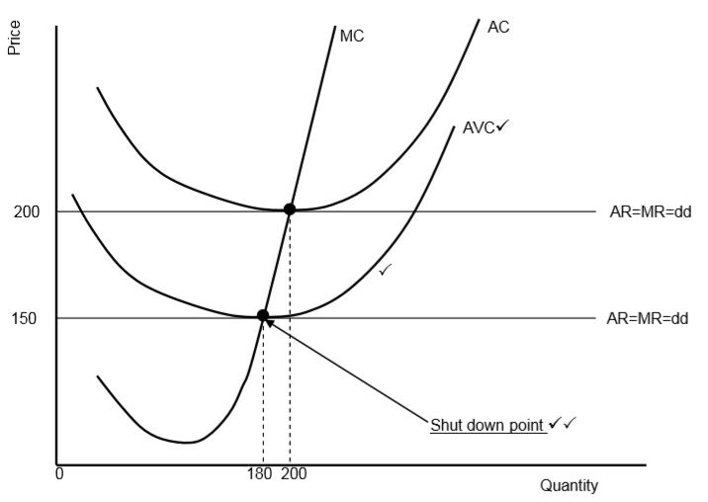  Marking grid  - Correct drawing and labelling of AVC curve = 2 marks  - Correct labelling of the shutdown point = 2 marks  Maximum 4 marks

1.3 | DATA RESPONSE
 | 1.3.1 | In which sector is the cost benefit analysis generally used?
 |  | - Public | (1)
 | 1.3.2 | Give any ONE redress method used by government to enforce redistribution of income.
 |  | - BEE  - Affirmative action  - Empowerment  - Land restitution  - Land redistribution  - Property subsidies for RDP houses  (Accept any other correct relevant response). | (1)
 | 1.3.3 | Briefly describe the term cost benefit analysis.
 |  | - A technique used to compare social cost and benefit of undertaking a project.  Accept any relevant correct response. | (2)
 | 1.3.4 | Why is it necessary to do a cost benefit analysis for large projects?
 |  | A cost benefit analyses will ensure:  - efficient allocation of scarce resources  - objectivity in decision making process / evaluate social costs and benefits of the project  - the elimination of subjectivity in the absence of price signals  Accept any relevant correct response. | (2)
 | 1.3.5 | Why are some projects undertaken although the financial cost is very high?
 |  | - Government is concerned about efficient public service rather than private cost  - The long-term social benefit is of greater importance than the initial money spent  - The focus is on whether a project will benefit the country as a whole (2x2)  Accept any relevant correct response. | (4)
1.4 | Use the graph below to explain the effect of positive externalities in the market.
 | - If, for example, the cost of school fees is at P, many learners will not be able to afford quality education  - Q represents what the market provides, and Q1 represents a growing demand for quality education (what society requires)  - Therefore the market is under-producing  - A subsidy is given which enable parents to afford quality education therefore the demand curve shifts to the right (D1)  - More learners (Q1) will receive quality education without having to pay more  - The welfare gain (positive externality) is indicated by the shaded area  OR  - DD represents the demand from individuals, that is, the private benefits gained from purchasing a particular good or service  - SS represents the direct cost of providing that good or service  - If it was possible to quantify the external benefits associated with the provision of this good or service, the social benefit accruing to society could be represented by D₁D₁.  - If the external benefits were to be taken into consideration, output will increase to Q₁ and the price would be P₁.  - In this case, freely operating markets were failing because they produce less than required of a socially useful good  (Accept any other correct relevant response) (4x2)  (Allocate a maximum of 4 marks for mere listing of facts or examples) |  | (8)
1.5 | Discuss the challenges a monopolist will face if excessively high prices are charged for the products.
 | The monopolist would not charge very high prices because:  - increasing the price might reduce the demand for the product that will reduce revenue and decrease profits  - consumers with limited budgets might switch to substitutes even though substitutes might not be close to the product of the monopolist  - their price increases are sometimes restricted by regulatory bodies such as NERSA (price of electricity) if electricity becomes too expensive, consumers can switch to gas or firewood  - a business might close down due to a persistent reduced demand and the loss of revenue  - doing so could encourage other businesses to enter the market and provide cheaper alternatives but not of the same quality  Accept any other correct relevant response)  (Accept any other correct relevant response) (4 x 2) (Allocate a maximum of 2 marks for mere listing of facts or examples) |  | (8)
 |  |  | [40]

