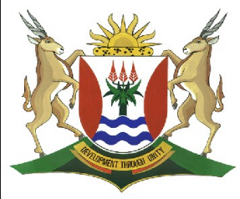
Province of the
EASTERN CAPE
EDUCATION

DIRECTORATE SENIOR CURRICULUM MANAGEMENT
(SEN-FET)
HOME SCHOOLING SELF-STUDY WORKSHEET ANSWER SHEET
SUBJECT | LIFE SCIENCES | GRADE | 12 | DATE | 07 April 2020
TOPIC | INHERITANCE OF BLOOD GROUPS (MULTIPLE ALLELES)  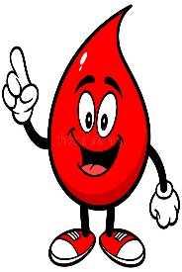 | TERM 1  REVISION |  | TERM 2 CONTENT

WORKSHEET: INHERITANCE OF BLOOD GROUPS 16 MARKS
- Write down the genotype for each individual based on the description given below.

  - Homozygous for the “B” allele ______
  - Heterozygous for the “A” allele ______
  - Type O ______
  - Blood group “A” and had a blood group “O” parent ______
  - Type “AB” ______ (5)

- Bob is married to Anne and they decide to have a baby. Bob is heterozygous for blood group B and Anne is blood group O.
What are the possible blood groups of their future children? Indicate the genotypic and phenotypic ratios of the children. (6)

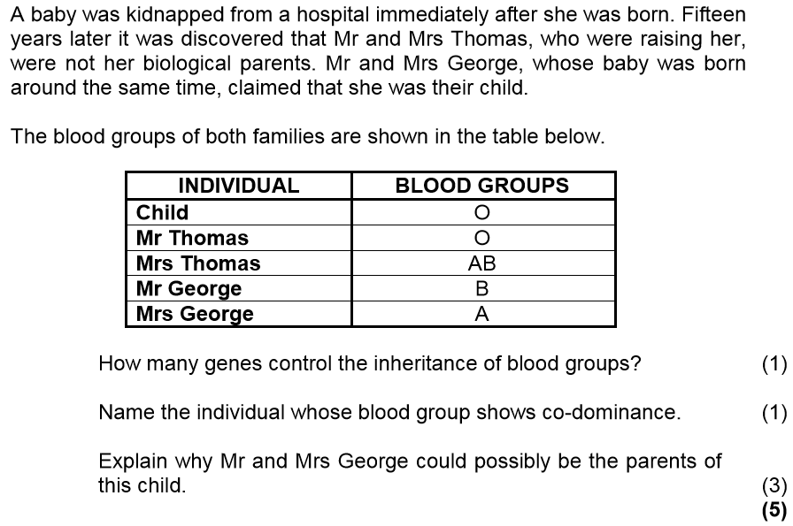
3.
3.1

3.2

3.3

TOTAL = 16
TYPICAL EXAM QUESTIONS: DO Q 2.4 P2 NOV 2018;
Q 1.4 NOV 2017

LEARNER ACTIVITY: TYPES OF DOMINANCE
1. Study the diagrams below and answer the questions:

KEY: Black fish (B) x Grey fish (G) | Type of dominance  Description  Crossing
KEY: Red bird (A) x Blue bird (a) | Type of dominance  Description  Crossing

white  red  pink  Key: Red flower (R)x White flower (W) | Type of dominance  Description  Crossing
TOTAL 15

