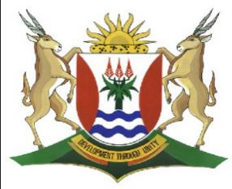 Province of the

EASTERN CAPE

EDUCATION

**DIRECTORATE SENIOR CURRICULUM MANAGEMENT (SEN-FET)**

**HOME SCHOOLING SELF-STUDY WORKSHEET ANSWER SHEET**

|  |  |  |  |  |  |
| --- | --- | --- | --- | --- | --- |
| **SUBJECT** | FITTING & MACHINING | **GRADE** |  | **DATE** | ARPIL 2020 WK 3 |
| **TOPIC** | MOMENTS: MEMORANUM | **TERM 1**  **REVISION** | (Please tick) | **TERM 2 CONTENT** | (√) |

**QUESTION 1**

MOMENTS

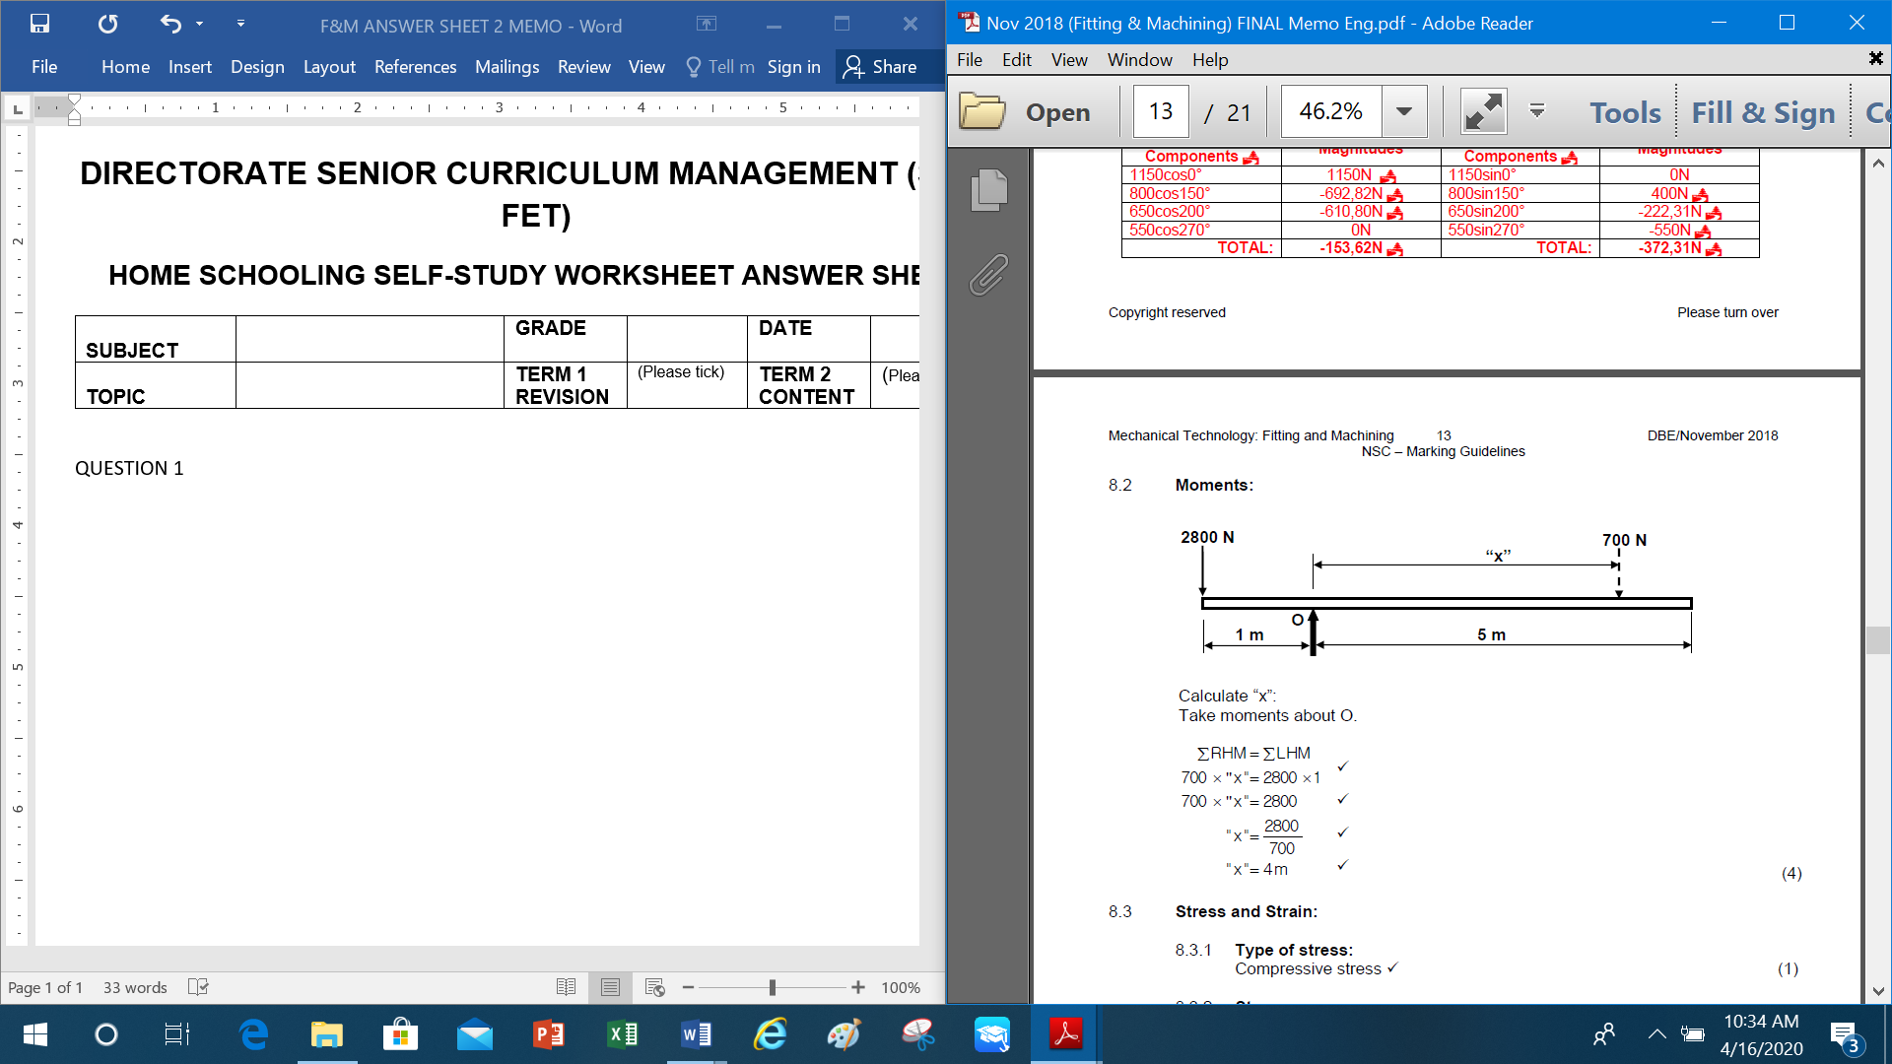

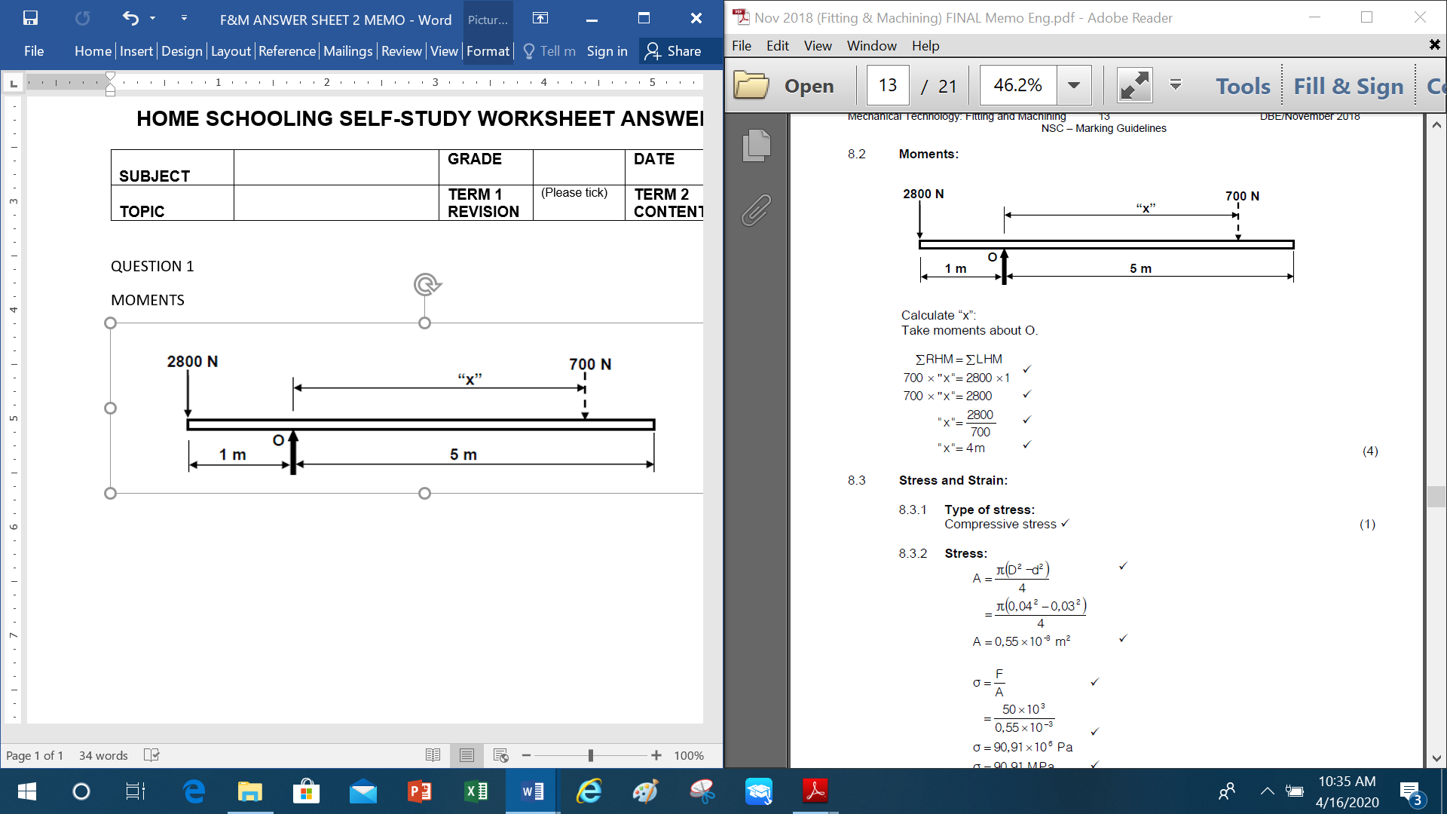

QUESTION2

|  |
| --- |
|  |

Take moments about S  
∑ clockwise moments = ∑ anticlockwise moments  
 60 (2) + 80(x-1,5) = 250(1,5)  
 120 +80x -120 = 375  
 80x = 375  
 x = $\frac{375}{80}$  
 = 4,69 m

**QUESTION 3**

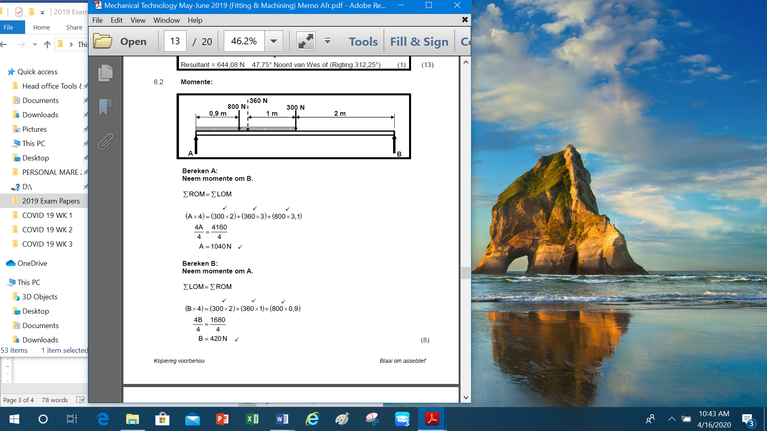

**Taking moments about A**

ΣLHM = $Σ$ RHM

**Taking moments about B**

$Σ$ RHM = ΣLHM

**QUESTION 4**

