Province of the
EASTERN CAPE
EDUCATION

DIRECTORATE SENIOR CURRICULUM MANAGEMENT (SEN-FET)
HOME SCHOOLING SELF-STUDY WORKSHEET TEST SHEET
SUBJECT | MARITIME ECONOMICS | GRADE | 12 | DATE | 10/04/20
TOPIC | MARITIME WORLD | TERM 1  REVISION | X | TERM 2 CONTENT | X

PLEASE READ THE FOLLOWING INSTRUCTIONS CAREFULLY
2. Answer all the questions.
3. Read the questions carefully before answering.
4. It is in your own interest to write legibly and to present your work neatly.
5. Where calculations are involved, all working must be shown.

SECTION A MULTIPLE-CHOICE QUESTIONS
QUESTION 1
Answer these questions by selecting the letter that represents the most suitable answer.
1.1 One of the organisations that will declare a ship seaworthy after an accident is the …
A Ship's Agent. B Classification Society. C Charterer. D P&I Club.
1.2 The agreement between the charterer and the ship owner in respect of the chartering of a ship is called the …
A Charter Register. B Charter Party. C Charter Agreement. D Charter Contract.
1.3 A ship is due to load coal at Richards Bay between 3 and 8 December. This period of time is called the …
A Laytime. B Laycan. C Demurrage. D Dispatch.
1.4 The maritime convergence zone between the Mediterranean Sea and the North Atlantic Ocean is called the …
A Turkish Straits. B Straits of Malacca. C Straits of Gibraltar. D Straits of Magellan.
1.5 The agreement between the owner of a ship in distress and the owner of a salvage tug regarding the salvage of a ship is called the …
A Lloyd's Register. B Lloyd's Open Form. C Lloyd's Open List. D Lloyd's Charter.
1.6 A charter whereby the ship has been chartered to move coal from Richards Bay to China for six months is called a …
A Voyage Charter. B Demise Charter. C Bareboat Charter. D Time Charter
1.7 The Incoterm that indicates that the consignee pays all charges from the time the cargo is stowed aboard the ship until its delivery at his premises is …
A FOB. B FAS. C FIO. D CIF.
1.8 The Incoterm that indicates that the consignor (shipper) pays all charges until the time the cargo arrives at the premises of the consignee.
A FOB. B FAS. C FIO. D CIF.

1.9 The type of marine insurance that covers the costs of a ship diverting from her course to land an injured crew member is …
A FFO. B Hull & Machinery. C TT Club. D P&I Club.
1.10 A weather phenomenon that brings very strong winds and rough seas to the central part of the Indian Ocean in the late summer is called a …
A Depression. B Mid-latitude cyclone. C Tropical cyclone. D High pressure cell.
1.11 The basis of the marine food chain is the …
A Zooplankton. B Bioplankton. C Phytoplankton. D Phyloplankton.
1.12 The figure that provides an indication of how many tons of cargo, fuel, fresh water, ballast water and stores a ship can carry is its …
A GRT. B MRT. C NRT. D DWT.
1.13 The IMO convention that covers the legal aspects of Bills of Lading is called the …
A Bill of Lading Convention. B Bill of Lading Code. C Carriage of Goods by Sea Convention. D Sea Transport Convention.
1.14 The IMO convention that covers the number of lifeboats and/or life rafts a ship should carry is called the …
A ISPS. B ISM. C SOLAS. D SAMSA.
1.15 Which of the following is a South African-owned island in the Southern Ocean?
A Marion Island. B Tristan da Cunha. C Gough Island. D Bouvet Island.
1.16 Which of the following will not result in a chartered vessel being off hire?
A The chartered ship diverting to render assistance to another ship that is on fire. B The chartered ship suffering engine trouble. C The chartered ship not being able to maintain the required speed for two days during the charter because of an engine problem. D The chartered ship's crew going on strike.
1.17 Which of the following is a cost that can be placed in the operations budget for a ship?
A Repayment of a bank loan on the ship. B Dry-docking. C Depreciation. D Ship's stores.
1.18 The South African government agency responsible for clearing imported cargo is the …
A South African Import Agency. B South African Receiver of Imports Agency. C South African Revenue Service. D South African Revenue Agency.
1.19 The term for seawater used to trim a ship is …
A Black water. B Ballast water. C Billage Water. D Brown Water.
1.20 Which is the weather-sensitive cargo in the list below?
A Aluminium Ingots. B Newsprint. C Iron ore. D Drilling pipes.
40 marks
SECTION B
QUESTION 2 THE MARITIME WORLD
2.1 What were the disadvantages of ships using coal for their fuel? (8)
2.2 How are naval architects and shipowners currently dealing with each of the following issues in ship design?
2.2.1 Air pollution (4)
2.2.2 Trying to make ships more fuel efficient. (6)
2.3 Study the graph below. It shows the "index" of the costs of building ships for the period January 2006 to January 2016. The values shown in the graph give an idea of increases or decreases in the cost of building ships. Now answer the questions set.
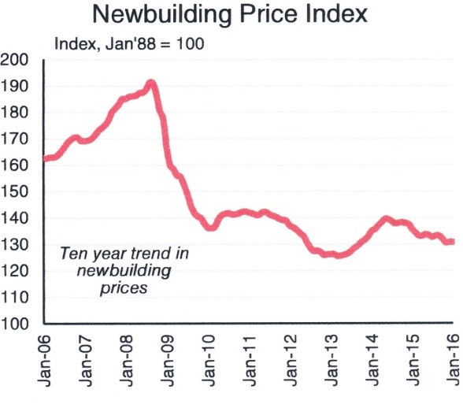

2.3.1 What is the highest index value on the graph? (2)
2.3.2 When did the index value begin to drop by more than 20 points? (2)
2.3.3 What was the cause of the rapid drop in the index value? (2)
2.3.4 Will shipowners be happy with the trend shown in the graph? Answer YES or NO. (2)
2.3.5 Explain your answer to Question 2.3.4. (4)
2.4 The major sources of the world's seafarers have changed over the last 30 years, and most seafarers now come from Asian or Eastern European countries, rather than from Western European countries such as Britain, Netherlands, Germany and Norway.
2.4.1 Name two countries that currently supply large numbers of seafarers to ships. (4)
2.4.2 Give three reasons for the decline in previously major seafaring nations as suppliers of seafarers. (6)
2.4.3 South Africa has a large number of young people and some believe that the shipping industry can be developed into a major employer of South African seafarers. What can be done to stimulate the development of local merchant shipping so that it can become a major employer of young people? (12)
2.5 Study the table below and answer the questions set.

SHIPPING STATISTICS – PORT EXE
SHIPS CALLING
2010 – 2015
2016 & 2017 estimated

YEAR >>> 2010 2011 2012 2013 2014 2015 2016 2017

SHIP TYPE

Container Ships 2100 2006 2114 2101 2356 2764 3118 3109

Bulk Carriers 204 232 241 221 1248 1809 2115 2332

A steel mill has been built at Port Exe. Iron ore (the raw material from which steel is made) and other minerals have to be imported. Some steel products are exported in containers and other steel products are exported in bulk.
2.5.1 Based on the information provided in the table, during which year did this steel mill begin to affect shipping at Port Exe? (2)
2.5.2 Explain why the number of container ships calling at Port Exe has been affected by the construction of the steel mill. (4)
2.5.3 What is the average number of container ships that have actually called at Port Exe per year? (2)
[100]

