Province of the
EASTERN CAPE
EDUCATION

DIRECTORATE SENIOR CURRICULUM MANAGEMENT (SEN-FET)
HOME SCHOOLING SELF-STUDY WORKSHEET ANSWER SHEET
SUBJECT | WELDING & METALWORK | GRADE | 12 | DATE | MARCH 2020
TOPIC | MATERIALS | TERM 1  REVISION | (√) | TERM 2 CONTENT | (Please tick)

QUESTION 1
1.1 |  | Explain the three steps for ALL heat treatment processes
 | 1.1.1 | Heat the metal slowly to a certain temperature to ensure a uniform temperature | 2
 | 1.1.2 | Soak the metal (soaking involves holding the metal at a pre-determined elevated temperature for a certain period to ensure uniform penetration of heat). | 2
 | 1.1.3 | Metal structure change takes place during Cool the metal at a certain rate to room temperature. | 2
1.2 |  | Critical Temperature
 | 1.2.1 | It is the temperature very critical or important during heat treating metals, and is when there is a phase change, structural change or crystalline structure change takes place. It depends on the carbon content. | 4
1.3 |  | Structural changes during heat treatment
 | 1.3.1 | Structural changes takes place at higher critical temperature. | 1
1.4 |  | Heat treatment that improves Machinability.
 |  | Annealing.

QUESTION 2
2.1 | Annealing is a process of heating a metal and allow it to soak at the same temperature for a specified time and cool it back to room temperature. Annealing relieves the metal of internal stresses and produces maximum softness. | 3
2.2 | Normalizing is when iron base alloys are heated to approximately 56° above upper critical temperature, allowed to soak at this temperature until it is uniformly heated and then cooled down to room temperature in still air.  It is done to relieve metals from internal stresses due to machining, forging and welding. | 3
2.3 | Hardening is achieving when a work piece is heated to a temperature slightly higher than the critical temperature, and then rapidly cooled by quenching it in water, brine or oil. Hardening is done in steel to enable it to resist wear, cut or abrasion. | 3
2.4 | Carburizing is a process used to harden low carbon steels that normally would not respond to quenching and tempering. This is done for economic reasons (utilizing less expensive steel) or design considerations to provide a tough part with good wear characteristics. | 3
2.5 | Tempering is reheating a quenched steel to a suitable temperature below the transformation temperature for an appropriate time and cooling back to room temperature. | 3

QUESTION 3
3.1 | 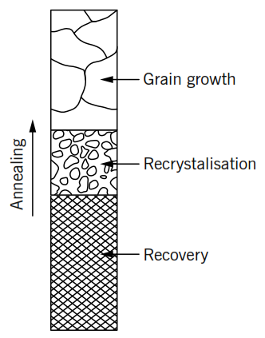  Annealing structural changes: | 5

