DIRECTORATE SENIOR CURRICULUM MANAGEMENT (SEN-FET)
HOME SCHOOLING SELF-STUDY WORKSHEET
SUBJECT | Nautical Science | GRADE | 10 | DATE | 9/4/20
TOPIC | Nautical terminology/Ship Parts/ Relative Positions/ Command and Control | TERM 1  REVISION | X | TERM 2 CONTENT | X
TIME ALLOCATION | 20min | TIPS TO KEEP HEALTHY  1. WASH YOUR HANDS thoroughly with soap and water for at least 20 seconds. Alternatively, use hand sanitizer with an alcohol content of at least 60%.  2. PRACTICE SOCIAL DISTANCING – keep a distance of 1m away from other people.  3. PRACTISE GOOD RESPIRATORY HYGIENE: cough or sneeze into your elbow or tissue and dispose of the tissue immediately after use.  4. TRY NOT TO TOUCH YOUR FACE. The virus can be transferred from your hands to your nose, mouth and eyes. It can then enter your body and make you sick.  5. STAY AT HOME.
INSTRUCTIONS | This worksheet is to be completed in your MRTE exercise/activity book.
Question 1

11.1 The diagram below illustrates the principal structural members or
parts of a ship’s hull. Name them accordingly. (12)

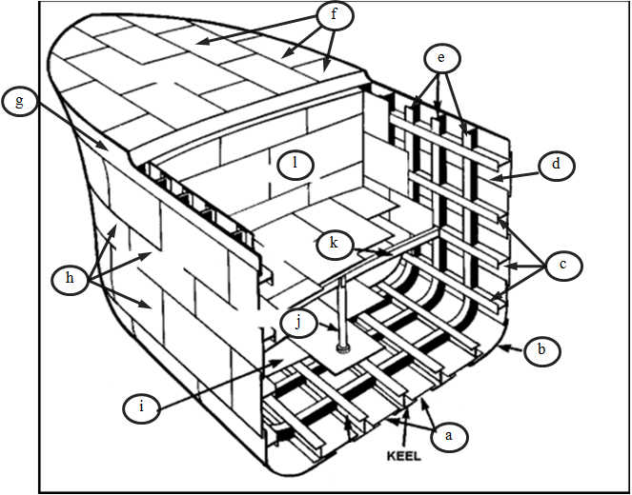

11.2 A double bottom is the watertight cellular structure between the Bottom
Plating and the Inner Bottom Plating.

a. What is the purpose of a double bottom hull? (2)
b. What use is the space provided by a double bottom hull
good for? (2)
c. For which type of ship is double bottom hull legally
compulsory? (2)

11.3 Name two types of hull designs. (2)

11.4 Indicate whether the statement is TRUE or FALSE:

- ‘Modular’ or ‘block’ style construction technique facilitates the
building of larger ships within shortened time frames. (1)

- A ‘dry dock’ is a port facility within which ship construction,
repairs and refurbishment usually takes place. (1)

- Grade A steel is prescribed for the pounding regions of a
Ship. (1)

- Traditionally the date on which a ship is launched becomes the
date of construction for that ship. (1)

- Ship construction inspection is undertaken by IMO engineers. (1) [25]

