

AGRICULTURAL TECHNOLOGY

PRACTICAL ASSESSMENT TASK

2009

This guideline consists of 17 pages.

TABLE OF CONTENTS

- Introduction 3

The Practical Assessment Task for Agricultural Technology

- Guide for teachers 4

Planning for the task
Requirements for the task
Resources for the task

- Guidelines for learners 7-10

- Assessment tools 11-14

PRACTICAL ASSESSMENT TASK FOR AGRICULTURAL TECHNOLOGY
INTRODUCTION

The 17 National Curriculum Statement subjects that contain a practical component all include a PAT, i.e. a Practical Assessment Task.

These subjects are:

- AGRICULTURE: Agricultural Management Practices, Agricultural Technology
- ARTS: Dance Studies, Design, Dramatic Arts, Music, Visual Arts
- HSS: Life Orientation
- SCIENCES: Computer Applications Technology, Information Technology
- SERVICES: Consumer Studies, Hospitality Studies, Tourism
- TECHNOLOGY: Civil Technology, Electrical Technology, Engineering Graphics and Design, Mechanical Technology

The PAT allows the teacher to directly and systematically observe applied competence. The PAT comprises the application/performance of the knowledge, skills and values particular to that subject.

The PAT is implemented across the last term of Grade 11 and the first two terms of the school year in Grade 12 and should be undertaken as one extended task. The planning and execution of the PAT differs from subject to subject. The evaluation and the moderation of the PAT will commence in the third term of Grade 12.

TEACHER GUIDE
The Practical Assessment Task for Agricultural Technology

Schools will be informed of the list of projects at the beginning of the third term of grade 11 of each academic year to allow the teacher to do his planning in advance. Schools will choose one option from given choices.

The Practical Assessment Task comprises a design component and a manufacturing component. The PAT leads to the design and development of a product according to the technological processes. The task should have functional value and must be based on real-life situations, for example the construction of a braai, workbench, neck clamp, or drinking trough for animals, etc. The learners should be familiarized with the assessment criteria before they start with the task.

The Practical Assessment Task in Grade 12 is externally set and moderated, but internally assessed. The project is completed under controlled conditions and is assessed by means of a rubric.

The PAT counts 25% of the total promotion mark (400) in Grade 12.

The Practical Assessment Task counts 100 marks and consists of a design portfolio (25 marks), and the final product (75 marks). The Practical Assessment Task therefore focuses on the development of the design portfolio (25 marks), the manufacturing processes (50 marks) and the final product (25 marks).

The Design Portfolio

The design portfolio should include evidence of how the development of the product was approached, that is:
- Analysis and planning of the assignment
- Interrelationship between technology, society and environment
- Sketches, diagrams or calculations used – if applicable
- Materials used
- General safety rules
- Cost calculations and materials list
- Knowledge and skills acquired in the manufacturing process
- Manufacturing processes that were followed
- Starting time and ending time – how long it took to complete, from start to finish
- Research or investigations undertaken
- Any other information that is relevant to the project

The format of the portfolio must be as follows:

Cover page: Learner name
School name
Exam number
Year
Index: Assignment
Planning/Research
Design sketches
Materials list
Cost calculations
Source list
Any additional information

The project should be completed over the following TWO phases:

Phase 1: Design: (25 Marks)
Learners must identify the problem or need in their chosen project, investigate the project, generate ideas and arrive at possible design solutions to make or produce the project. The last step is to evaluate and communicate the solution to the problem or need with the teacher. The evidence of this phase will be located in the design portfolio which will start in term 4 of Grade 11 and continue to the end of January/February, Grade 12.

Phase 2: Manufacturing: (75 Marks)
Learners construct the actual product or artefact at the start of January / February, Grade 12 and finalise it at the end of term 2, Grade 12. If the design solution does not lend itself to a full-scale artefact, a scaled model or a representation can be produced. However, in the latter instance, the learner is expected to provide full-size sections showing construction details including relevant surface finishing. A model can indicate the context in which the product is to be used.

Note: Learners submit the product or artefact for assessment by the end of the second term of Grade 12. The accompanying planning done in phase 1 (design portfolio) must also be submitted for assessment at this time. Phase 1 and phase 2 are assessed simultaneously.
The criteria for assessing the Design Portfolio (25 marks) are the following:

- Analysis and planning of the problem
- Interrelationship between technology, society and the environment
- Ability to generate ideas
- Providing a solution
- Sketching (dimensions, welding symbols, scale, and projection symbol)
- Materials, tools and equipment used
- General safety rules
- Cost calculations and materials list
- Evidence of comparisons between different processes, skills and materials
- Portfolio presentation

The criteria for assessment during the manufacturing of the product (face moderation)
(50 marks) are the following:

- Safe handling and care of tools/equipment
- Skills relating to the use and maintenance of tools and equipment
- Knowledge of materials to solve problems
- Application of different techniques and processes
- Skills demonstrated in the application of processes

The criteria for assessing the quality of the final product (25 marks) are the following:

- Addresses the problem/need. The product fulfils the purpose for which it was designed and shows innovation that is appropriate to the problem.
- Dimensions and measurements of the final product
- Appearance: Finishing off. This includes filing, grinding, sanding and painting.
- Functionality of the final product. Does it function properly?
- Time management. Has the product been completed within the given time?

AGRICULTURAL TECHNOLOGY

Practical Assessment Tasks (PAT)

2009

Guidelines for Learners

LEARNER TASK:

Introduction:
The artefact product that learners will construct is a security gate that can be utilised on the farm. The skills and knowledge acquired in Agricultural Technology will be utilised by the learners to engage in this project.

The product / artefact that the learners will construct will consist of approximately 60% of the processes gained in the theoretical work done during the year. These processes consist of various tasks that can be undertaken on the farm. The learners utilise their skills and knowledge in Agricultural Technology to engage in this project.

Kindly note that the Design portfolio must start in term 4 of Grade 11 if possible and must be finished by the end of January/February in Grade 12. The construction process must be finished by the end of the second term in Grade 12. Assessment and moderation will be conducted in the third term.

Assignment:

The product/artefact that learners are required to construct is a security gate used on the farm.

Learners must submit the product / artefact for assessment by the end of the second term. The accompanying planning done in phase 1 (design portfolio) must also be submitted for simultaneous assessment with the product at this time.

The resources required for this project:

The resources required for the project would depend on the design of the gate which will be decided upon by the learner. Learners themselves must get the opportunity to decide on and design a security gate for the farm, therefore the given example remains only an example. Learners can use the example or they can design their own security gate.

Design Portfolio (25 marks)

The criteria for assessing the Design Portfolio (25 marks) are the following:
- Analysis and planning of the assignment
- Interrelationship between technology, society and the environment
- Ability to generate ideas
- Providing a solution
- Sketching (dimensions, welding symbols, scale, and projection symbol)
- Materials, tools and equipment used
- General safety rules
- Cost calculations and materials list
- Evidence of comparisons. E.g. different processes, skills or materials
- Portfolio presentation
- The starting time and ending time – how long it took to complete from start to finish
- The investigations or research undertaken (need to give details of all resources used including web sites, etc)
- Any other information that is relevant to the project.

Construction (50 marks)
The criteria for assessing during the manufacturing of the product (face moderation) (50 marks) are the following:

- Safe handling and care of tools/equipment
- Skills relating to use and maintenance of tools and equipment
- Knowledge of materials to solve problems
- Application of different techniques and processes
- Skills demonstrated in the application of processes

Quality (25 marks)

The criteria for assessing the quality of the final product (25 marks) are the following:

- Addresses the problem/need. The product fulfils the purpose for which it was designed and shows innovation that is appropriate to the problem.
- Dimensions and measurements of the final product
- Appearance: Finishing off. This includes filing, grinding, sanding and painting.
- Functionality of the final product. Does it function properly?
- Time management. Is the product complete?

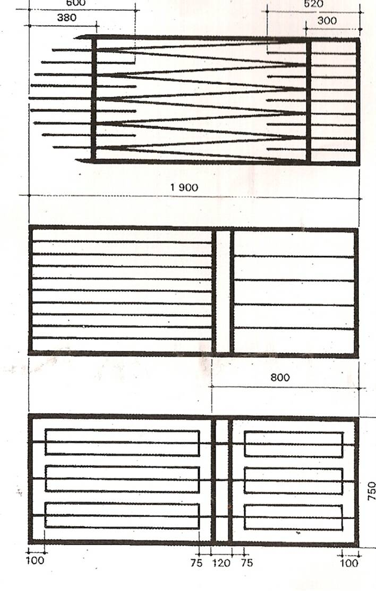
Project - A Security Gate
Step 2
Getting it together:
Step 3
- Place the frame back onto the drawing and mark the positions of the vertical bars onto the frame.
- Lay the 12 mm tubing on the frame and mark the lengths. (If the bars are to be at an angle, mark the angles at which they are to be cut)
- Cut the 12 mm lengths.
- Place lengths back in position one at a time, and tack weld
them to the frame.
- When all bars are in position, complete the welds and clean all the weld joints.

- Measure the positions of the hinges and lock and tack them to
the frame. (Afrox Tip: Check that they match the position on the
wall before you complete the welds)

- Draw the gate frame, including cross members on
a flat steel or concrete work surface.
- Lay the 25 mm tubing on the drawing and mark it for
length and angle of cut.
- Cut the lengths accordingly and lay them back on the drawing. (Afrox Tip: hold them together with magnets)
- Check that the joints fit closely without gaps.
- Tack weld each joint, check for square and complete the
welds.
- Clean all the weld joints.
Step 1

EXAMPLE OF AN ASSESSMENT RUBRIC FOR THE PAT.
ASSESSMENT TASK:
Name of Candidate:………………………………………………………..School:……………………………………….
Grade : ………………………………………………………..Date :……………………………………….
DESIGN PORTFOLIO | MANUFACTURING PROCESS | QUALITY OF PRODUCT | TOTAL | NAME OF ASSESSOR | NAME OF EXTERNAL  MODERATOR
/25 | /50 | /25 | /100

A. RUBRIC FOR ASSESSMENT OF THE DESIGN PORTFOLIO
CRITERIA | 1 | 2 | 3 | 4 |  | 5 | POSSIBLE MARK | MARK OBTAINED
Planning Skills:  Analysis and diagnosis | Shows no attempt to identify and collect information to analyse the given problem or need. | Shows an attempt to identify and collect relevant information to analyse the given problem or need. | Identifies the given problem correctly and collects relevant information to analyse the problem or need. | Analyses the given problem correctly and shows evidence of the use of a wide range of information to understand the problem or need. |  | Identifies the given problem correctly and uses a variety of investigation strategies to obtain relevant information that assisted in developing and design of innovative ideas. | 5
Interrelationship between technology, society & environment | Makes no attempt to consider the interrelationship between technology, society & environment. | Awareness of the interrelationship between technology, society & environment was demonstrated. | Awareness and knowledge of interrelationship between technology, society & environment was demonstrated. | Application and knowledge of interrelationship aspects. |  | Application and knowledge of interrelationship aspects and the implementing of preventative measures. | 5
Generate ideas | Mentions some ideas. | Shows some awareness of alternative ideas. | Offers some alternative ideas with a limited reasoning of choices. | Uses original and creative ideas and chooses the most suitable option. |  | Generates an excellent variety of alternative and innovative ideas.  The preferred option is well justified with clear links to the design. | 5
Solution | Attempts to come up with limited design sketches and some specifications and constraints relating to the given problem. | Attempts to come up with design sketches, specifications and constraints relating to the given problem. | Provides design sketches and a variety of specifications and constraints relating to the given problem. | Provides excellent design sketches and a list of relevant specifications and constraints to the given problem. |  | Provides excellent innovative design sketches that is extremely well formulated and defines the need according to the given problem. | 5
Sketching | Provides irrelevant sketches that demonstrate limited drawing skills. | Provides some relevant sketches with incorrect lines and/or wrong symbols. | Provides relevant sketches with correct lines and symbols. | Provides sketches with correct lines and symbols and related to the given problem. |  | Provides excellent sketches according to the given problem considering possible solutions. | 5
Material, tools and equipment list | Attempts to list some materials, tools & equipment. | Provides a list of materials, tools and equipment incorrect or insufficient. | Provides a list of relevant material, tools and equipment. | Provides a list with a variety of relevant materials, tools and equipment needed. |  | Provides a list of the most relevant materials, tools and equipment needed in a creative format. | 5
General Safety | Attempts to consider Safety Regulations. | Shows some awareness of Safety Regulations. | Shows awareness, knowledge and application of Safety Regulations. | Shows awareness, knowledge and application of Safety Regulations regarding a variety of conditions. |  | Shows awareness, knowledge and application of Safety Regulations regarding all possible conditions and considers preventative measures. | 5
Cost calculations and materials list | Provide a materials list with no calculations. | Attempts to do cost calculations by using incorrect units, data and materials list. | Provides cost calculations using correct units and data collected without consideration of constraints. | Provides cost calculations using correct units and data collected and considers constraints. |  | Provides cost calculations using correct units and data collected and considers relevant constraints. | 5
Comparisons | No comparisons | Poor comparison of one process | Comparison of different processes, skills and materials. | A thorough comparison of different processes, skills and materials |  | A thorough comparison of different processes, skills and materials and comes to a conclusion | 5
Portfolio presentation | The portfolio is incomplete and poorly ordered and prepared. | The portfolio is completed but poorly ordered and prepared. | The portfolio is completed and adequately ordered and prepared. | The portfolio is completed and well presented. |  | The completed portfolio presentation shows a high level of innovation and creativity. | 5
TOTAL MARK |  |  |  |  |  |  | 50÷2=25

B. RUBRIC FOR ASSESSMENT OF THE CONSTRUCTION PROCESSES
CRITERIA | 1 | 2 | 3 | 4 | 5 |  | POSSIBLE MARK | MARK OBTAINED
Safe handling of tools/ equipment (face moderation) | Demonstrates awareness of safety measures. | Demonstrates awareness and knowledge of some safety measures. | Demonstrates adequate knowledge and awareness of applicable safety measures. | Demonstrates sufficient knowledge and awareness of all applicable safety measures. | Demonstrates sufficient knowledge and awareness of all applicable safety measures and apply preventative measures. |  | 5
Skills relating to handling of  tools and equipment  (face moderation) | Demonstrates limited knowledge and skills related to tools and equipment used. | Demonstrates some knowledge and skills related to tools and equipment used and housekeeping. | Demonstrates adequate knowledge and skills related to tools and equipment used and evidence of housekeeping. | Demonstrate adequate knowledge and skills related to tools and equipment used and good housekeeping. | Demonstrate sufficient knowledge and skills related to maintenance and use of tools and equipment and excellent housekeeping. |  | 5
Knowledge of materials | Shows limited background knowledge on materials used. | Shows some knowledge of materials and their properties. | Shows adequate knowledge of materials and their properties and concepts. | Shows adequate knowledge of materials and their properties, concepts and principles. | Shows sufficient knowledge of materials and their properties, concepts and principles to solve problems. |  | 5
Processes and techniques | Demonstrates some knowledge of inappropriate techniques used. | Demonstrates limited knowledge of techniques used. | Demonstrates adequate knowledge of correctly selected techniques. | Demonstrates adequate knowledge on how to select and apply the relevant techniques correctly. | Demonstrates sufficient knowledge of correctly selected and applied techniques considering possible constraints. |  | 5
Skills used in  processes  (face moderation) | Demonstrates limited knowledge of skills needed. | Demonstrates some knowledge of skills needed. | Demonstrates adequate knowledge of skills needed. | Demonstrates adequate knowledge of skills needed and considering some constraints. | Demonstrates sufficient knowledge of skills needed and considering relevant constraints. |  | 5
TOTAL MARK |  |  |  |  |  |  | 25x2=50

C. RUBRIC FOR ASSESSMENT OF THE QUALITY OF THE FINISHED PRODUCT
CRITERIA | 1 | 2 | 3 | 4 | 5 |  | POSSIBLE MARK | MARK OBTAINED
Address the  Problem/need | The product is incomplete. The completed product lacks details and makes interpretation difficult. | The product is complete but does not address the problem or need at all. | The product is complete and partly addresses the problem or need. | The product fulfils the purpose for which it was designed and shows no real evidence of innovation in the solution to the identified problem or need. | The product fulfils the purpose for which it was designed and shows innovation that is appropriate to the identified problem or need. |  | 5
Dimensions and measurements of the final product | Dimensions differ completely from original design. Shows no effort in making correct measurements. | Dimensions differ from original design. Shows some effort in making correct measurements. | Some dimensions differ from original design. More accuracy and effort is shown in making correct measurements. | Dimensions differ slightly from original design. Shows much more accuracy and effort in making correct measurements. | Measurements and dimensions correlate completely with original design. |  | 5
Appearance:  Finishing off. Filing,  grinding, sanding and painting | No finishing off. No filing, painting or sanding. Shows little effort in making the appearance acceptable. | Product’s appearance not acceptable due to some of the finishing methods that were not followed. | Product’s appearance acceptable due to some of the finishing methods that were used. | Product’s appearance more acceptable due to finishing off that was done but no painting. | Product’s appearance is very acceptable and shows a high level of innovation and creativity. |  | 5
Functionality of the  final product. Does it function properly. | The product is incomplete and does not function at all. | The product is complete but it is not functional at all and shows no new improvements. | The product is complete, and functions but shows no new improvements and little innovation. | The product is complete, functions well and shows new improvements and innovation. | The product is complete, functions very well and shows many new improvements and a very high level of innovation. |  | 5
Time management | Very little evidence of time management. | Demonstrates some sense of time management but planning not realistic. | Evidence of realistic time management in planning but not keeping to the plan. | Manages time well according to the initial plan. | Manages time exceptionally well by considering alternatives according to the initial plan. |  | 5
TOTAL MARK |  |  |  |  |  |  | 25

