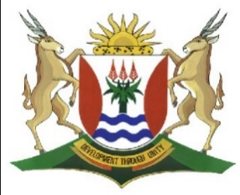
Province of the
EASTERN CAPE
EDUCATION

DIRECTORATE SENIOR CURRICULUM MANAGEMENT (SEN-FET)
HOME SCHOOLING SELF-STUDY MARKING GUIDELINES
SUBJECT | ACCOUNTING | GRADE | 10 | DATE | 11 May 2020
TOPIC | Term 2 Content | REVISION

QUESTION 1
1.1 GENERAL LEDGER OF HLOPHE TRADERS
TRADING ACCOUNT
2020  Feb | 28 | Cost of Sales |  | 360 000 | 2020  Feb | 28 | Sales (648 000 – 5 000) |  | 643 000
 |  | Profit and Loss (Gross Profit) |  | 283 000
 |  |  |  | 643 000 |  |  |  |  | 643 000

1.2 PROFIT AND LOSS ACCOUNT
2020  Feb | 28 | Wages and Salaries |  | 160 000 | 2020  Feb | 28 | Trading Account |  | 283 000
 |  | Vehicle Expenses |  | 17 000 |  |  | Rent Income |  | 66 000
 |  | Advertising |  | 6 500 |  |  | Commission Income |  | 25 600
 |  | Stationery |  | 4 100 |  |  | Interest Income |  | 2 100
 |  | Water and Electricity |  | 4 800
 |  | Interest Expense |  | 39 200
 |  | Sundry Expenses |  | 11 300
 |  | Capital (Net Profit) |  | 133 800
 |  |  |  | 376 700 |  |  |  |  | 376 700

