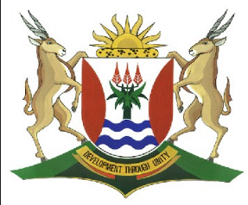
Province of the
EASTERN CAPE
EDUCATION

DIRECTORATE SENIOR CURRICULUM MANAGEMENT (SEN-FET)
HOME SCHOOLING SELF-STUDY WORKSHEET HOME ANSWER SHEET
SUBJECT | MARITIME ECONOMICS | GRADE | 10 | DATE | 26/05/20
TOPIC | ANSWERS TO TYPES OF SHIPS AND TERMINOLOGY | TERM 1  REVISION | X | TERM 2 CONTENT | X
Question 1
1.1 Bulk Carriers, Containerships, Passengerships (3)
1.2
- Craned handysized bulk carrier
- Panamax Max
- Multipurpose cargo vessel
- Dredger
- Coastal tanker
- Handysize (6)
1.3
- Homogenous Cargo (2)
- It is the vessel that carries/transports cargo from one to another (2)
- Suezmax can transit through suez canal and capsize can transit through Cape of Good hope or Cape Horn (2)
1.4
- Ferries
- Ro-Ro
- Hold
- Gally
- Ton-Miles (5)

