Demonstration of Language Across Curriculum (LAC)
GRADE: 8 NATURAL SCIENCES & 11
AGRICULTURAL SCIENCES

TOPIC: The atom

SUB TOPIC: The structure of an atom
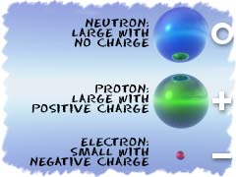

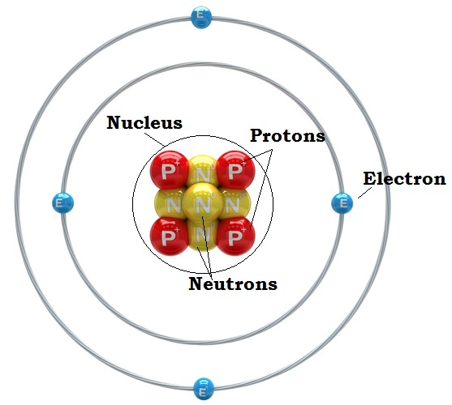

What is an Atom?

The word 'atom' comes from the Greek word for indivisible. Atoms are the smallest particle of an element. Atoms are the building blocks of molecules, and molecules are the building blocks of matter. Atoms are made up of three particles: protons, neutrons and electrons.
The protons and neutrons are always in the center of the atom. Scientists call the center region of the atom the nucleus. The electrons are always found moving around the center in areas called shells or orbitals.
The electron always has a "-", or negative, charge. The proton always has a "+", or positive, charge. The neutron has a neutral charge. All atoms have equal numbers of protons and electrons so that they are neutral. The total number of electrons in an atom is always the same as the number of protons in the nucleus. This means atoms have no overall electrical charge. If there are more positive protons or negative electrons in an atom, you have a special atom called an ion.

ACTIVITY 1: LISTENING AND SPEAKING
Ask the following questions to activate prior knowledge and to deal with key vocabulary
- Why do things look different?
- Why is water different from alcohol?
- Explain what you understand by the following words
  - matter (definition or rewording)
  - indivisible (use the prefix to form the opposite meaning)
  - particle (diminutive)
  - charge (make connections)
  - positive (make connections)
  - negative(make connections)

ACTIVITY 2: During Listening
- Play the clip on ‘What are atoms?’
- Search for meaning-identify main and supporting ideas
- Constantly check understanding of message by making connections, making and confirming questions, making inferences, evaluating and reflecting
- Stop periodically to allow for note taking, such as new vocabulary in the following template.

K | W | L
What I know | What I want to know / find out | What I learnt

ACTIVITY 3: POST-LISTENING
- Review notes taken during listening
- Confirm the accuracy of the notes.

ACTIVITY 4: READING AND VIEWING
- Read article on’ What is an Atom’ silently.

POST-READING
- Label the parts of an atom using the information form the article.

ACTIVITY 5: WRITING AND PRESENTING

Write a short paragraph of five to ten lines and answer the following questions:
- Describe the basic structure of an atom
- What are the three particles that make up an atom?

Use the following checklist to evaluate your paragraph:

Criteria | ✓
Written in full sentences
All parts of an atom described
Spelling and punctuation errors

Mark allocation:
Content = 7
Language = 3 (10)

ACTIVITY 6: ASSESSMENT PROJECT
- Use the marshmallows or cotton balls, pipe cleaners and beads to build
an atom model
- Present the model you have designed. (20)
ASSESSMENT TOOL - Rubric

