Grade 11Agricultural Sciences
BASIC CHEMISTRY

GENERAL ATOMIC STRUCTURES
- The make-up of the atom.
- Atom is a basic unit of matter.
- Examples being: - hydrogen atom, nitrogen atom, carbon atom.
- What is matter?
- Anything that occupies space and has mass.
- Examples being: - soil, spade, livestock etc.
- Consolidation of concepts.
- Any example of matter, such as soil, livestock consists of atoms. Therefore there cannot be matter without atoms, thus basic unit of matter.
- What is an element?
- A substance that cannot be chemically changed or broken down into anything simpler.
- Elements in agriculture can be found in fertilizers which could be organic or inorganic by nature.
- This elements form important nutrients to plants namely: - nitrogen, phosphorus & potassium.
- Also elements cane found in pesticides which are used to destroy, repel or control pests.

ATOMIC STRUCTURES
Atoms are made of different components namely:-
- Energy level / orbits / shells
- Circular path-like around the nucleus.
- Number of electrons determines the number of shells around the nucleus.
- Electrons
- Negatively charged particles revolving around the nucleus in the orbits.
- Can be shared, donated or accepted during bonding/chemical reaction.
- Nucleus
- Found in the middle of the atom.
- Contains both neutrons & protons.
- Neutron
- Neutrally charged.
- Proton
- Positively charged.
- Determine the atomic number of an atom.

Schematic representations of an Atom
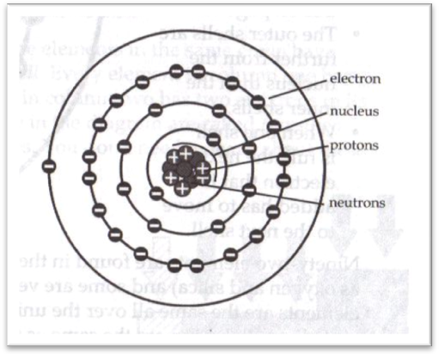

Periodic table
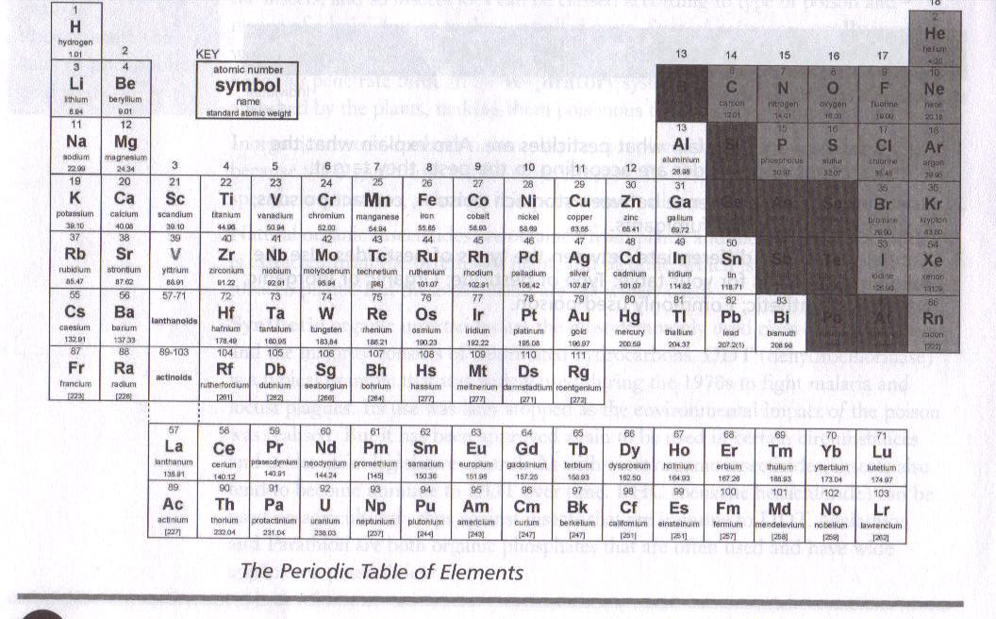
Important information from periodic table
- Symbol of an element.
- Atomic number.
- Relative Mass Number.
Symbols: - hydrogen = H, oxygen = O, carbon = C, iron = Fe, sodium = I, nitrogen = N, sulphur = S.

Atomic number
- The number which determine the position of the element in the periodic table.
- Also it indicates the total number of protons in the nucleus of the atom.
Atom | Symbol | Atomic number | Protons | Electrons
Hydrogen | H | 1 | 1 | 1
Oxygen | O | 8 | 8 | 8
Iron | Fe | 26 | 26 | 26
Chlorine | Cl | 17 | 17 | 17

Configuration of atom
- Hydrogen (H) : atomic number 1
- Helium (He) : atomic number 2
- Lithium (Li) : atomic number 3

Energy level / shells / orbits
- First level accommodates maximum of two electrons.
- Second level accommodates maximum of eight electrons.
- Third level accommodates maximum of eight electrons.
- Fourth level accommodates maximum of eight electrons.

Stable (Inert gases)
- Have a maximum number of electrons on their outer energy level.
- They are less reactive.

Unstable
- Have less than maximum number of electrons required for the energy level.
- They are very reactive.

Valence electrons.
- Refers to the number of electrons found on the outer energy level.
- Refers to bond possibility/eventuality

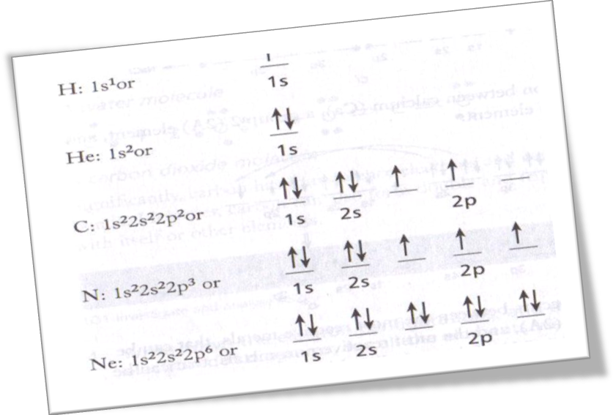
Atom | Atomic number | Valence electron (s)
Carbon | 6 | 4
Oxygen | 8 | 6
Nitrogen | 7 | 5
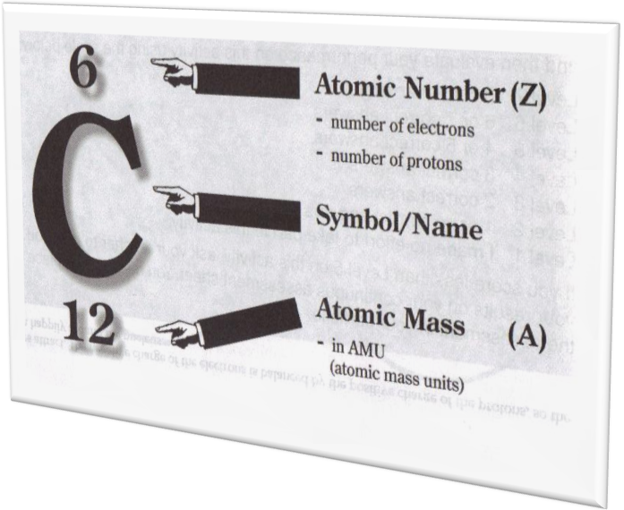

Mass number
- Refers to the total number of protons and neutrons in the nucleus of the atom.
- Mass number is always indicated on the periodic table.
- To obtain the exact number of neutrons, subtract the number of protons from the mass number.

Isotopes
- Have the same atomic number but have different mass number.
- The number of electrons and protons are the same, but number of neutrons is different.
Example of hydrogen isotopes, namely: - protium, deuterium & tritrium
 | Protium | Deuterium | Tritrium
Atomic number | 1 | 1 | 1
Number of protons | 1 | 1 | 1
Number of electrons | 1 | 1 | 1
Number of neutrons | 0 | 0 | 2
Mass number | 1 | 2 | 3

Lewis / dot structure
- Representation of number of electrons on the outer shell with a dot.
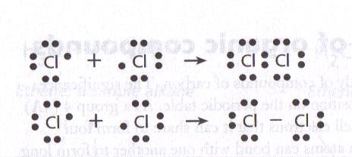

Coupers structure/structural formula
- Dash symbol.
- Representation of sharing of electrons, or number of bonds between atoms.
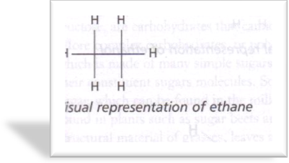

Chemical bonding
- Joining or linking of two or more atoms
- Bonding happens because of electrostatic force between two positive and negative ions.

Types of chemical bonding
- Ionic / electrovalent bond
- Occurs when the positive ion and the negative ion bond to form the molecule.
- Covalent bond
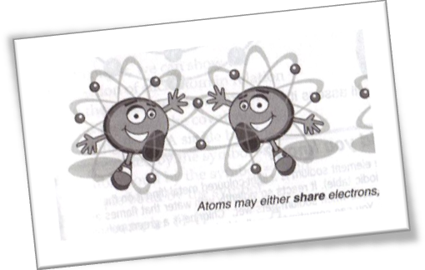
- Two or more atoms are held together as a result of sharing electrons.
- Polar covalent bond
- Two or more atoms share electrons and two electrical ends (poles) are created. E.g. water molecule. (H₂O)
- Non-polar covalent bond
- Sharing of electrons in two or more atoms doesn’t result in formation of two opposite poles. E.g. hydrogen molecule (H₂)
- Weak / hydrogen bond
- Occurs amongst the molecules involving the hydrogen. E.g. water-water linkage.

COMPOUNDS
Definition: - a substance which consists of two or more elements chemically combined together.

Types of compounds
- Organic compounds: - 1. Contain carbon & hydrogen elements. 2. Sulphur, phosphorus, nitrogen might be included.
- Alkalines/paraffin/hydrocarbons
- Pure hydro-carbon chain.
- Single bond between C-H
- Names usually ends with –ane.
- Functional group is the group (-CH₃)
- First four are gases.
Examples of alkanes
- Methane CH₄
- Ethane CH₃CH₃
- Propane CH₃CH₂CH₃
- Butane CH₃(CH₂)₂CH₃
- Alcohols
- Functional group is hydroxyl group (-OH).
- Name usually end with –ol or –anol.
- Fermentation of glucose/fructose forms ethanol & water.
- Ethanol is changed to ethanol acid if it exposed to atmospheric oxygen.
Examples of alcohols
- Methanol (CH₂OH)
- Ethanol (CH₃CH₂OH)
- Propanol (CH₃(CH₂)₂OH
- Butanol (CH₃(CH₂)₃OH
- 1,2,3-Propantriol / glycerol / glycerine CH₂OHCHOH₂OH
- Fatty acids (carboxylic acid)
- Functional group is carboxyl group/acid group (-COOH)
- –OH in alcohol is replaced by acid group to form the fatty acid.
Examples of fatty acids
- Methanoic acid / formic acid HCOOH
- Ethanoic acid / acetic acid CH₃COOH
- Propanoic acid / propionic acid CH₃CH₂COOH
- Butanoic acid / butyric acid CH₃(CH₂)₂COOH
Types of fatty acids
        - Saturated fatty acid
- Don’t have double between any carbon atoms.
Examples
- Palmatic acid CH₃(CH₂)₁₄COOH
- Stearic acid CH₃(CH₂)₁₆COOH
        - Unsaturated fatty acid
- Double bond between two carbon atoms.
Examples
- Oleic acid CH₃(CH₂)₇CH=CH(CH₂)₄COOH
- Lipids (fats & oils)
- Synthesized when alcohol reacts with fatty acids.
Properties of lipids
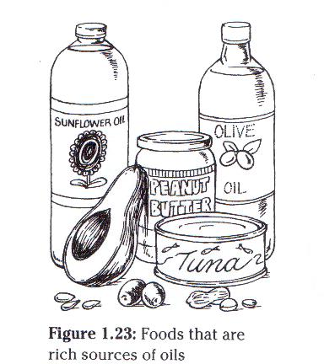
- Plant lipids (oil)
- Unsaturated and synthesized from oleic acid.
- Melting point of 13⁰C.
- Liquid at room temperature.
- Essential for human diet.
- Less likely to cause fatty obstruction in the blood. (heart attack)
- Animal lipids (fats)
- Saturated and synthesized from palmatic & stearic acid.
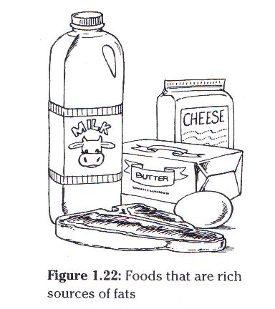
- Palmatic melts at 13⁰C and stearic at 70⁰C.
- Solid at room temperature.
- Cause accumulation of fats in blood vessels. (atherosclerosis)
- Less reactive (no double bond between carbon atoms)

Functions
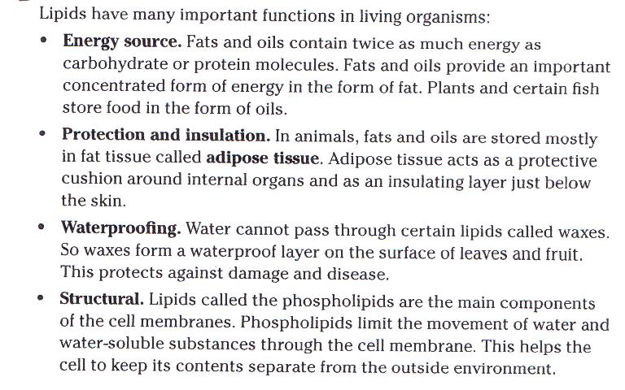

- Proteins
- Complex chemical compounds consisting of amino acids.
Characteristics of amino acids
- All contain amino group (-NH₂).
- All contain acid group (-COOH).
- Some contain sulphydryl group (-SH)
Examples of amino acids
- Glycine (NH₂CH₂COOH)
- Alanine (NH₂CHCH₃COOH)
- Cystine (NH₂CHCH₂SHCOOH)
Formation of polypeptide chains
- Two monomers form dipeptide.
- Energy is required for this process.
- Type of bond is known as peptide bond.
- Dehydration process is also in place.
Formation of tripeptide
- Consist of three amino acids (monomers).
- Two water molecules split-off two peptide linkages.
- Polypeptides are formed by a number of monomers peptides bonds.
Hydrolysis of proteins
- Protein molecules are broken down amino acids.
- Then proteins are absorbed in the form of amino acids.
- Water is added to split the protein molecule.

Functions
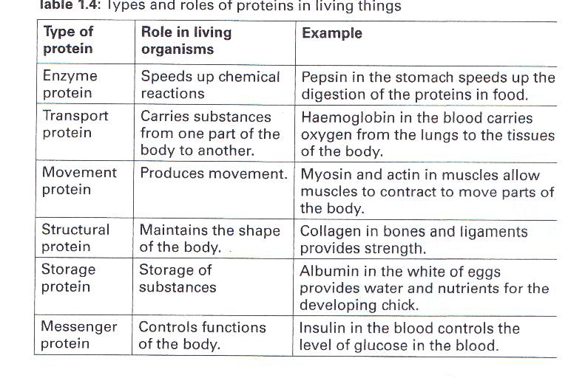
- Carbohydrates
- Source of energy.
- Consist of carbon, hydrogen, & oxygen.
- Ratio of hydrogen to oxygen is 2:1
- General formula C_{X}(H₂O)_{Y}
Carbohydrates groups
- Monosaccharides (simple sugars)
- Building blocks of carbohydrates.
Examples
- Trioses C₃H₆O₃
- Tetroses C₄H₈O₄
- Pentoses C₅H₁₀O₅
- Hexoses C₆H₁₂O₆
Types of hexoses
            - Glucose C₆H₁₂O₆
            - Galactose C₆H₁₂O₆
            - Fructose C₆H₁₂O₆
- Heposes C₇H₁₄O₇
Synthesis of monosaccharides from disaccharides
- In vitro reaction
- Occurs outside the cell (test tube)
- Rate of can be accelerated by heating the reactant.
- A catalyst is also used for the reaction to take place.
- In vivo reaction
- Occurs inside the living cell.
- Occurs at the specific rate.
- Disaccharides (complex sugars)
- Consist of two monosaccharides.
Types of disaccharides
- Maltose (malt sugar)
Glucose + glucose = maltose + water
C₆H₁₂O₆ + C₆H₁₂O₆ = C₁₂H₂₄O₁₁ + H₂O
- Lactose (milk sugar)
Glucose + galactose =lactose + water
C₆H₁₂O₆ + C₆H₁₂O₆ = C₁₂H₂₄O₁₁ + H₂O
- Sucrose (crane sugar)
Glucose + fructose = sucrose + water
C₆H₁₂O₆ + C₆H₁₂O₆ = C₁₂H₂₄O₁₁ + H₂O
Synthesis of disaccharides
- Polysaccharides (many sugars)
- Glucose serves as building block of polysaccharides.
- General formula (C₆H₁₀O₅)_{n}
Important polysaccharides
- Starch
- Source of energy.
- Dextrin
- Intermediate product during hydrolysis of starch.
- Glycogen
- Stored in animal liver & muscle.
- Cellulose
- Hardest part of the carbohydrates.
- Provides plants with support & strength.
- Lignin
- Not easily digestible part sugars.
- Chitin
- Main component of the external skeleton of insects.
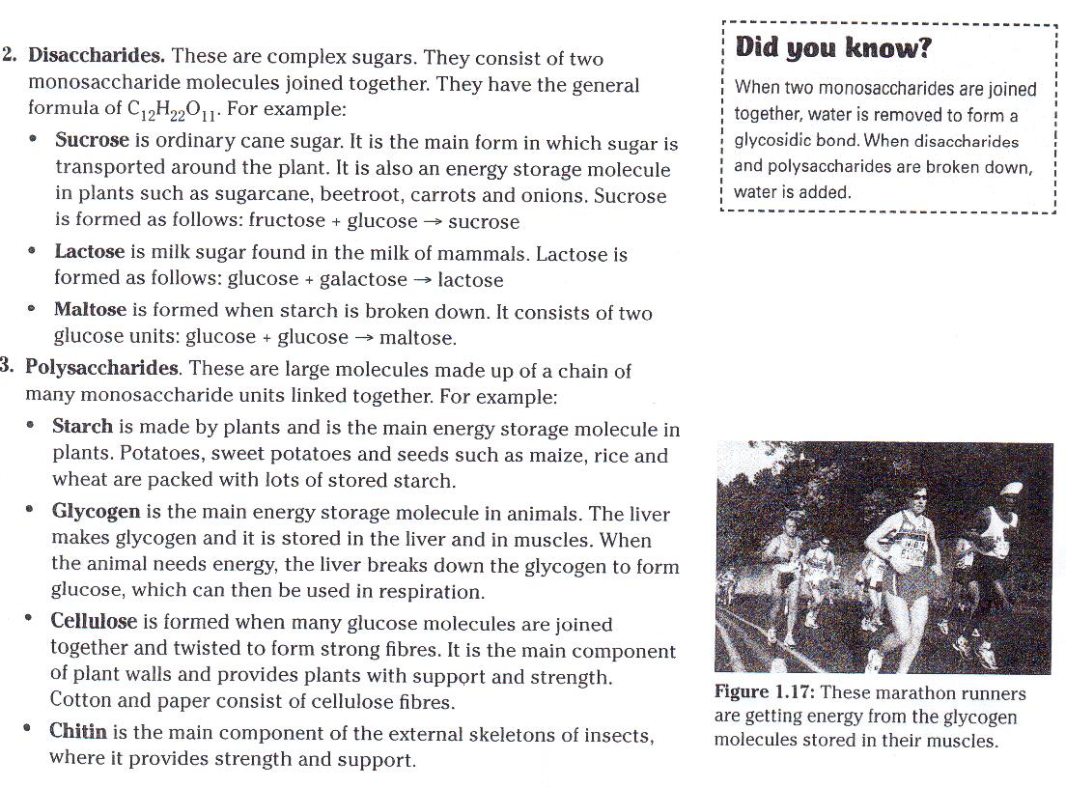
- In-organic compounds: - do not contain both carbon hydrogen
- Water
- It is made up of two molecules of hydrogen bonded to an oxygen molecule.
- Have both negative & positive.
- Electrically polarized.
- found as ice, liquid & vapour.
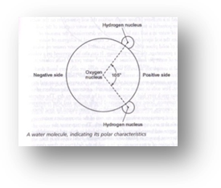
Properties of water
- Universal solvent
- Colourless
- Density of 4ºC
- High heat capacity
Importance of water
- Main solvent
- Facilitates chemical reactions
- Regulates temperature
- Transport agent
- Lubricant
- Source of hydrogen & oxygen
Water cycle
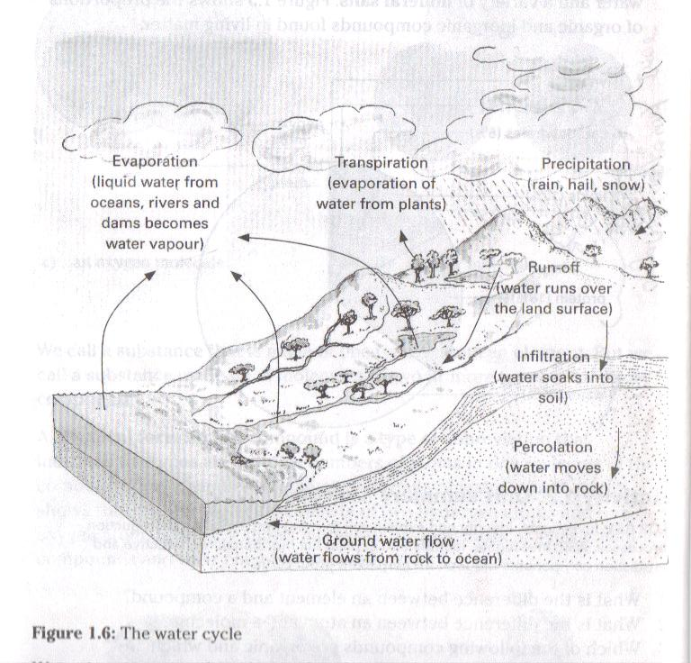
- Carbon dioxide
- made of one carbon atom bonded to two oxygen atoms.
- Chemical formula is CO₂.
- occurs naturally in the atmosphere.
- By-product of respiration.
Properties of CO₂
- Odourless
- Colourless
- Non-toxic
- Forms carbonic acid if combined with water.
Importance of CO₂
- By-product of respiration.
- Raw material of photosynthesis.
Carbon cycle
- A process whereby carbon dioxide from the atmosphere forms part
of carbon cycle in which carbon is recycled from the atmosphere to
the living organisms and back
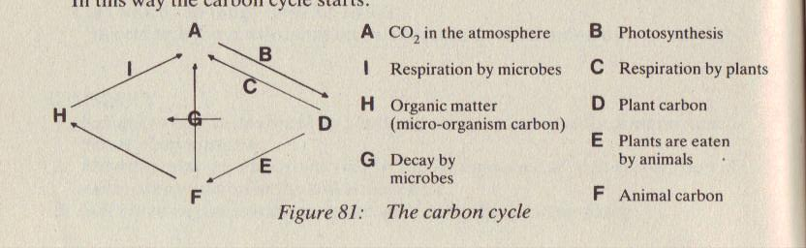

- Mineral salts
- Come from the rock particles.
- Dissolve in water in the soil and are easily absorbed by the plants through their roots.
- Most minerals ionize.
These are some of the important elements needed by the plants; if there is a shortage in the soil they should be replaced.
Elements | Importance | Types of fertilizer
Nitrogen (N) | Keep leaves & stems green | Manure, inorganic fertilizer.
Phosphorus (P) | Healthy roots growth, seeds & fruit production. | Inorganic fertilizers, bonemeal.
Potassium (K) | Colour & development of flowers, fruits.  Disease resistant. | Inorganic fertilizers.

If plants do not get enough of these elements for healthy growth, they begin to show deficiency symptoms. Eg. Lack nitrogen results in leaves turning pale yellow.
- For soil to run-out of elements, this can be due to lack of knowledge in ploughing method. (monoculture)

FORMATION OF SIMPLE COMPOUNDS
- Water (H₂O)
- H+H+O = H₂O
- Carbon dioxide (CO₂)
- C+O+O = CO₂
- Ammonia (NH₃)
- N+H+H+H = NH₃
- Methane (CH₄)
- C+H+H+H+H = CH₄
- Glucose (C₆H₁₂O₆)
- 6C+12H+6O = C₆H₁₂O₆
Structural formula
Element/compound | Formula | Structural formula
Hydrogen | H₂ | H-H
Oxygen | O₂ | O=O
Hydrogen Chlorine | Hcl | H-Cl
Water | H₂O | H-O-H
Carbon Dioxide | CO₂ | O=C=O
Methane | CH₄
Ammonia | NH₄

Solutions
Homogeneous mixture of the solute and solvent. E.g. salt & water is a perfect solution.
Classification of solutions according to concentration of solute.
- Diluted solution: - little solute as compared to solvent. (weak solution)
- Concentrated solution: - high rate of solute as compared to solvent.
- Saturated solution: - more than the maximum that can be dissolved in a solvent.
- Isotonic solution: - equal amount between solvent and solute.
Types of solutions
- Solid in liquid, eg. Sugar in water.
- Liquid in liquid, eg. Alcohol in water.
- Gas in liquid, eg. Oxygen in water.
- Gas in gas, eg. Oxygen in nitrogen.
- Gas in solid, eg. Ammonia absorbed in charcoal.
- Solid in gas, sulphur fumes in air.
- Solid in solid, alloy of zinc and copper.

Acid aqueous solution
Acids are proton donor. Acids aqueous solution contains more hydrogen ions. (H⁺)
E.g. if you add HCl in H₂O it dissociates into H⁺ + Cl⁻ , H⁺ is attracted to the negative pole of water molecule and form H₃O that causes acidity.

Alkaline aqueous solution
Bases are proton acceptor; alkaline aqueous solution contains more OH⁻
E.g. if you dissolve NH₃ in water, water dissociates into H⁺ + OH⁻ and forms NH₄ and that causes alkalinity.

Ions
An atom that has obtained an electric charge due to its gaining (anion) or losing (cation) an electron.

pH value
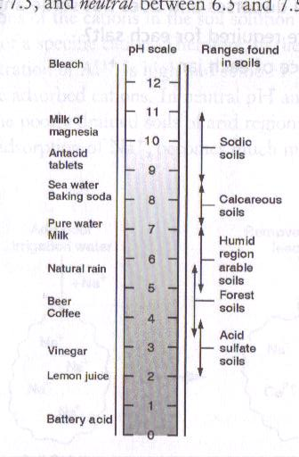
Power of hydrogen.

The scale used to indicate the acidity, neutrality or alkalinity of the solution.
- Ranges from 0 -14
- Acid 0 – 6.5
- Neutral 7
- Alkaline 7.5 - 14

Indicators
Devices or liquids to determine the pH of the solution.
Device/liquid acid (colour) base (colour)
- Methyl red red yellow
- Methyl orange red yellow
- Bromothymol blue yellow red
- Phenolphthalein clear red
- Alizrih yellow yellow red
- Litmus paper red blue
- Universal indicator table is used.
- pH meter electrical instrument used to measure pH

Neutralisation
Reaction between the hydrated hydrogen ions of an acid and the oxide or hydroxide ions of a base to form water, a salt being formed at the same time.
Examples
Acid + Base Water + Salt
- HCl + NaOH ↔ H₂o + NaCL
- HCl + KOH ↔ H₂o + KCl
- HNO₃ + NaOH ↔ H₂o + NaNO₃
- HNO₃ + KOH ↔ H₂o + KNO₃
- H₂SO₄ + NaOH ↔ H₂o + Na₂SO₄

Colloids
General properties of colloidal system
- Molecular solution
- Molecules are homogeneous dispersed among each other in the solution. (true solution)
- Colloidal dispersion:-
- Particles do not settle under the influence of gravity.
- Particles cannot be removed by ordinary filtration.
- Particles form the dispersed phase.
- Later molecules form the dispersion medium.
Types of colloids
- Sol: - a solid dispersion in liquid, eg. Milk of magnesia.
- Emulsion: - liquid dispersed in liquid, cream globules in milk.
- Gel: - fine solid network in liquid, eg. Jelly or agar.
- Aerosol: - solid or liquid in a gas, air freshner.
- Suspension
- Dispersed particles are large and are affected by gravity.
- Suspended particles can be removed by filtration.
- Relationship between surface area and volume of particles
- The smaller the particle, the larger the surface area but the volume remains the same.
- Dispersion phase and dispersion medium
- Colloidal particle form the dispersion phase and water form the dispersion medium.
- Emulsion
- The materials are both in liquid phase but do not mix readily. E.g. oil & water.
- True emulsion occurs when an emulsifying agent is added. E.g. egg white (emulsifying agent) added to water & olive oil.
- Tyndall effect
- The solution has different properties than the colloidal system.
- A light beam is focused and shone through a glass beaker containing the liquid,
- If the liquid is a solution, the light passes through the liquid and cannot be seen,
- When the light passes through a colloid, the particles are large enough to disperse the light and the beam of light is easily seen.
- The different effect these two types of dispersion have on light is called the Tyndall effect.
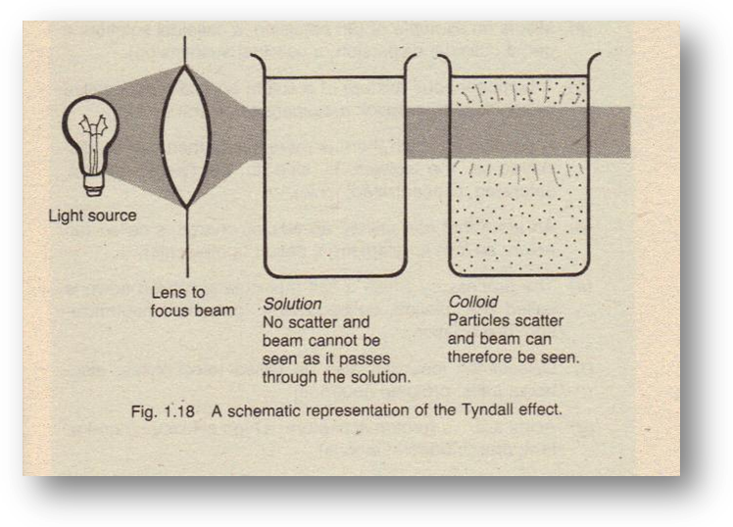
- Adsorption of ions
- Ions adhere to the surface of colloids.
- Colloids are negatively charged and have a large surface area.
- Positively charged ions or polar molecules are absorbed by colloids.
- Flocculation
- Colloidal particles form aggregates and become affected by gravity.
- The effect is induced by addition of calcium hydroxide, hydrochloric acid or sodium chloride.
- Deflocculation
- Colloidal particles are dispersed in the system.
- Dispersion is induced by ammonium hydroxide.

