Province of the
EASTERN CAPE
EDUCATION

DIRECTORATE SENIOR CURRICULUM MANAGEMENT (SEN-FET)
HOME SCHOOLING SELF- STUDY ANSWER SHEET
SUBJECT | ECONOMICS | GRADE | 11 | DATE | 22/04/2020
TOPIC | MACROECONOMICS | TERM 1  REVISION |  | TERM 2 CONTENT | X
TIME ALLOCATION | 20 MINUTES MARKS: 30 | TIPS TO KEEP HEALTHY  1. WASH YOUR HANDS thoroughly with soap and water for at least 20 seconds. Alternatively, use hand sanitizer with an alcohol content of at least 60%.  2. PRACTICE SOCIAL DISTANCING – keep a distance of 1m away from other people.  3. PRACTISE GOOD RESPIRATORY HYGIENE: cough or sneeze into your elbow or tissue and dispose of the tissue immediately after use.  4. TRY NOT TO TOUCH YOUR FACE. The virus can be transferred from your hands to your nose, mouth and eyes. It can then enter your body and make you sick.  5. STAY AT HOME.
INSTRUCTIONS | INSTRUCTIONS AND INFORMATION  - Answer ALL questions in the ANSWER BOOK  - Number the answers correctly according to the numbering system used in this question paper.  - Write the question number above each answer.  - Leave 2–3 lines between subsections of questions  - Write neatly and legibly.

QUESTION 1
1.1 | Answer the following questions
 | 1.1.1. | List any TWO examples of complementary goods (2x1) |  | (2)
 | 1.1.2 | What would encourage a producer to continue increasing its production? 2018 (1x2) |  | (2)
1.2 | Study the graph below and answer the questions that follow:
 | 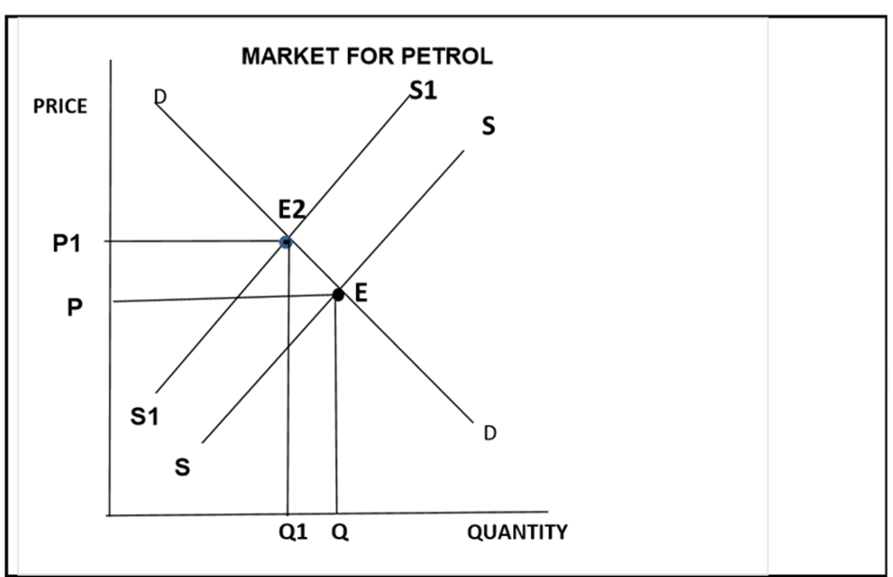
 | 1.2.1 | What does the shift from S to S1 show? |  | (1)
 | 1.2.2 | What is the impact on price of the shift in supply from S to S1? |  | (1)
 | 1.2.3 | Briefly describe the term quantity supplied |  | (2)
 | 1.2.4 | Explain the cause of a shift in supply from SS to S1S1 |  | (2)
 | 1.2.5 | Draw the graph of the complement product of petrol and indicate what the reaction would be. |  | (4)
1.3 | Differentiate between product and factor markets. |  |  | (8)
1.4 | With the aid of graphs, explain how an increase in demand of a product affects the factor market. |  |  | (8)
TOTAL |  |  |  | [30]

