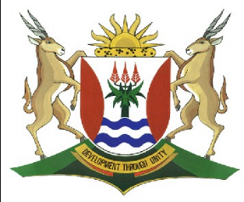
Province of the
EASTERN CAPE
EDUCATION

DIRECTORATE SENIOR CURRICULUM MANAGEMENT (SEN-FET)
HOME SCHOOLING SELF-STUDY WORKSHEET
SUBJECT | GEOGRAPHY | GRADE | 11 | DATE | 18/05/20
TOPIC | GOMORPHOLOGY | TERM 2  REVISION | √√ | TERM 2 CONTENT | √√
TIME ALLOCATION | 1 Hour | TIPS TO KEEP HEALTHY  1. WASH YOUR HANDS thoroughly with soap and water for at least 20 seconds. Alternatively, use hand sanitizer with an alcohol content of at least 60%.  2. PRACTICE SOCIAL DISTANCING – keep a distance of 1m away from other people.  3. PRACTISE GOOD RESPIRATORY HYGIENE: cough or sneeze into your elbow or tissue and dispose of the tissue immediately after use.  4. TRY NOT TO TOUCH YOUR FACE. The virus can be transferred from your hands to your nose, mouth and eyes. It can then enter your body and make you sick.  5. STAY AT HOME.
INSTRUCTIONS

- Notes on Topography Associated with Massive Igneos rocks
- Worksheet on Massive Igneous rocks
- Please revise all concepts before going through your worksheet.
- Revise at least 1 hour per day.
- Please revise question papers from 2014 to 2019 on the ECEXAMS website
NB: Answer sheets will follow on Friday

Topography Associated with Massive Igneous Rocks
Granite forms large batholiths and the top of an exposed Batholith is called a dome.
Dolerite and basalt are the most common type of igneous rock formed with rapid surface cooling
If cooling takes place beneath the surface of the Earth the rock formed will have large crystal as the cooling would have taken place slowly.
Granite is a common form of igneous rock that forms beneath the Earths surface.
If the Magma reaches the surface of the Earth cooling will be rapid and there will be lack of crystal structure in the rock.
Dolerite intrusions forms Sills and Dykes
Magma wells up from great depths of the Earth in liquid

Identification of batholiths, laccoliths, lopoliths, dykes and sills
Lopolith:
- Is a saucer shaped feature
- Formed by intrusion of magma between layers of Sedimentary rocks
- The weight of overlying rock causes the intrusion to collapse while cooling
- Forms a cuesta basin when exposed due to erosion
Batholith:
- Is the largest intrusive feature
- Forms deep below the Earth’s Surface
- The rock type is Granite
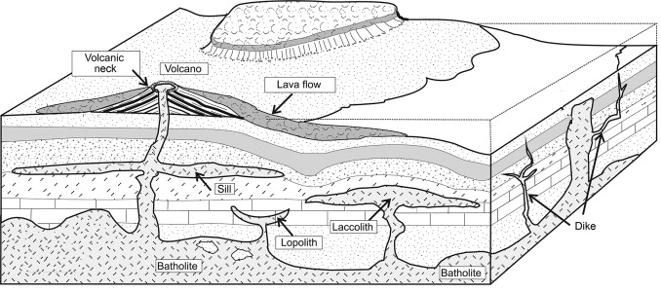
Dyke:
- Vertical intrusion of magma between horizontal layers of sedimentary rocks.

Laccolith:
- Is a mushroom shaped feature
- Intrusion of Magma between layers of sedimentary rock forms a laccolith
- The upward bending of the sedimentary rock is a result.
- It results in a cuesta dome when overlying sedimentary rocks are eroded,exposing the laccolith.

Sill
- Horizontal intrusion of magma between sedimentary rocks forms sills.
- Dolerite is the common rock Common in the Karoo landscapes

Characteristics and processes associated with the development of granite domes and tors
Granite when exposed on the surface of the Earth, forms: Granite domes and Tors.
Land  forms | Granite Dome | Tor
Characteristics | - Usually round and smooth when exposed.  - Light in colour  - Exposed domes are part of a much larger and deeper lying Batholith | - Isolated, exposed pile of jointed igneous rocks.  - These rocks are stacked on top of one another and well-rounded in appearance.  - The boulders are not be joined to each other with the exemption of the bottom row of boulders which may still be attached to the solid rock below. Eg Granite
Processes | - Intruding Batholiths cools down which results in the contraction of the Magma.  - Overlying rocks are removed by weathering. Removal causes the pressure to decrease leading to the expansion of the Batholith.  - Expansion joints develop which are curved in shape.  - Water seeps into these cracks and weathering takes place along the joints resulting in a rounded granite dome.  - Once the granite dome has been exposed on the surface of the earth,further weathering takes place which causes exfoliation and granular disintegration. | - Development of a Tor starts with the cooling of rock below the surface of the Earth.  - Cooling magma results in joints and cracks in the rocks.  - Seeping ground water into the cracks and joints results in weathering.  - Further joints and cracks occur with erosion of surface layers.  - Ground water also dissolves minerals  - Removal of overlying rock layers exposes the core stones of the igneous rocks.  - The pattern of the core stones is determined by how far apart the joints were in the original intrusions.
Diagram of the Landforms | 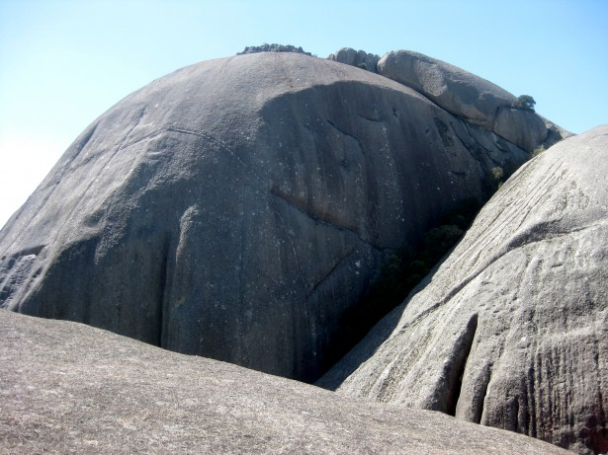 | 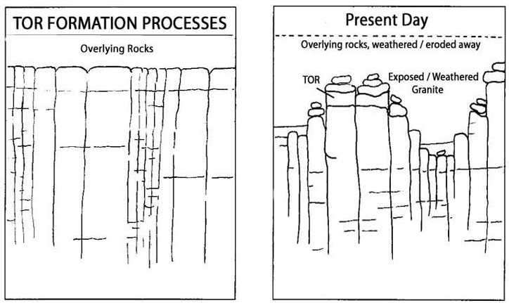
Questions Topography associated with Massive Igneous Rocks.
1.1. Study FIGURE 1.1 A and B which shows topography associated with massive igneous rocks.
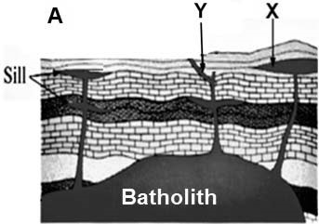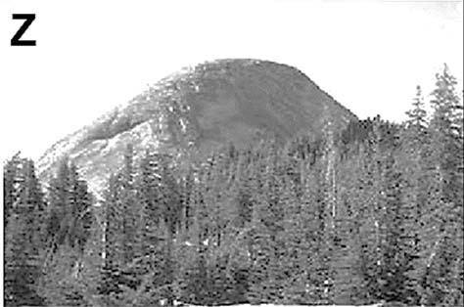
B

 | 1.1.1 | What is the difference between intrusive and extrusive igneous rocks? | (2 x1) | (2)
 | 1.1.2 | Identify igneous landforms X and Y. | (2 x1) | (2)
 | 1.1.3 | How does landform X form? | (2 x1) | (2)
 | 1.1.4 | Name TWO characteristics evident in sketch A that is typical of a batholith. | (2 x1) | (2)
 | 1.1.5 | Refer to photo B, a dome-shaped landform.  - What type of igneous rock is this dome-shaped landform? Characteristic of?  - Is this dome-shaped landform an example of intrusive or  extrusive igneous rocks?  © Name the type of weathering that occurs on this dome-  shaped landform.  (d) Explain how this dome-shaped landform has formed. | (1 x1)  (1 x1)  (1 x1)  (2 x2) | (1)  (1)  (1)  (4)
1.2 Choose the correct term in brackets to make the statements in QUESTION 1.2.1–1.2.7 true. Write the correct word next to the question number, for example 1.2.8 ITCZ.
 | 1.2.1 | (lava/magma) is set under the earth’s surface,
 | 1.2.2 | an (intrusive/extrusive) landform is formed
 | 1.2.3 | The largest/smallest) of this type of landform is the batholith
 | 1.2.4 | The lopolith is a bowl shaped landform and is linked to the magma chamber through a
 | 1.2.5 | (pipe/plate)
 | 1.2.6 | A granite dome ,like the Paarl mountains,formed because of weathering of a (lopolith/laccolith)
 | 1.2.7 | or a (dyke/batholith) | (7x1) | (7)
1.3 FIGURE 1.3 is based on the development of tors over time.

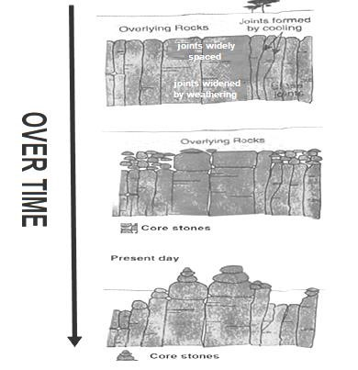

 | 1.3.1 | What are tors? | (1x1) | (1)
 | 1.3.2 | Name the massive igneous rock from which tors develop. | (1x1) | (1)
 | 1.3.3 | Describe the appearance of the present-day core stones of the tors. | (1x2) | (2)
 | 1.3.4 | Why is it possible for the core stones to remain in place although  they seem very loose? | (2 x2) | (4)
 | 1.3.5 | Outline the development of tors in a paragraph of approximately  EIGHT lines. | (4x2) | (8)
 |  |  | [38]

