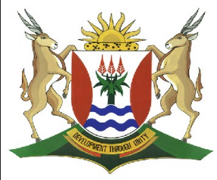
Province of the
EASTERN CAPE
EDUCATION

DIRECTORATE SENIOR CURRICULUM MANAGEMENT (SEN-FET)
HOME SCHOOLING SELF-STUDY WORKSHEET
SUBJECT | INFORMATION TECHNOLOGY PRACTICAL | GRADE | 11 | DATE | 11 May to 15 May 2020
TOPIC | Revision – Database Management | TERM 1  REVISION | (Please tick) | TERM 2 CONTENT
TIME ALLOCATION | 2hr | TIPS TO KEEP HEALTHY  1. WASH YOUR HANDS thoroughly with soap and water for at least 20 seconds. Alternatively, use hand sanitizer with an alcohol content of at least 60%.  2. PRACTISE SOCIAL DISTANCING – keep a distance of 1m away from other people.  3. PRACTISE GOOD RESPIRATORY HYGIENE: cough or sneeze into your elbow or tissue and dispose of the tissue immediately after use.  4. TRY NOT TO TOUCH YOUR FACE. The virus can be transferred from your hands to your nose, mouth and eyes. It can then enter your body and make you sick.  5. STAY AT HOME.
INSTRUCTIONS | Resources used// Most of this week’s work is taken from the New DBE book  - Information Technology Practical Book Grade 11 , DBE Chapter 4  - Past Exam Papers  Answer all questions

Database Management Software: Assessment

Assessment: DBMS lesson 3 and 4
- Briefly describe why it was necessary to create a server database in the place of a desktop database.
- Name some of the differences between server – and desktop databases.
- Explain in your own words how a server database work.
- Define the term distributed database.
- Name two reasons why one will make use of a distributed database.
- The Google big table database is one of the distributed databases available. Discuss the following in terms of Google Big Table. (You can make use of the research provided)
  - What it is.
  - How it works.
  - What it is used for.
  - Why was it created?
- Name one career that you can follow in the database field and discuss the function of this person.

